

Faculty of Applied Sciences  
Bachelor of Science in Computing

**COMP490 Final Year Project  
Progress Report**Academic Year 2022/23

|  |  |
| --- | --- |
| Parsons problem generator and solver | |
|  |  |
| Project number: | 19 |
| Student ID: | P-19-0834-5 |
| Student Name: | Jane Liu |
|  |  |
| Supervisor: | Philip Lei |
| Assessor: | Charles Lam |
|  |  |
| Submission Date: | 24/11/2022 |

Declaration of Originality

I, Jane Liu, declare that this report and the work reported herein was composed by and originated entirely from me. This report has not been submitted in any form for another degree or diploma at any university or other institute of tertiary education. Information derived from the published and unpublished work of others has been acknowledged in the text and a list of references is given in the bibliography.



Jane Liu

02/11/2022

Abstract

Parsons problem, a type of programming question reordering mixing up prepared code blocks by dragging and dropping to build predefined answer codes, has been used in introductory programming popularly. However, the existing Parsons problem has never been expanded in higher-level programming courses like Data Structures and Algorithms. Since this course is too complex and abstract for students to write codes directly, it is also vital to use Parsons problem to add preparation steps before they actually begin writing codes by themselves. It cannot just simply change the operating codes with the same structure of Parsons problem due to the difference between these two courses. Therefore, in this project, four concrete types of questions from Data Structures and Algorithms are analysed to show the drawbacks for directly using the traditional one and amelioration aiming at these drawbacks.

[Refer to the application document for Alberta]

[Refer to the ppt about abstract]

Acknowledgement

Write your own acknowledgement

Table of Contents

1 Introduction 10

1.1 Objectives 10

1.2 Risk Assessment 12

1.2.1 Risk 1: The computer used for implementation may break down 12

1.2.2 Risk 2: The system does not support different devices 12

1.2.3 Risk 3: Users reject this website because of the inferior user interface 12

1.3 Summary 13

2 Background and Related Work 14

2.1 Background 14

2.2 Related Work 15

3 Design Approach 16

3.1 Parsons Problem Analysis 16

3.1.1 Object Oriented Programming 17

3.1.2 Algorithm Analysis 19

3.1.3 Recursion 21

3.1.4 Data Structures Implementation Comparison and Algorithms Comparison 22

3.2 Balance the degree of difficulty 25

3.2.1 Switch Different Difficulty Levels 25

3.2.2 Pre-scaffold 26

3.2.3 Context 26

3.3 Holistic Analysis 27

3.4 Dynamic Modelling 29

3.5 Data Modelling 30

4 Implementation 35

4.1 Major Techniques and Tools Used 35

4.1.1 Front-end 35

4.1.2 Back-end 36

4.2 Traditional Parsons Problem 37

4.2.1 Overview of Implementation of Traditional Parsons Problem 37

4.2.2 Drag-and-drop 39

4.2.3 2D View 40

4.2.4 Check and Show Feedback 43

4.2.5 Distractor 45

4.3 Contextual Clues 46

4.3.1 Customize Solution 46

4.3.2 Show in Answer Pool 47

4.3.3 Check and Feedback 48

4.4 Multiple Step 49

4.4.1 Customize solution 49

4.4.2 Show and Check 51

4.5 Algorithm Comparison 52

4.6 Switch Difficulty Level 52

5 Results and Discussion 54

5.1 Project Outcome 54

5.1.1 Results of basic 54

5.2 Future Work 55

6 Conclusion 56

References 57

Table of Figures

Figure 1: Probability impact matrix – initially (left) and solutions (right) 12

Figure 2 Changing method positions does not affect the correctness of codes 16

Figure 3: The description of methods in a stack (left) and the corresponding codes (right) 17

Figure 4 The traditional Parsons problem (above) and the variation of Parsons problem (below) 18

Figure 5: Performance of a heap-based priority queue 20

Figure 6 The recursion example code of the Tower of Hanoi 20

Figure 7 Steps for solving Fibonacci Sequence 21

Figure 8: The array-based stack and the linked-list-based stack 22

Figure 9 The ordered array stack code pool (left) and the unordered linked-list stack code pool (right) 23

Figure 10 Selection sort (left), insertion sort (middle) and the mixed code pool (right) 24

Figure 11 Example for inserting key code fragments 25

Figure 12 Student Activity Diagram 28

Figure 13 Teacher Activity Diagram 29

Figure 14 ER Diagram 33

Figure 15 ER diagram 34

Figure 16 Create new question 35

Figure 17 Upload predefined solution 35

Figure 18 Rearrange the code blocks vertically by dragging and dropping 36

Figure 19 Check users' answer and give feedbacks 36

Figure 20 Gantt Chart 37

List of Tables

Table 1: Table of prioritized risk 12

Table 2 Entity 29

Table 3 Relationship between entities 30

Table 4 Attributes in each entity 31

Table 5 Logical Data Model 32

# Introduction

In recent years, with the computer industry boom, a growing number of people prefer to major in science in computing at their universities in order to find decent jobs after graduating. However, for some of the learners of this program, the courses are not straightforward, especially some courses having programming practices. To equip students with the programming skills, an advanced learning method, Parsons problem, has been introduced into the introductory programming courses (CS1 [1]). With the drag-and-drop programming style, this method allows the students to reordering the mixing up prepared blocks of codes to build the predefined solutions, which provides students with preparation steps by giving them sterling answers to refer before they need to write codes by themselves. Although Parsons problem gives notable assistance in programming study, it is limited in the programming practices in CS1 and it has never been used in teaching activities in higher-level programming courses such as Data Structures and Algorithms (CS2 [1]). Admittedly, students taking intermediate-level programming courses should be able to write code instead of just rearranging the order of provided answer blocks. However, because of the abstractness and complexity of programming in this course, it is also a challenging task for students to write it by themselves directly. Thus, it is of the essence to introduce Parsons problem to build a “bridge” for students to grow their programming capability. However, since there are some differences between CS1 and CS2, the traditional Parsons problem cannot be applied in CS2 without any adjustment. Therefore, in this project, how to use Parsons problem in new ways to fit the programming exercises in CS2 is discussed.

## Objectives

This project aims to design and build a website for computer usage to let teachers input problems and solutions (in Python), generate Parsons problems according to the inputs, make students solve the generated Parsons problems, and provide feedback for the solutions. The major objectives of this project are as follows:

* Study the existing Parsons problem components (question description, correct code fragments and distractors) and common methods to reduce the difficulty (pre-scaffold and context)
* Design new ideas for using Parsons problem in CS2 according to the concrete questions in exercise of CS2
* Design the system architecture to have a blueprint of the project
* Design and implement a database to store the data about accounts, questions, solution code fragments, distractors, and feedbacks
* Design and implement a web page for teachers to input the questions with corresponding solutions
* Design and implement a function to generate Parsons according to the inputs problem, including cutting the whole python file into code fragments and presenting these code fragments in a random way
* Design and implement a web page showing code pools with code fragments in random orders and structured place with vertical dimension and horizontal dimension
* Design and implement a function for students to drag and drop code fragments from the pools and put them in the structures places in proper order with proper indentation
* Design and implement a function for students to evaluate the code generated by students and give them some feedback

In this project, the Parsons problem will be used to handle the exercises in CS2 to have preparation steps for students to write codes by themselves. The variation of Parsons problem can not only take the advantages of the existing Parsons problem (like improving students’ engagement and reducing students’ cognitive load [2]), but also have some new benefits. To be more specific, the new design can handle the specific concepts only existing in CS2. In addition, it can help students to build excellent habits to solve problems. Last but not least, it can help students to consolidate what they have learned through many different ways.

There are several challenges in this project. Firstly, it needs to study intensively the concrete exercises in CS2 to figure out the possible amelioration of existing Parsons problem. Secondly, it needs to design and develop proper Parsons problem fitting the exercises in CS2. Last challenge is to implement a 2D view for dragging and dropping the code blocks.

## Risk Assessment

This section will describe three risks encountered in the project, illustrate the severity priorities of these three risks, and show the effectiveness of the related solution by comparing the impact and possibility before and after.

### Risk 1: The computer used for implementation may break down

Since the whole project work, including codes and documents, is stored on the computer, it will be a disaster when computer errors occur. All work will disappear in a moment, and the previous effort will go down the drain, which will seriously affect the project's progress.

Solution: Take advantage of online backups such as GitHub or Google Drive to ensure the progress will not be affected when the computer acts up.

### Risk 2: The system does not support different devices

Although this web-based project is designed to be used on computers majorly, some users may try to open it on their tablets. Since the changes in screen sizes between these three kinds of devices, some interfaces of web pages may look too small or too strange, which may bring users an awful experience and reduce their motivation for further use of this website. In that case, it does not seem conducive to the future growth of this project.

Solution: Design a responsive website to fit the size of different devices satisfying users’ needs on various devices.

### Risk 3: Users reject this website because of the inferior user interface

If the user interface is unfriendly, the user may misunderstand some instructions given by this website and repeat some unexpected wrong actions again and again, which wastes a lot of users’ time and may cause users to be impatient and give up easily. And this situation is not beneficial for the long-term development of this project.

Solution: Apply common design principles like Eight Golden Roles to the interfaces. In addition, simulate a user to access some related projects and get some ideas from their design.

To sum up the severe level of these previously mentioned risks, a priority risk table has been shown in Table 1.

Table 1: Table of prioritized risk

|  |  |
| --- | --- |
| Priority | Risk Identifier and Description |
| 1 | Risk 1: The computer used for implementation may break down |
| 2 | Risk 3: Users reject this website because of the inferior user interface |
| 3 | Risk 2: The system does not support different devices |

As shown in Table 2, there are three related risks. Specifically, the first risk has the highest priority since it may redo the whole work, which may significantly delay the development of this project. Subsequently, the third risk has lower priority than the previous risk since the project can still perform when affected by this risk. However, this risk may cause the users to feel confused and fretful, so they may not want to use the website again, which is unsuitable for the popularization of the website. Lastly, the second risk has the lowest priority since this website will be major used on computers, and only a few people using other platforms are affected by this risk.

The probability impact matrixes have been shown in the following two figures to directly show between before and after using solutions.

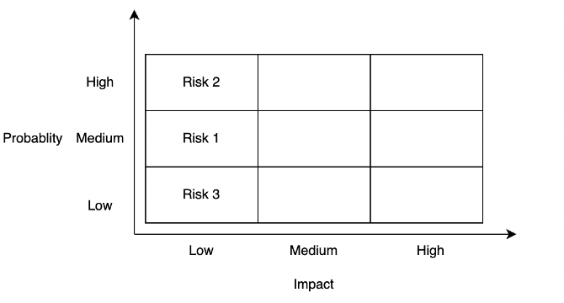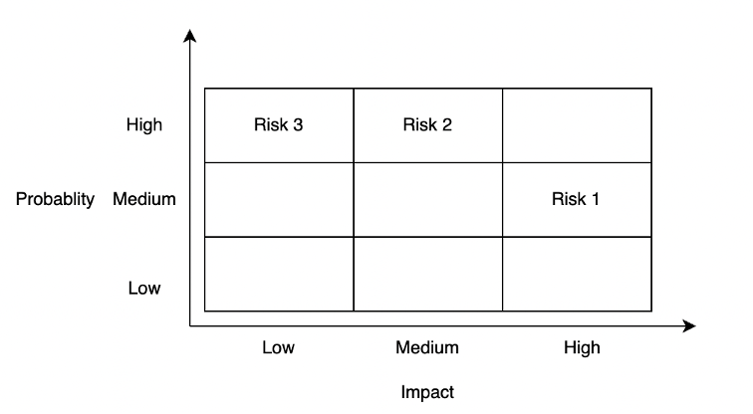

Figure 1: Probability impact matrix – initially (left) and solutions (right)

## Summary

This report is organized as follows: Chapter 2 introduces the background and related work of Parsons problem. Chapter 3 presents the problem analysis. Chapter 4 shows the on-going work and future work. Chapter 5 is the conclusion.

# Background and Related Work

This chapter explains the background and related work of Parsons problem. In the background section, the components and structures of Parsons problem are explained. In addition, the brief difference between the existing Parsons problem and the common limitations of these work are also explained.

## Background

The Parsons problem is a drag-and-drop-style code-reordering problem. Precisely, in a Parsons problem, a prepared correct, complete solution code of a specific problem is cut into plenty of small code fragments in lines. These code fragments are provided to students in a random order in a code pool with some incorrect or improper ones (distractors). And students should select the correct code fragments from the code pool and drag and drop these code fragments to place them the correct order. During this period, students can get some instruction feedback based on their reordered answers, and they need to improve their answers based on the feedback until they get the same answer as the predefined answer [2].

The Parsons problem contains the following four components:

* **Question descriptions** illustrate the questions in text or activity diagrams. Using activity diagrams in Parsons problem, students can understand the problem’s solution logic before they begin solving it [2].
* **Correct code fragments** are lines in correct solution codes. Since students only need to choose and reorder prepared code fragments instead of writing codes directly, the cognitive load is reduced, so the difficulty of programming questions is discounted [2]. In addition, this design provides magnificent solution examples as reference material for students to analogize some similar questions.
* **Distractors** are some incorrect or improper code fragments mixing with the original correct ones. By comparing with the correct code fragments, students can not only distinguish some common errors but also cultivate good coding habits like using meaningful and conforming naming rules names [2].
* **Feedback** is used to give students improving hints based on students’ solutions. There are two different types of feedback – line-based feedback and execution-based feedback. Line-based feedbacks evaluate students’ solution by comparing them with the prepared solution, while execution-based feedbacks evaluate students’ solution by running codes directly. Both kinds of feedback can provide students with instant feedback to give students some instructions for improving [3].

Besides the contribution of Parsons problems components in reducing difficulties of programming questions, there are two common methods to ease the programming problem further:

* **Pre-scaffold**: it reduces difficulty by providing hints of the organization of solution codes. It can be achieved by indicating some structures like loop structures based on braces or indentations [4]. Moreover, it also can be achieved by giving subgoals [5].
* **Context**: some settled code is provided around the sorting codes [6].

## Related Work

This method has been used in many previous work about programming education. To be more specific, Parsons and Haden developed a web-based tool for generating Parsons problems for introductory programming in BASIC with jumbled distractors, pre-scaffolding, and absolute line-based feedback [2] [3]. Besides, Karavirta et al. developed a Parsons problems project called js-parsons for introductory programming in Python with no distractors, student-scaffolding, and relative line-based feedback [3] [6]. Lastly, Amruth developed Epplets for introductory programming in C+, C#, and Java with distractors and relative line-based feedback [3] [7]. In conclusion, although the previous work provides Parsons problem practice in several programming languages with different structures, these projects have one thing in common – they are only applied for introductory programming, which gives this project room for improvement.

# Design Approach

This chapter explains the design approach in high level, including Parsons problem analysis, balance the degree of difficulty, holistic analysis, dynamic modelling and data modelling. In Parsons problem analysis, the differences in questions between CS1 and CS2 are explained. In balance the degree of difficulty, the ways to reduce the difficulty are explained. In holistic analysis, the overall blueprint of Parsons problem summarizing the before two sections are defined. In dynamic modelling, the activity diagram of teachers and students are illustrated. In the final section of this chapter, the database design is explained.

## Parsons Problem Analysis

The traditional Parsons problem has shown its advantages in exercises of CS1. However, since there are plenty of differences between the exercises in CS1 and CS2, it is not so proper to apply Parsons problem directly in CS2 without tailored improvement. Thus, some new ideas should be introduced to Parsons problem. The limitation of the traditional Parsons problem and new ideas will be discussed in the following paragraphs by comparing the difference between CS1 and CS2.

Unlike CS1, the codes in CS2 are much more complex and abstract in the following three general aspects. To be more precisely, students are supposed to not only understand the meaning of every line but also be able to organize these single lines into larger blocks (like methods, classes, even algorithms) in order to have a deeper understanding of the features of data structures, the recursive solving method, and the algorithms analysis. In addition, codes are no longer the only points covered in Parsons problem. Some new abstract elements like pseudocode and algorithms analysis should also be involved in exercises of CS2. Finally, high comparing ability is required in CS2 since there are plenty of similar concepts like stacks and queues, different types of trees, and different algorithms to solve the problems.

The difference between the CS1 and CS2 courses mentioned above leads to deficiencies in applying the traditional Parsons problem. To show these limitations in detail and introduce the improvement aiming at these limitations, the exercises in the famous textbook *Data Structures and Algorithms in Python* [8]were analyzed, and four common question types were identified.

### Object Oriented Programming

Object-oriented programming is a programming model based on objects, which includes attributes and methods [9]. In CS1, since all the programming parts are Structured Programming, the object-oriented programming concept has never been involved. However, in CS2, this concept becomes one of the focal points since it is the foundation to build different data structures. But after introducing this concept, Parsons problem for data structure questions cannot have unique answers since the methods in the classes can change their positions without affecting the correctness of the results (for example, Figure 2).

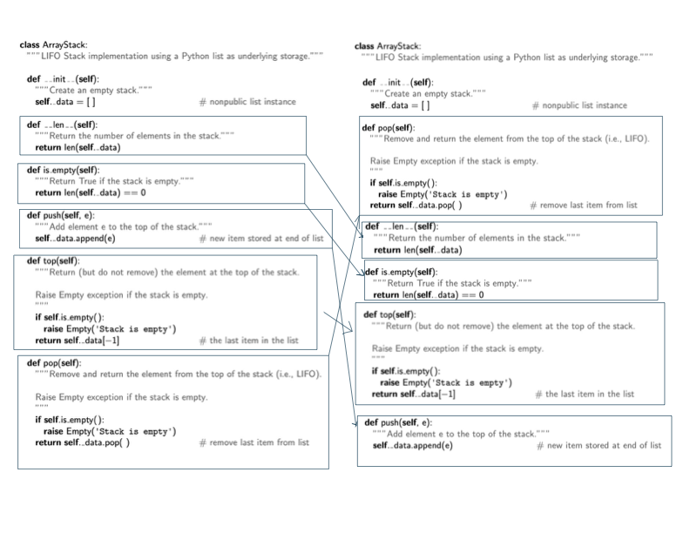

Figure 2 Changing method positions does not affect the correctness of codes

To have a unique answer, some paragraphs describing the functions of the methods should be listed in a specific order in the question description, and students are asked to build methods one by one in a matching order. For example, in Figure 3: The description of methods in a stack (left) and the corresponding codes (right), the left part shows the description of methods of an abstract data type stack in a specific order, and the corresponding methods are implemented in a matching order in the right part. In this way, a unique order of answers is defined by design. Thus, Parsons problem can not only fit the object-oriented programming type of questions but also keep some of its reordering features simultaneously. More importantly, this new design idea enhances students’ understanding of the whole method instead of just every individual line. Further, by this design, students also can have a general idea about what features of a specific abstract data type (ADT) should have [8].

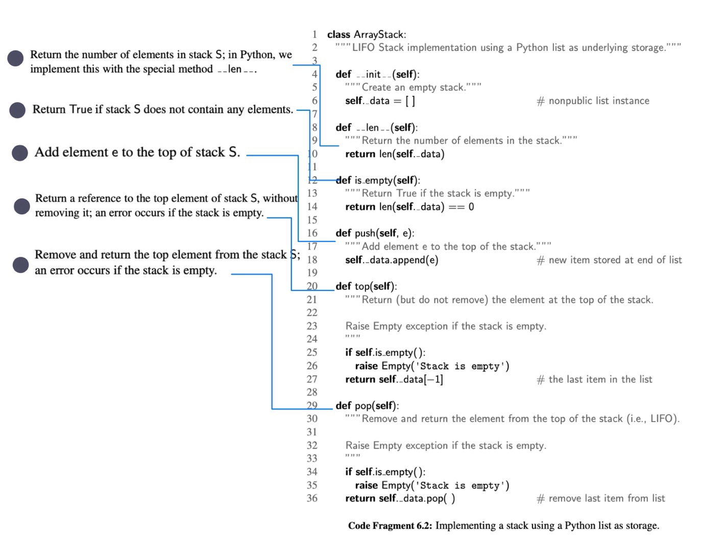

Figure 3: The description of methods in a stack (left) and the corresponding codes (right)

Another way to handle this problem is only to check the availability of methods and the contents of methods but ignore the positions of the methods. This variation of Parsons problem is significantly different from the traditional Parsons problem (Figure 4). Specifically, in the traditional Parsons problem, the interchangeable lines are combined into a larger block to have a unique answer [6]. In this way, it ignores the smaller parts (lines) and focuses on the bigger ones (blocks). By contrast, the new design looks the opposite way compared to the previous design. It ignores the bigger parts (order between different methods) and focuses on the smaller parts (lines inside the methods).

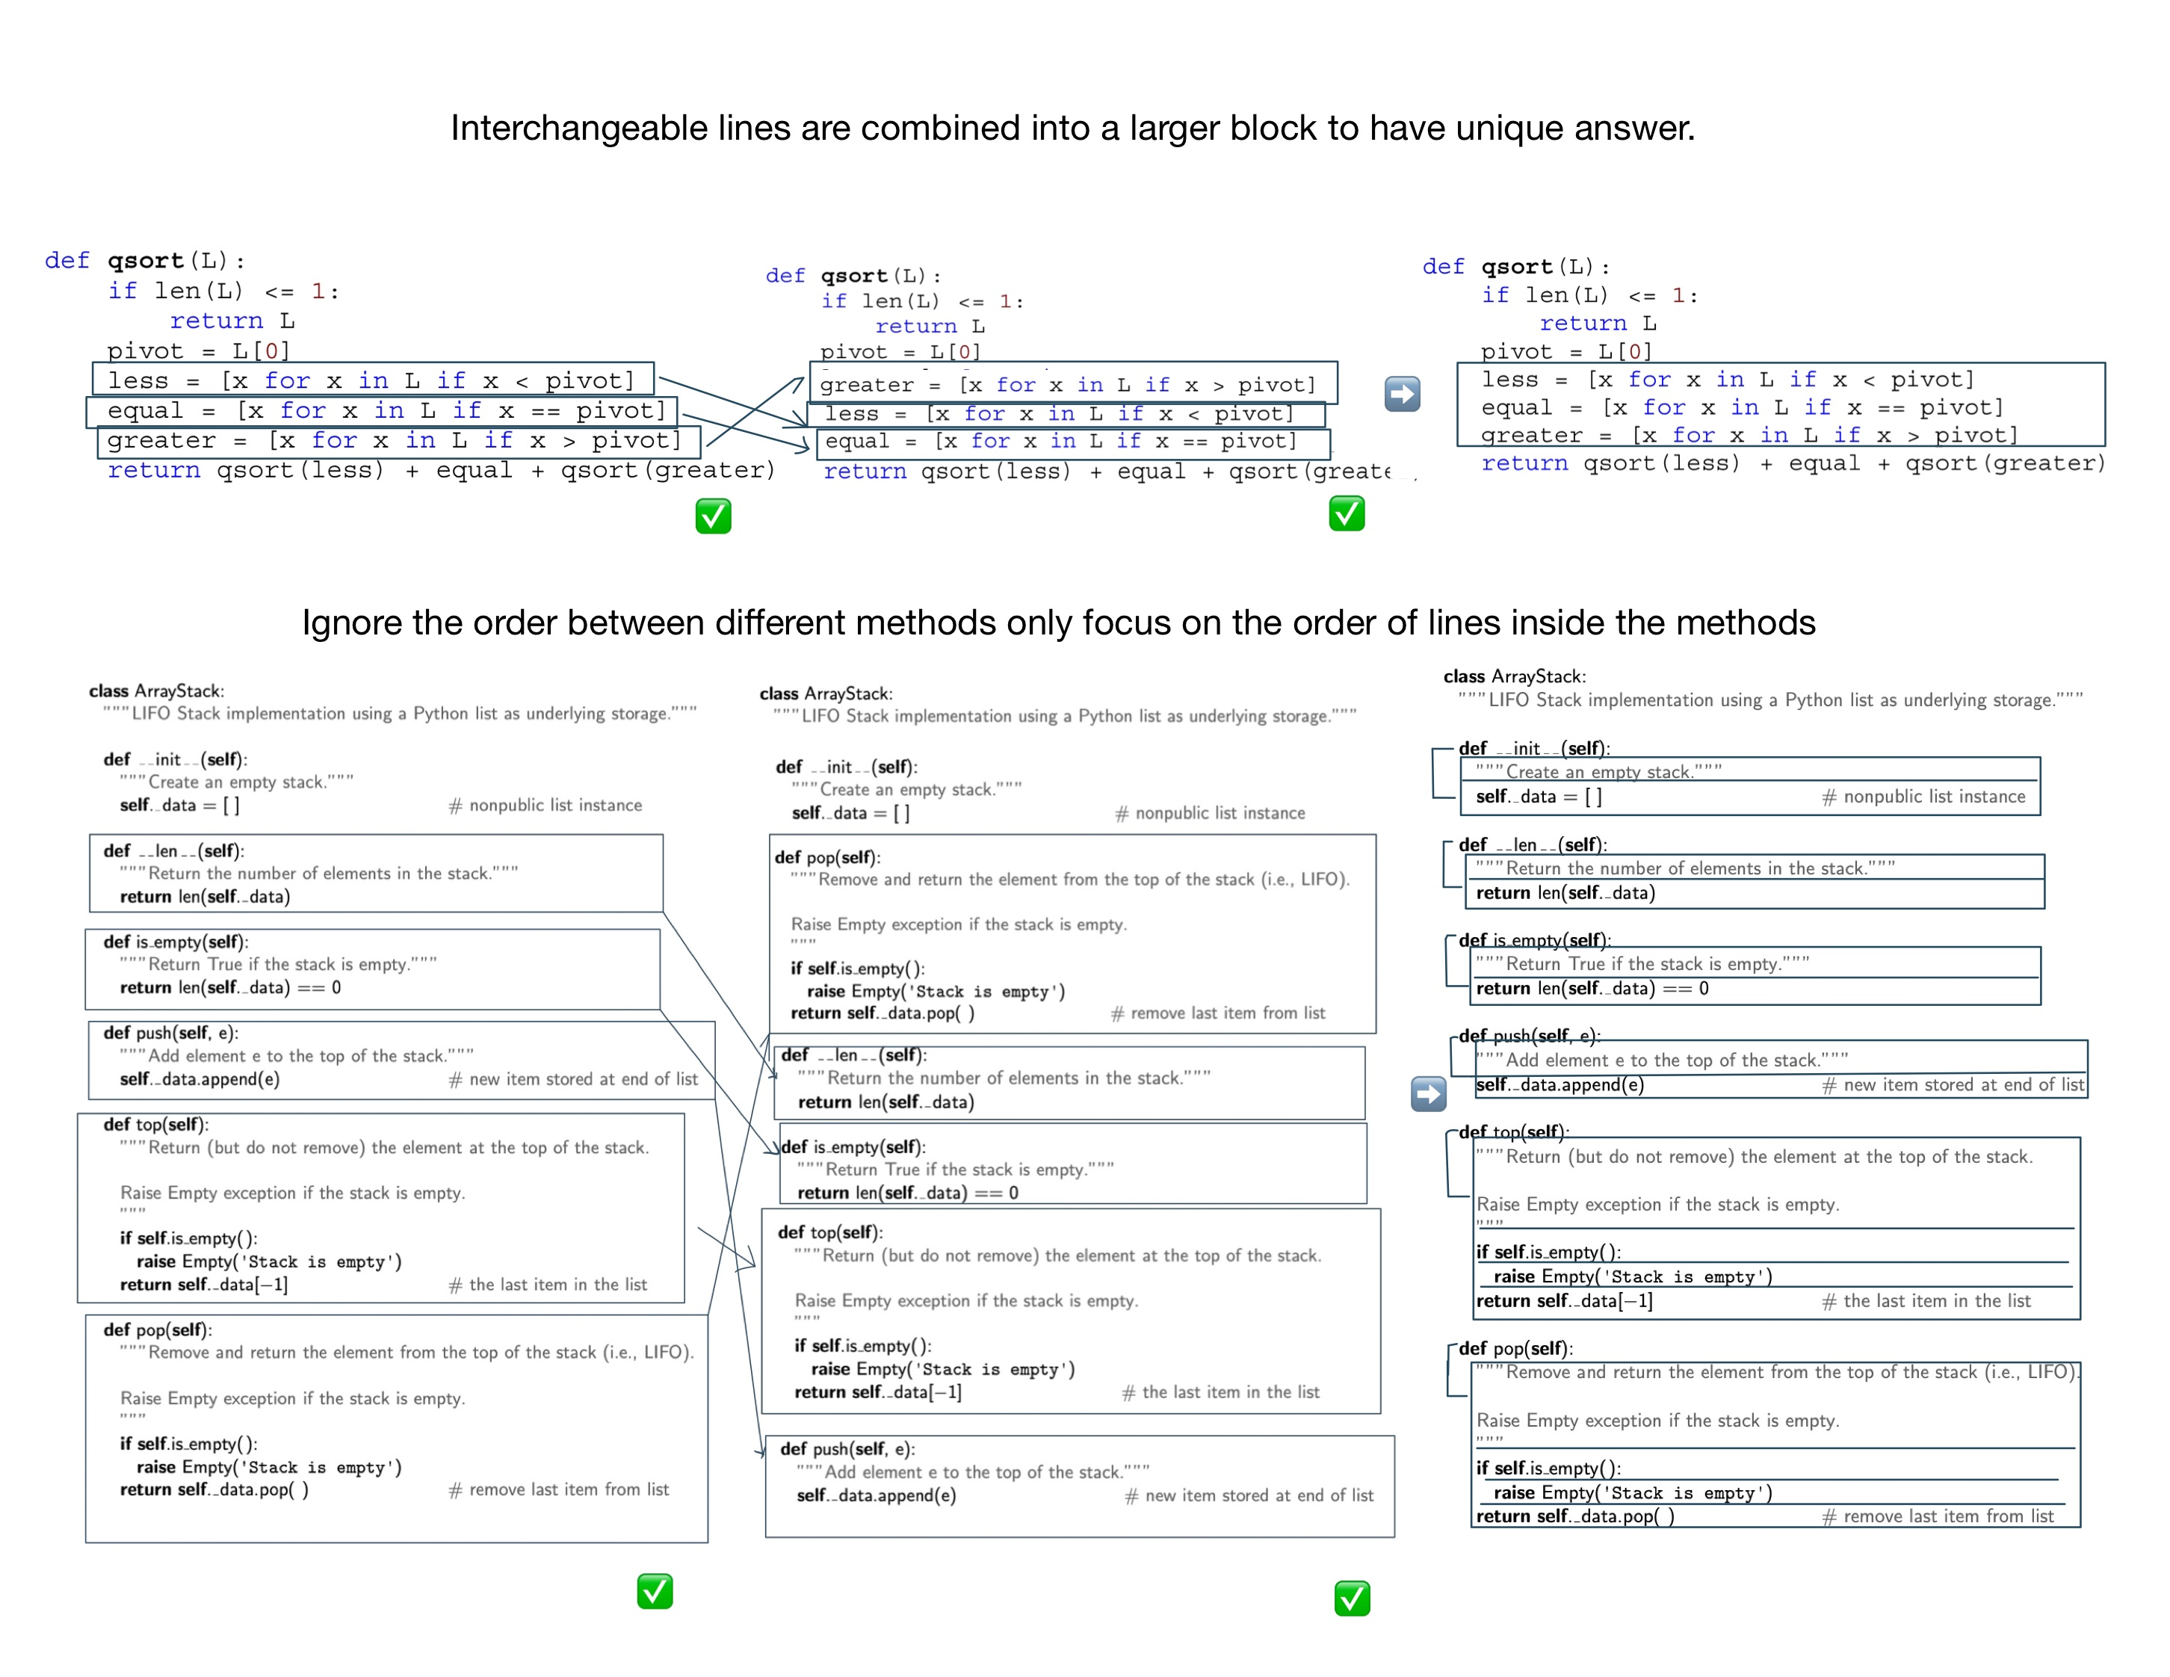

Figure 4 The traditional Parsons problem (above) and the variation of Parsons problem (below)

### Algorithm Analysis

Algorithm analysis, which is a core part of CS2, is to use the running time to evaluate whether a data structure or an algorithm is efficient or not [8]. Since the growth rate of running time as a function of the input size n is vital for algorithm analysis, big O, which shows the significant parts affecting the growth, is introduced in algorithm analysis [8]. Since the only major data structure used in CS1 is array – one of linear data structure, the algorithm analysis in CS1 can be done simply by counting the number of times a statement runs. In other words, the algorithm analysis in CS1 mostly depends on the loop structures in the codes so that there are only four functions (the constant function, the linear function, the quadratic function, and the cubic function and other polynomials) are used in programming. By contrast, the codes in CS2 involves more complicated non-linear data structures such as trees or graphs, which means that students should not only consider the impact of code structures but also non-linear data structures when analyzing the codes. For example, a loop to traverse a balance tree will consume O(log n) steps, not O(n) steps (where n is the number of nodes in the tree). Thus, more big O classes are used commonly in CS2 (the constant function, the logarithm function, the linear function, the N-log-N function, the quadratic function, the cubic function and other polynomials, and the exponential function) [8]. It is strenuous to ascertain which functions are the correct functions to describe the efficiency of the specific data structures and algorithms. Besides the impact of non-linear data structure, the recursion is another reason to make the analyzing experiencing learned from CS1 impractical. It is not straightforward to observe how many times a recursion function done. For these reason, the algorithm analysis parts are always ignored in CS1, so the traditional Parsons problem for CS1 certainty cannot handle this algorithm analysis questions, which is another drawback for using traditional Parsons problem directly in CS2.

To involve the algorithm analysis, only operating the code cannot satisfy the situation anymore. Thus, a new component – comment – is introduced in Parsons problem. To be more specific, the comments are used to provide different big O classes for choosing. Students need to select the correct corresponding big O class comments and insert them into codes to do algorithm analysis of the whole code. Unlike the previous reordering questions, this question is more like a multiple-choice question since students can put the comment wherever they like. Furthermore, this new idea also can be expanded in two ways. One way is to provide not only big O but also the described reasons to get big O. In this way, students can have a deeper understanding of algorithm analysis instead of just guessing big O classes according to their feelings. Another way is to let students match different big O classes with different parts in codes. This way can be used to track the change points of big O classes (like outer for loop and inner for loop), or it can be used to compare different methods in a data structure and let students know the characteristics of a data structure (For example, a heap is quick to get the min value, but it is slow to add nodes, shown in Figure 5).

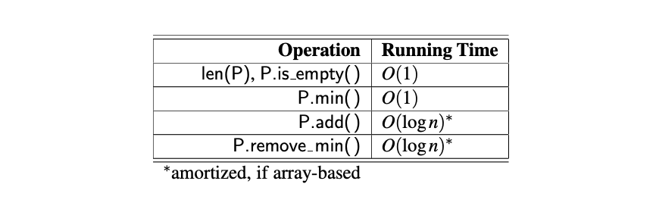

Figure 5: Performance of a heap-based priority queue

### Recursion

Recursion is solving a problem by solving a subproblem with the same structures as the original problem. It is achieved by calling the function itself, passing smaller argument values to build subproblems, finding the answers to subproblems, and using these answers to solve the original problem. Unlike in CS1, the recursion method is called inside instead of outside of the method body, which requires students with deeper understanding in the whole picture of entire methods besides concrete lines in the methods. For this reason, it leads to a dramatic increase in the difficulty of problems, and the traditional Parsons problem cannot significantly reduce complexity. Concretely, the traditional Parsons problem reduces difficulty by providing some code fragments for students to read. However, in the recursion type of question, it is arduous to understand the meaning of every line of code even if the whole code is given in order (like the recursion example code of the Tower of Hanoi in Figure 6 [10]). Thus, the assistance coming from code reading of Parsons problem is notably shrunk, and it is almost like letting students write code directly. That is why the traditional Parsons problem needs to be improved to give students more hints in solving recursion questions.

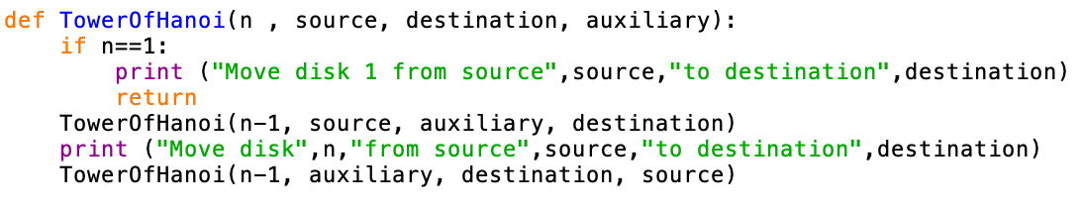

Figure 6 The recursion example code of the Tower of Hanoi

According to the suggestions for designing recursive algorithms provided by the textbook, it is beneficial to find a few specific subproblems which have the same structures as the original problems [8]. To achieve the suggested way, a new pre-scaffold way – organizing in several steps – is introduced into Parsons problem. To be more specific, one recursion question is divided into some steps. The first step is to let students reorder the code of base cases (the end point of every recursion chain [8]). Subsequently, change the values of parameters used in this recursion algorithm to have other subproblems. And in this step, the previous base cases should also be involved. In other words, students need to build these subproblems by calling the method in the base cases. In the following step, students should choose the correct method headers with proper signatures. In the final step, students are required to reorder the actual recursion codes with all the previous codes as references. This new pre-scaffold way can be partially helpful for students to solve the recursion problems. In this new way, students are provided with more hints (like subproblems) than directly solving recursion questions. Thus, they are less like to be all at sea (Figure 7).

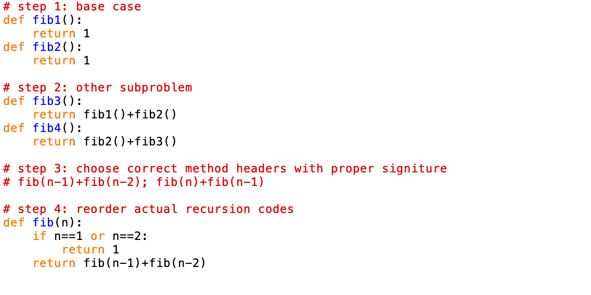

Figure 7 Steps for solving Fibonacci Sequence

### Data Structures Implementation Comparison and Algorithms Comparison

One of the characteristics of code in CS2 is similar to each other. For example, the codes can have the same data structures but are implemented in different ways (like the array-based stack and linked-list-based stack in Figure 8) or different solving algorithms for the same problems (like bubble sort and selection sort for sorting numbers problem). Although it is ok to use the traditional Parsons problem individually for each code, it would be more worthwhile to help students to compare these similar codes and consolidate the difference and similarities between these codes. Therefore, the students can distinguish them and have a better understanding.

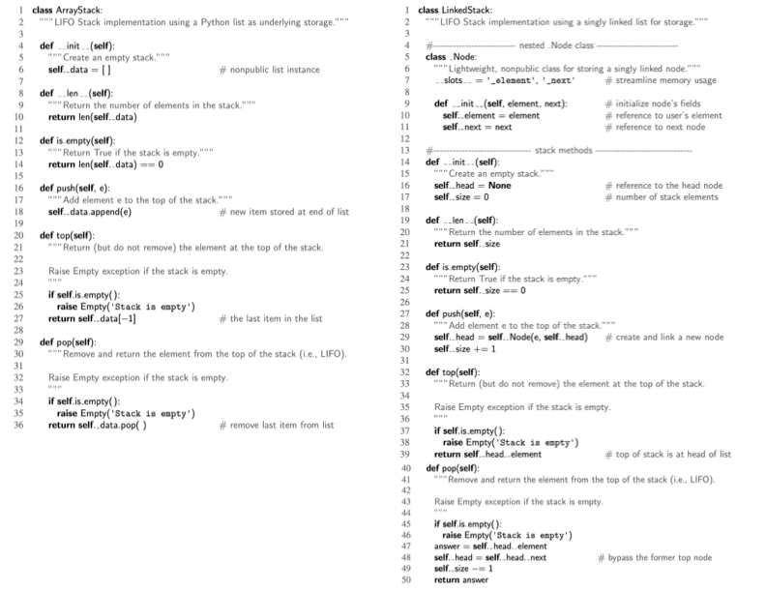

Figure 8: The array-based stack and the linked-list-based stack

The transfer learning method is used to compare the same data structures implemented in different ways. In other words, two different codes with some common parts are provided, and students need to choose the common parts from one of the codes using these common parts to build another one. In this way, students can understand new knowledge by transforming what they have learned before. Taking the two implementation ways of a stack as an example, students can drag and drop the method headers in an array-based stack as some components to build a linked-list-based stack. In such a manner, students can have a general idea about the common parts (the methods supported in a stack abstract data type) and what differences are (implementation details caused by array structure or linked list structure). Besides, the completed ordered array-based stack codes also can be hints to support students in building the linked-list-based stack Figure 9.

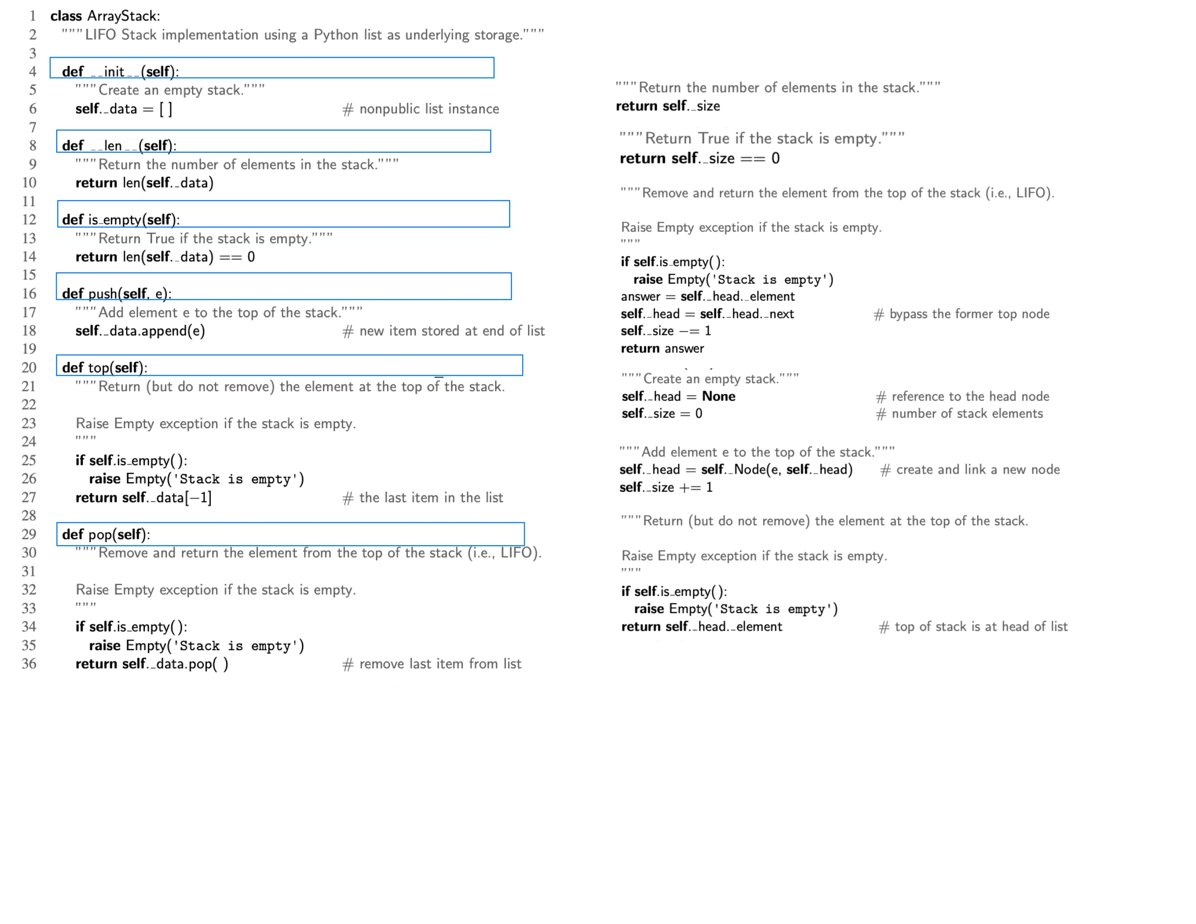

Figure 9 The ordered array stack code pool (left) and the unordered linked-list stack code pool (right)

To compare different algorithms of the same question, two algorithms are mixed by using distractors, and students are supposed to distinguish and order each of them from the mixing code pool. More specifically, unlike traditional distractors, which are all used to show some incorrect or improper code [2], a group of correct, complete codes of an algorithm is introduced as distractors to mix with another algorithm. In other words, the jumbled code fragment pool includes two different correct algorithms, and students should pick up, rearrange, and submit the code fragments in these two algorithms separately. This setting method is significantly applicable in CS2 since many questions have this characteristic – one question with several solving algorithms, for example, bubble sort, selection sort, insertion sort for sorting numbers, and breadth-first search, depth-first search for searching. In this way, it can help students to distinguish similar algorithms in the same categories mentioned before. It is worthwhile when students have learned more than one algorithm and begin to use them mostly because of blurry memory Figure 10.

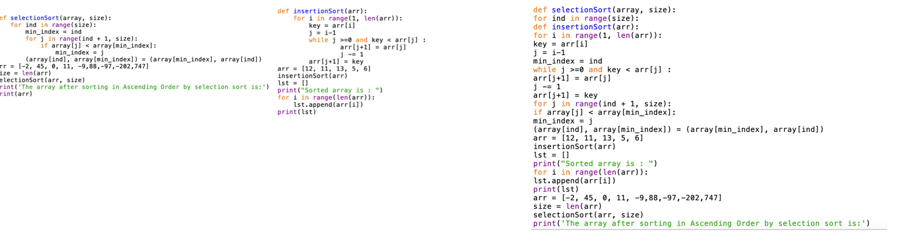

Figure 10 Selection sort (left), insertion sort (middle) and the mixed code pool (right)

## Balance the degree of difficulty

The critical function of Parsons problem is to add a preparation stage before students begin to write codes. This preparation stage is achieved mainly by reducing the difficulty caused by directly writing codes. In other words, one of Parsons's key issues is to find a balance point in the degree of difficulty, which is more accessible than writing codes from scratch but still valuable to practice. To fulfill this demand, three different methods (selecting difficulty level, pre-scaffold, and context) are introduced in the following paragraph.

### Switch Different Difficulty Levels

In the traditional Parsons problem, whether pre-scaffold or not, the problem is always predefined with a fixed difficulty level, which means that students cannot ask for further help with additional hints if they meet problems in solving this Parsons problem. Since the codes in CS1 are pretty simple, this problem may not happen frequently and may not affect students solving problems. However, due to the increase in the complexity of the codes in CS2, this problem begins to become a huge issue. Multiple difficulty levels are set to handle this issue, and students are allowed to switch to a more accessible version of this question halfway. For example, three different difficulty levels are set. Specifically, Level 0 is to just cut codes in lines and allow students to reorder them. Subsequently, in Level 1, the headers of methods and predefined description comments are placed in the correct positions for hints. In Level 2, the codes are grouped by methods so that students can only reorder smaller parts of codes for every method instead of selecting from the whole mixing codes pool. In Level 3, some codes in methods are fixed as context and only some core parts need to be reordered. If students find the present version of Parsons problem too difficult, they can change to a more accessible version.

### Pre-scaffold

Pre-scaffolding is to give students some structures for hints. This kind of method to handle the difficulty has already been used in the existing Parsons problem, like providing loop structures. This method is also used in CS2 courses but with some extension. To be more specific, pre-scaffolding can be achieved by separating codes by different methods like the example shown before. In addition, pre-scaffolding also can be achieved by separating codes into different steps, like the example shown in recursion questions. Finally, this method also can be achieved by separating codes according to different subgoals helping students to divide a vast, complex problem into more minor simple questions [5]. A hint for each subgoal is provided as a comment.

### Context

Context is used to provide some ordered codes as information and let students only reorder some smaller parts in the middle of these ordered codes. Context can be done a step further, which means that students only need to insert some key code fragments into the correct location of the whole code file. And to keep the question valuable, some wrong codes are also provided to confuse students. This kind of question is extra valuable for iterator and recursion questions (Figure 11).

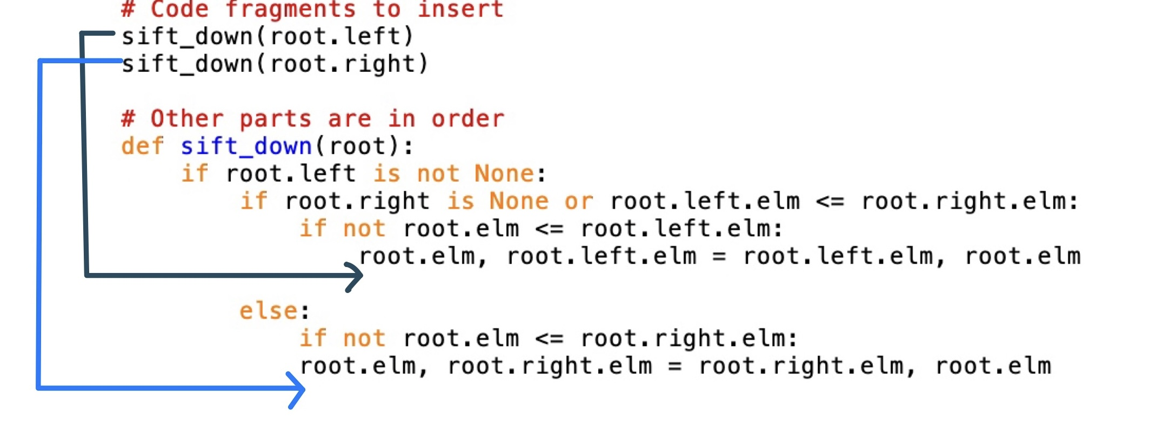

Figure 11 Example for inserting key code fragments

## Holistic Analysis

To sum up all descriptions of Parsons problem mentioned in chapter 2, chapter 3.1, and chapter 3.2, the project should be able to handle nine different types of Parsons problems grouped into the following five categories:

* **Traditional**: in this category, the Parsons problem only has the basic functions - rearranging jumbled predefined codes and getting feedback about the reordered answers. This category has one type of Parsons problem:
* **Traditional**: this type of Parsons problem is the one used in introductory programming courses in the existing work mentioned in chapter 2.
* **Contextual clues:** in this category, some ordered codes are provided as hints in Parsons problem. This category has two types of Parsons problems:
* **Context:** this type of Parsons problem is used as one of the ways to handle the difficulty mentioned in chapter 2. It can also be used to fix the order of methods in data structure implementation to have unique answers (chapter 3.1.1) by providing the method headers as context.
* **Insert Key Code:** this type of Parsons problem is the advanced version of the Context Parsons problem mentioned in chapter 3.2.3 to reduce the difficulty further. Compare to the Context Parsons problem, fewer code lines are involved, and the concrete insertion positions are not shown to students directly.
* **Multiple-lines-based Block Code:** in this category, multiple lines can be grouped as a unit to show, drag and drop, or check. It is no longer limited to comparing line by line, which means that the codes can be organized in a more flexible way. This category has three types of Parsons problems:
* **Multiple Step:** this type of Parsons problem divides the original codes into several steps to let students solve complex problems by solving each small part. This type of Parsons problem can be used for the recursion problem (chapter 3.1.3) or setting as a pre-scaffold Parsons problem (chapter 3.2.2).
* **Check Only Inside Block:** this type of Parsons problem allows students to switch the order between blocks and focus on the order of lines inside every block. It can be used to handle not-unique-answer situations caused by changing the positions of methods in a class (chapter 3.1.1).
* **Link together:** this type of question is just to bind multiple lines as a whole block. Being different from the previous two types of questions, the order of lines inside the block is no longer considered. This type of question can handle the not-unique-answer situation caused by interchangeable lines (chapter 3.1.1).
* **Multiple Solutions:** this category allows the comparison between multiple related solutions. There are two types of Parsons problems in this category:
* **Data Structures Implementation Comparison:** this type of question is used to compare the same data structures with different implementations (chapter 3.1.4). In this type of question, students combine one answer by using the codes coming from two solutions.
* **Algorithm Comparison:** this type of question is used to compare related algorithms (chapter 3.1.4). In this type of question, students split two solutions from one group of jumbled codes.
* **Comment:** in this category, the correctness of comments is also under consideration. This category has one type of Parsons problem:
* **Algorithm Analysis:** this type of question can introduce the time complexity of algorithm analysis mentioned in chapter 3.1.2.

After declaring the nine different types of questions, the additional characteristics of Parsons problem in this project can be summarized from the following perspectives – allowing some special-marked code fragments (context, key code, or comment); allowing the coexistence of lines and blocks; allowing multiple solutions. These new characteristics significantly change the workflow of generating or solving Parsons problems. Specifically, teachers need to take some time to customize the predefined solutions instead of just inputting the solutions inside the system (like marking special code fragments or grouping several code fragments as blocks). In addition, because of these characteristics, the way of checking the answers and giving feedbacks is also changed. Concretely, the answer can not simply be checked by comparing it with the original predefined files (line-based feedback) since switching the orders of blocks should be allowed. Besides, it may also not be so proper to check the answer by execution (execution-based feedback) since the comment should also be checked. Actually, in this project, the answer is checked based on comparing codes with the original file, but it supports the switch order of blocks. More details will be declared in the next several sections.

## Dynamic Modelling

In this section, the interaction between the users and the system is illustrated by activity diagrams.

Figure 12 illustrates the activity diagram of students. Students need to register or login first, otherwise, they can only browse the question list. After registering or login successfully, students can select a question from the question list, view the question detail, reorder the jumbled codes by drag-and-drop code fragments, check the answer, and get feedback. If they achieve 100% correctness, the solving procedure of this question is finished and they can do other questions. If they do not achieve 100% correctness, they are supposed to adjust the answers based on the feedback and check it again. In addition, students can also browse answer records in history and redo some questions they do not satisfy with their score or think important.

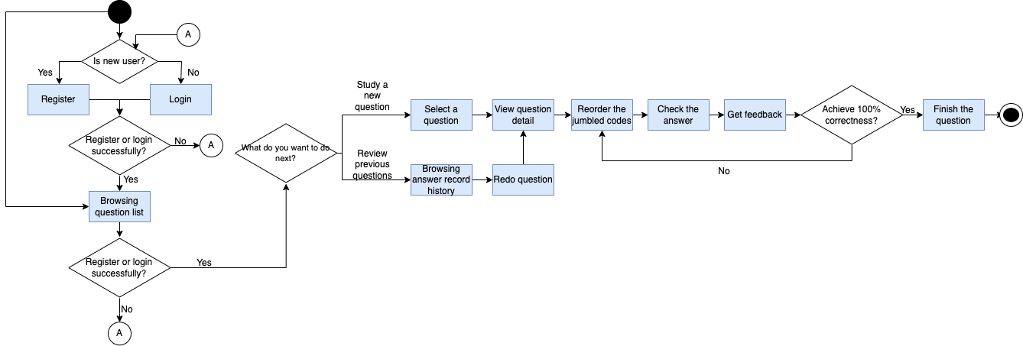

Figure 12 Student Activity Diagram

Figure 13 illustrates the teacher activity diagram (omitting the activities which are the same as student activity diagram). Besides the activity involved in student activity diagram, teachers can create a new question after registering or login. They can input question information, choose question type, upload solution, customize solution based on question type. If there are easier version of this question, teachers will go back to choose the question type of the new question and customize the solution again. If not, the teacher will go to question detail page.

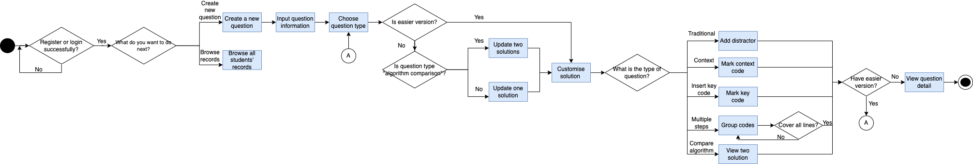

Figure 13 Teacher Activity Diagram

## Data Modelling

In this section, the entities, the attributes, and the relationship between entities are illustrated. Besides, the ER diagram is also shown.

The stored information are majorly about the class, user, question, solution, codes and code organization (fragment, block, difficulty level), distractor, easier version and record.

Table 2 Entity illustrates the entity used in this database.

Table 2 Entity

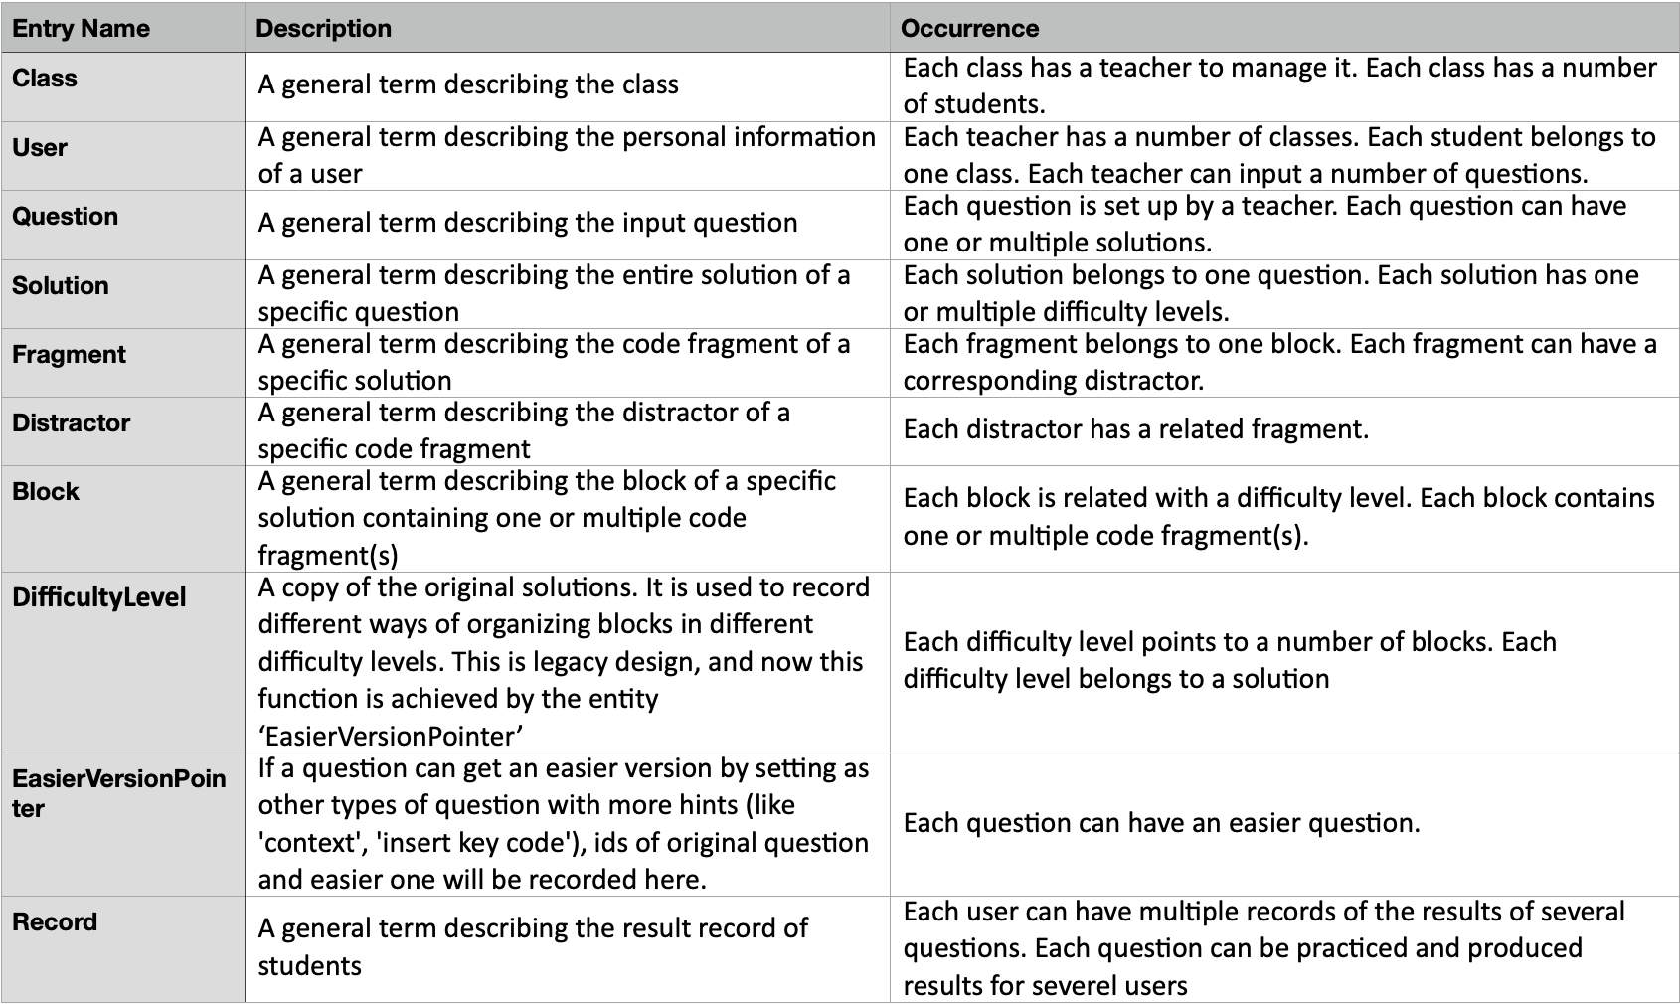

Table 3 illustrates the relationship between entities.

Table 3 Relationship between entities

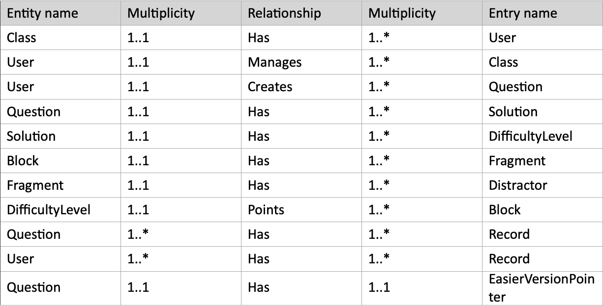

Table 4 illustrates the concrete attributes in every entity. By means of recording code line in ‘fragment’ entity plus recording block id and fragment id in correct order in the attribute ‘BlockSeq’ of ‘DifficultyLevel’ entity and in the attribute ‘FragmentSeq’ of entity ‘Block’, the coexistence of block and line is achieved.

Table 4 Attributes in each entity

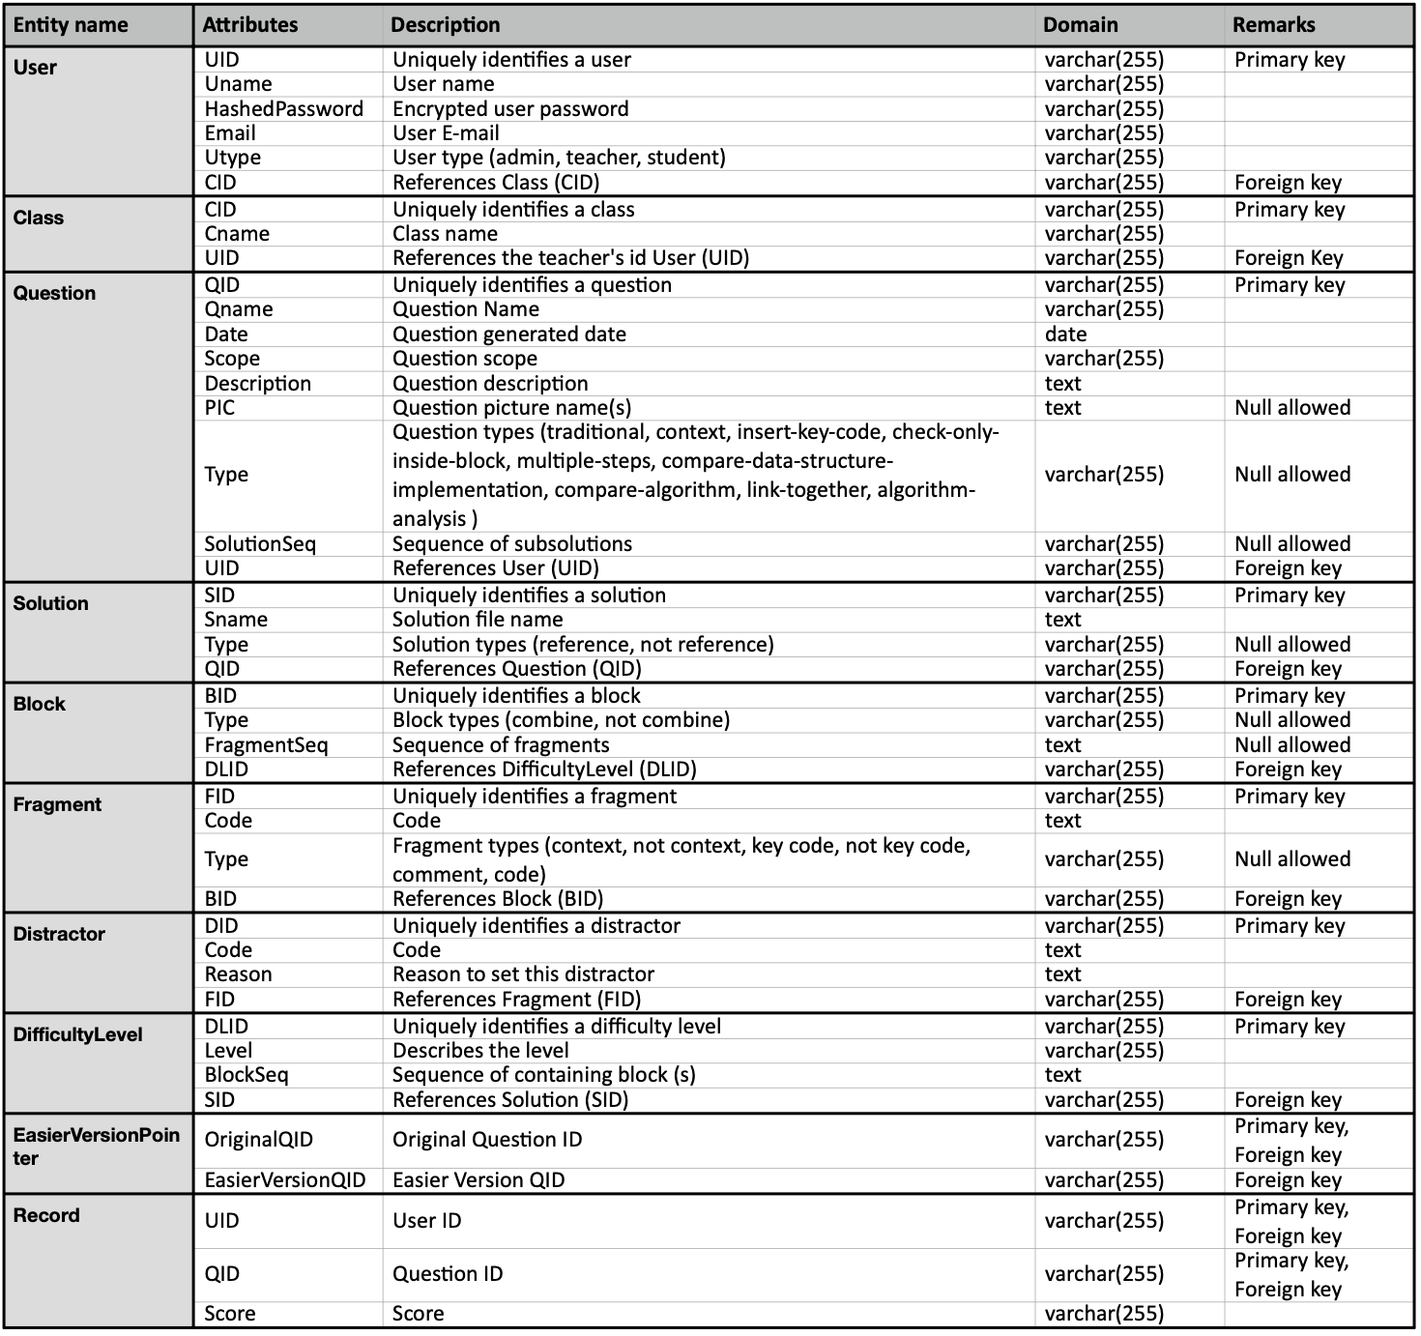

Table 5 illustrates the logical data model between entities.

Table 5 Logical Data Model

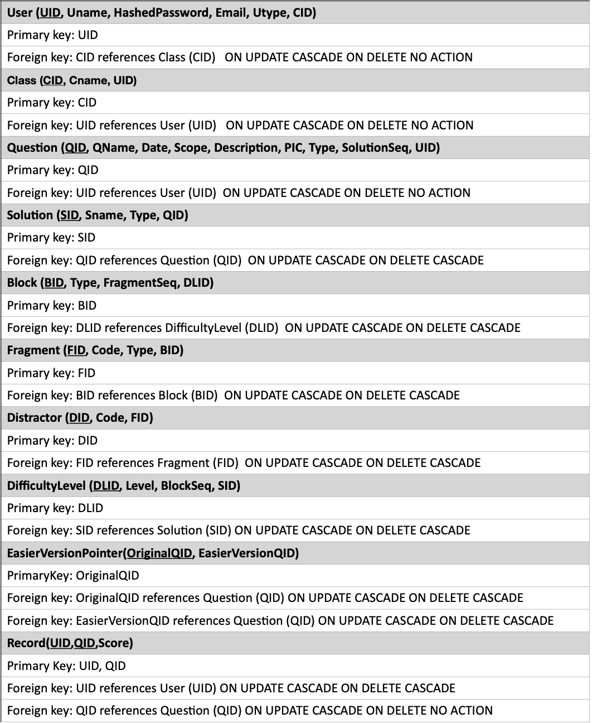

The ER diagram is defined as Figure 14 according to the information of data model mentioned previously.

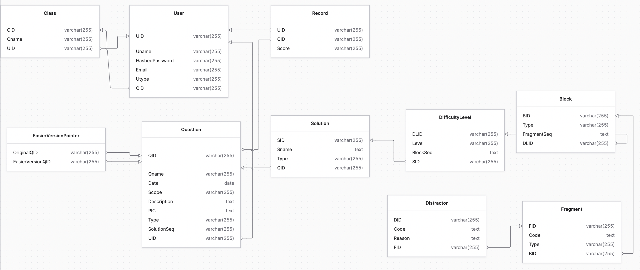

Figure 14 ER Diagram

# Implementation

In this chapter, the on-going and future work are explained. In the on-going work, data modelling and the implementation of the prototype are shown. Subsequently, the Gantt chart is shown in the second part. Finally, a draft idea about what to do to complete the project is explained.

## Major Techniques and Tools Used

In this project, modern web application solution – separation of front-end and back-end is adopted. Thanks to the separation, different parts of this project can be developed more independently, which is convenient for future expansion or maintenance. For this reason, the techniques and tools are classified into front-end and back-end two different parts.

### Front-end

The front-end are major based on the combination of Vue.js, Tailwind CSS and TypeScript. In addition to those major techniques, some Vue tools (Vue Router, Vuex, Vue Draggable) are also used in this project. Finally, Axios is also involved in this project.

The front-end is mainly built with framework Vue.js [11]. Vue.js is lightweight but high performance. It also combines HTML, CSS, TypeScript codes into components, which increases the code readability and reusability [12].

The visual design is implemented with the CSS framework Tailwind CSS [13] instead of raw CSS. With the predefined class, the process of creating custom CSS style is simplified, and the responsive layouts are achieved effortlessly [14]. Besides, since Tailwind CSS is a low-level framework, it can provide more flexibility and control than other CSS framework like Bootstrap [15].

TypeScript [16] is used in this project instead of JavaScript. TypeScript is a superset of JavaScript. And it contains not only all advantages of JavaScript, but also can prevent some runtime errors caused by unexpected types of value when using JavaScript [17].

Vue Router [18], the official router for Vue.js, is used in this project. Vue Router makes the navigation between different pages in the project much easier than the direct redirection in JavaScript [19].

Vuex – a statement management pattern and library – is used in this project. It acts as a centralized information store for all components in the project, which makes storing users’ data locally simple [20].

Vue Draggable [21] is used as the key tool to support drag-and-drop action in the project. In addition to the basic drag-and-drop action, it also supports clone and replace. The tutorial about Vue Draggable is referred [22].

To communicate with the back-end, Axios [23] is used in the front-end scripts. Compared with fetch in JavaScript, Axios supports the automatic transformations of JSON data, which is convenient to handle response data. In addition, Axios is more secure than fetch for preventing Cross-site request forgery [24].

### Back-end

Back-end is major based on Python. Besides, FastAPI and MariaDB is used separately as API server and database.

Back-end codes are written in Python [25]. The reason of using Python is that codes in Python can be much shorter than the same codes in Java, which means that it is easier to write.

FastAPI [26], a web framework for building APIs with Python, is used to handle the request from front-end, call related methods to interact with database, generate and send the response back to the front-end. It is fast and has high performance.

MariaDB is a perfect choice for database. MariaDB is open source and has high performance.

## Traditional Parsons Problem

In this section, the implementation of traditional Parsons problem in this project is introduced briefly to pave the way for the implementation of other types of Parsons problem. Among these implementation details, the parts about drag-and-drop, showing in 2D view, checking and showing feedback will be introduced systematically. In addition, the implementation about distractor is also introduced.

### Overview of Implementation of Traditional Parsons Problem

The core functions in this project are inputting question and solution, customizing question, showing question, and checking answer. To be more specific, firstly, question information is collected and store as a new ‘Question’ in the database (with empty ‘SolutionSeq’). Subsequently, the solution(s) is/are uploaded. And the sequence of solution id is recorded in ‘SolutionSeq’ of ‘Question’ with separating by semicolons (Figure 15). After that, the solution is cut into lines and these lines of codes are stored in the ‘Fragment’ belonging to single ‘Block’ and single ‘Difficulty Level’ (‘Level’ in ‘Difficulty Level’ is set as ‘1’). At the same time, the fragment sequence is recorded in the ‘FragmentSeq’ of ‘Block’ in the same way for recording solution sequence (Figure 16). Up to this point, the basic order of codes is recorded. The following part – customizing question is mainly about adding distractors, marking some special fragments, grouping fragments, and creating easier version. This part will be introduced later. In the next part, the fragments are got according to the question id (Figure 17). And these fragments can be drag-and-drop to the answer pool. In the final part, the fragment codes in correct order are got according to the ‘FragmentSeq’ recorded before (Figure 18). And the contents of students’ answers and the standard answers are compared to check and give feedback. More details about checking and feedbacks will be introduced later.

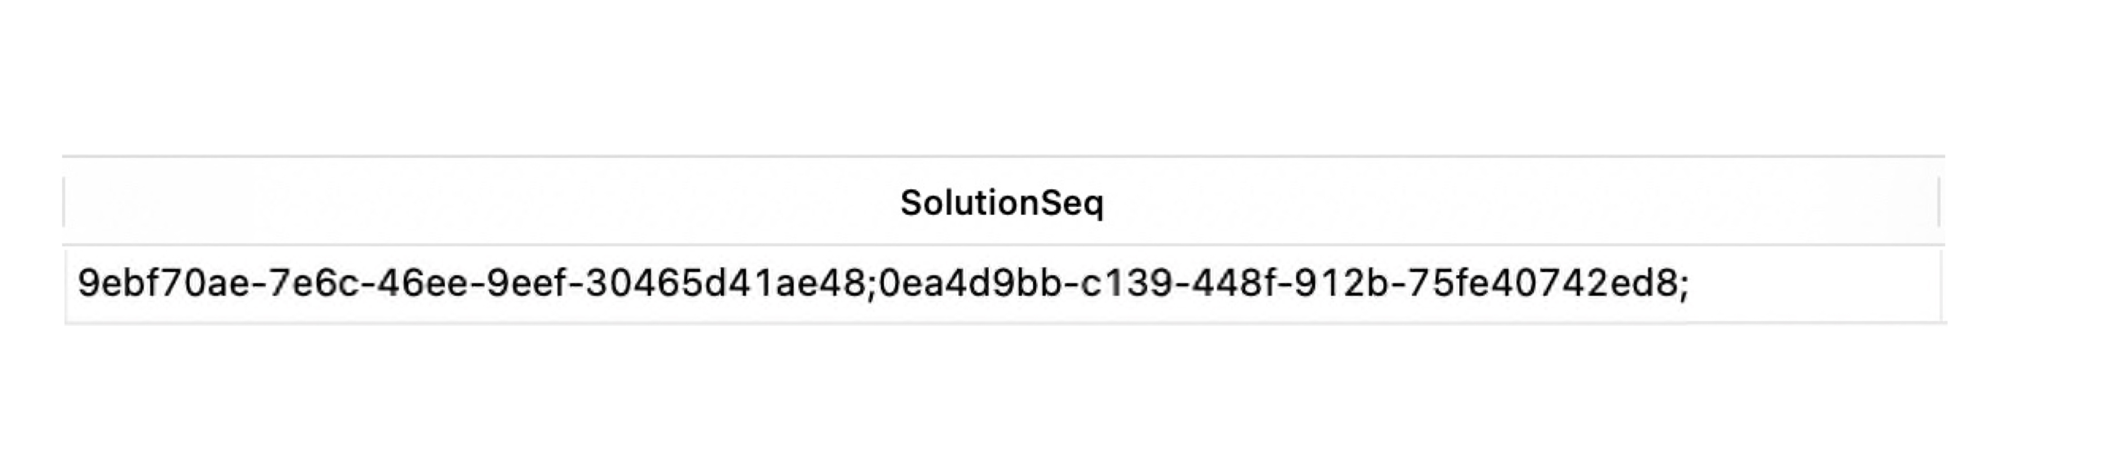

Figure 15 Example of ‘SolutionSeq’ of ‘Question’ in database

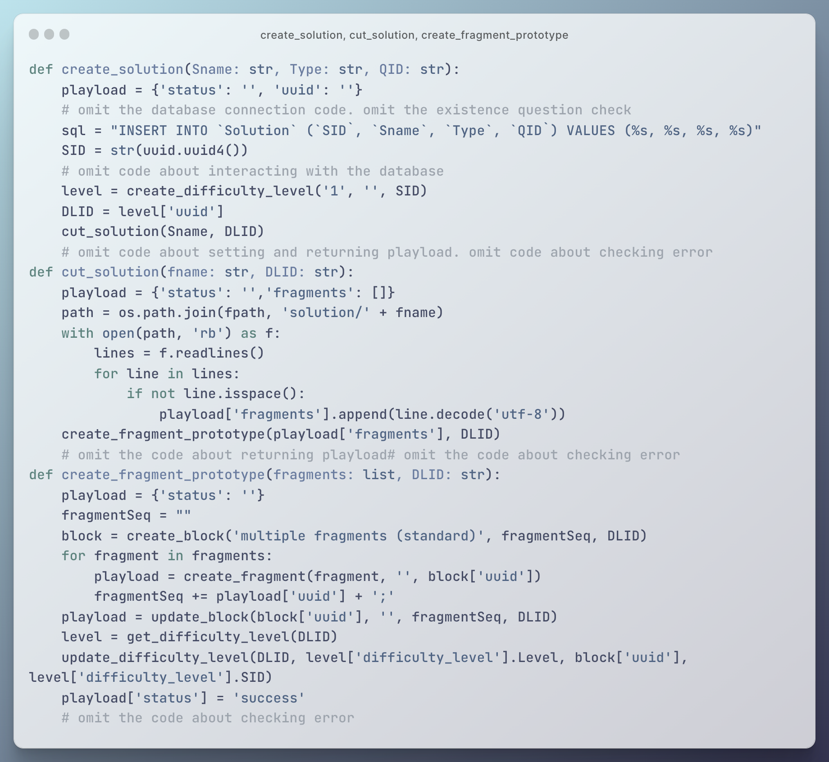

Figure 16 Related methods about storing codes in database

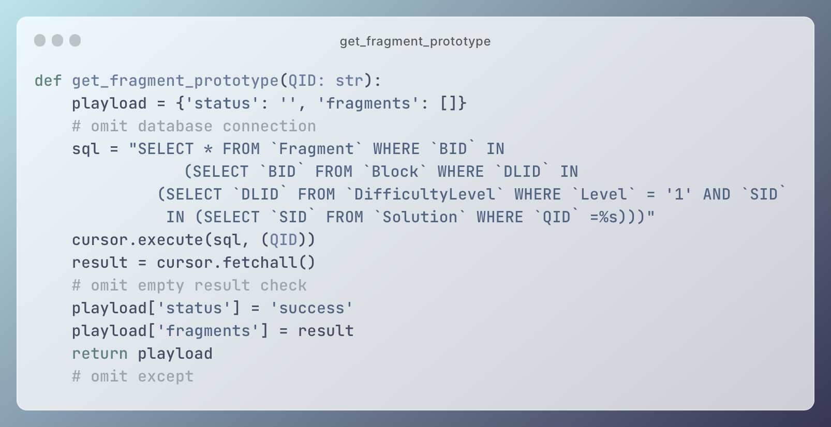

Figure 17 Get fragments according to question id

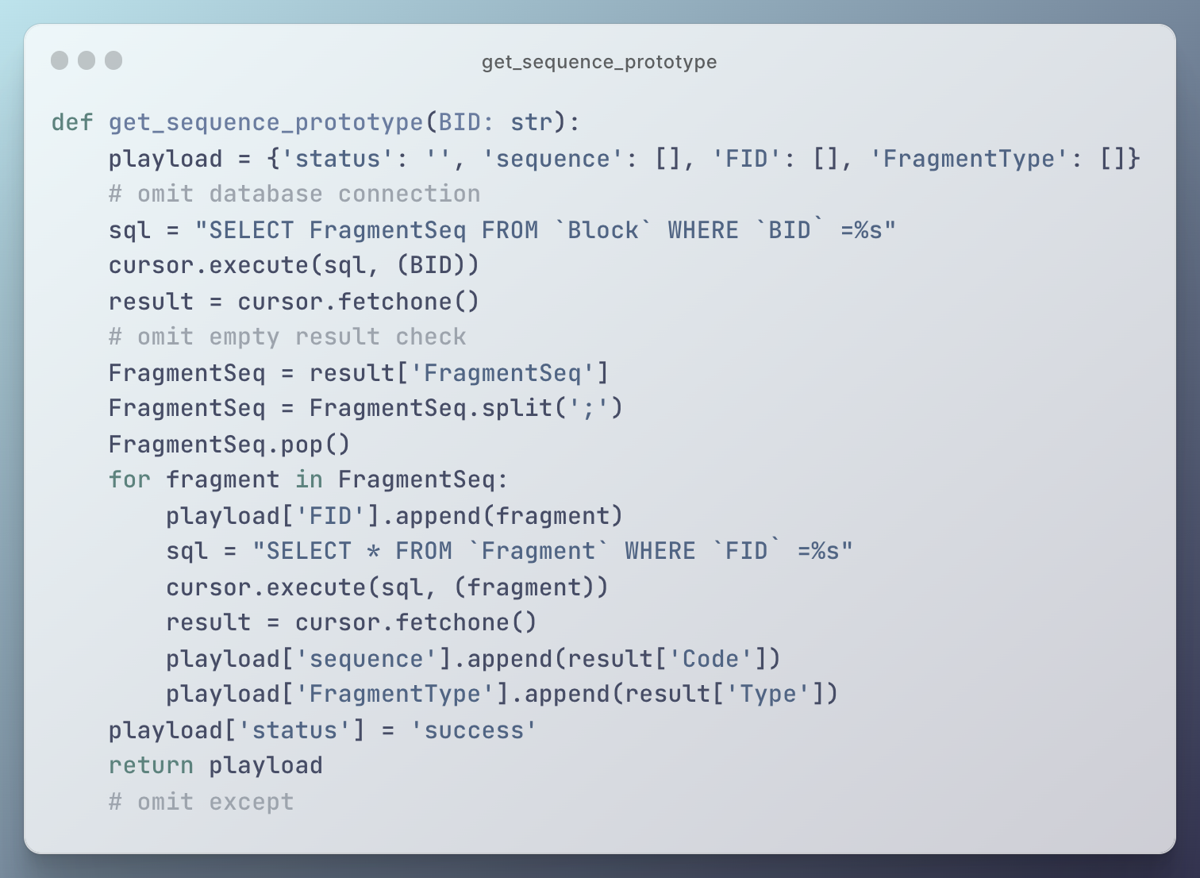

Figure 18 Get order of codes

### Drag-and-drop

The drag-and-drop action is implemented by the tool Vue Draggable. By using the tag ‘VueDraggableNext’, the codes can be dragged and dropped between the code pool and the answer pool. The contents of code fragments can be stored in lists ‘pool.code’ and ‘pool.answer’ (Figure 19).

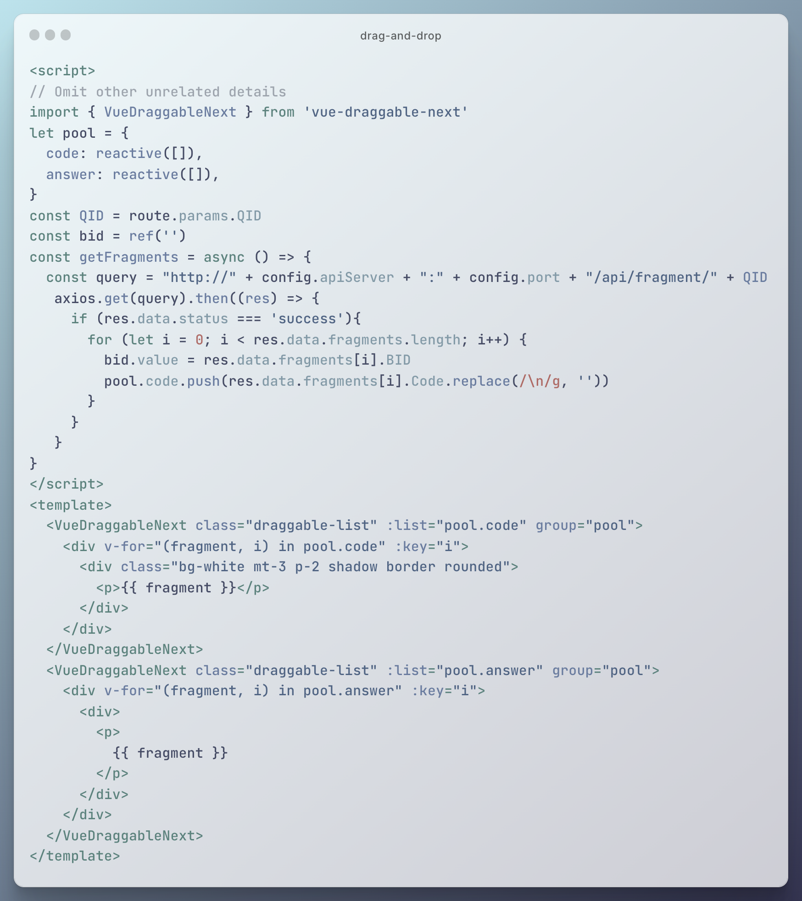

Figure 19 Drag-and-drop

### 2D View

Unlike other programming language, Python indicates the code blocks by using indentation. For this reason, the codes of Parsons problem in Python should not only be shown in vertical way but also horizontal way.

Unfortunately, although the Vue Draggable can support to put items either in horizontal or vertical way, it does not support put in two ways at the same time. There are some alternatives on the Internet to achieve similar effects of showing horizontally and vertically. Specifically, Vue Grid Layout [27] can show different items in a grid layout as shown in Figure 20. But this tool does not suit needs for showing indentation of Python codes because of the following two reasons. Firstly, when the block is moved to other columns, the block below will automatically replace the original place of moved block. If this tool is used to show the Python codes, it is possible that the indentation or code in the next line fill in the place in this line. That is disaster for user experience. Secondly, the width and height of blocks can be customized, which seems unduly flexible for the fixed height of code lines. Another alternatives are Vue Draggable Nested [28] or he-tree [29]. Both tools can show nested elements by using multidimension arrays (for example Vue Draggable Nested in Figure 21). Since one dimensional array is used for 1D view as shown in 4.2.2, previous code cannot be reused because of changing data structures, which causes a lot of problems and wastes time.

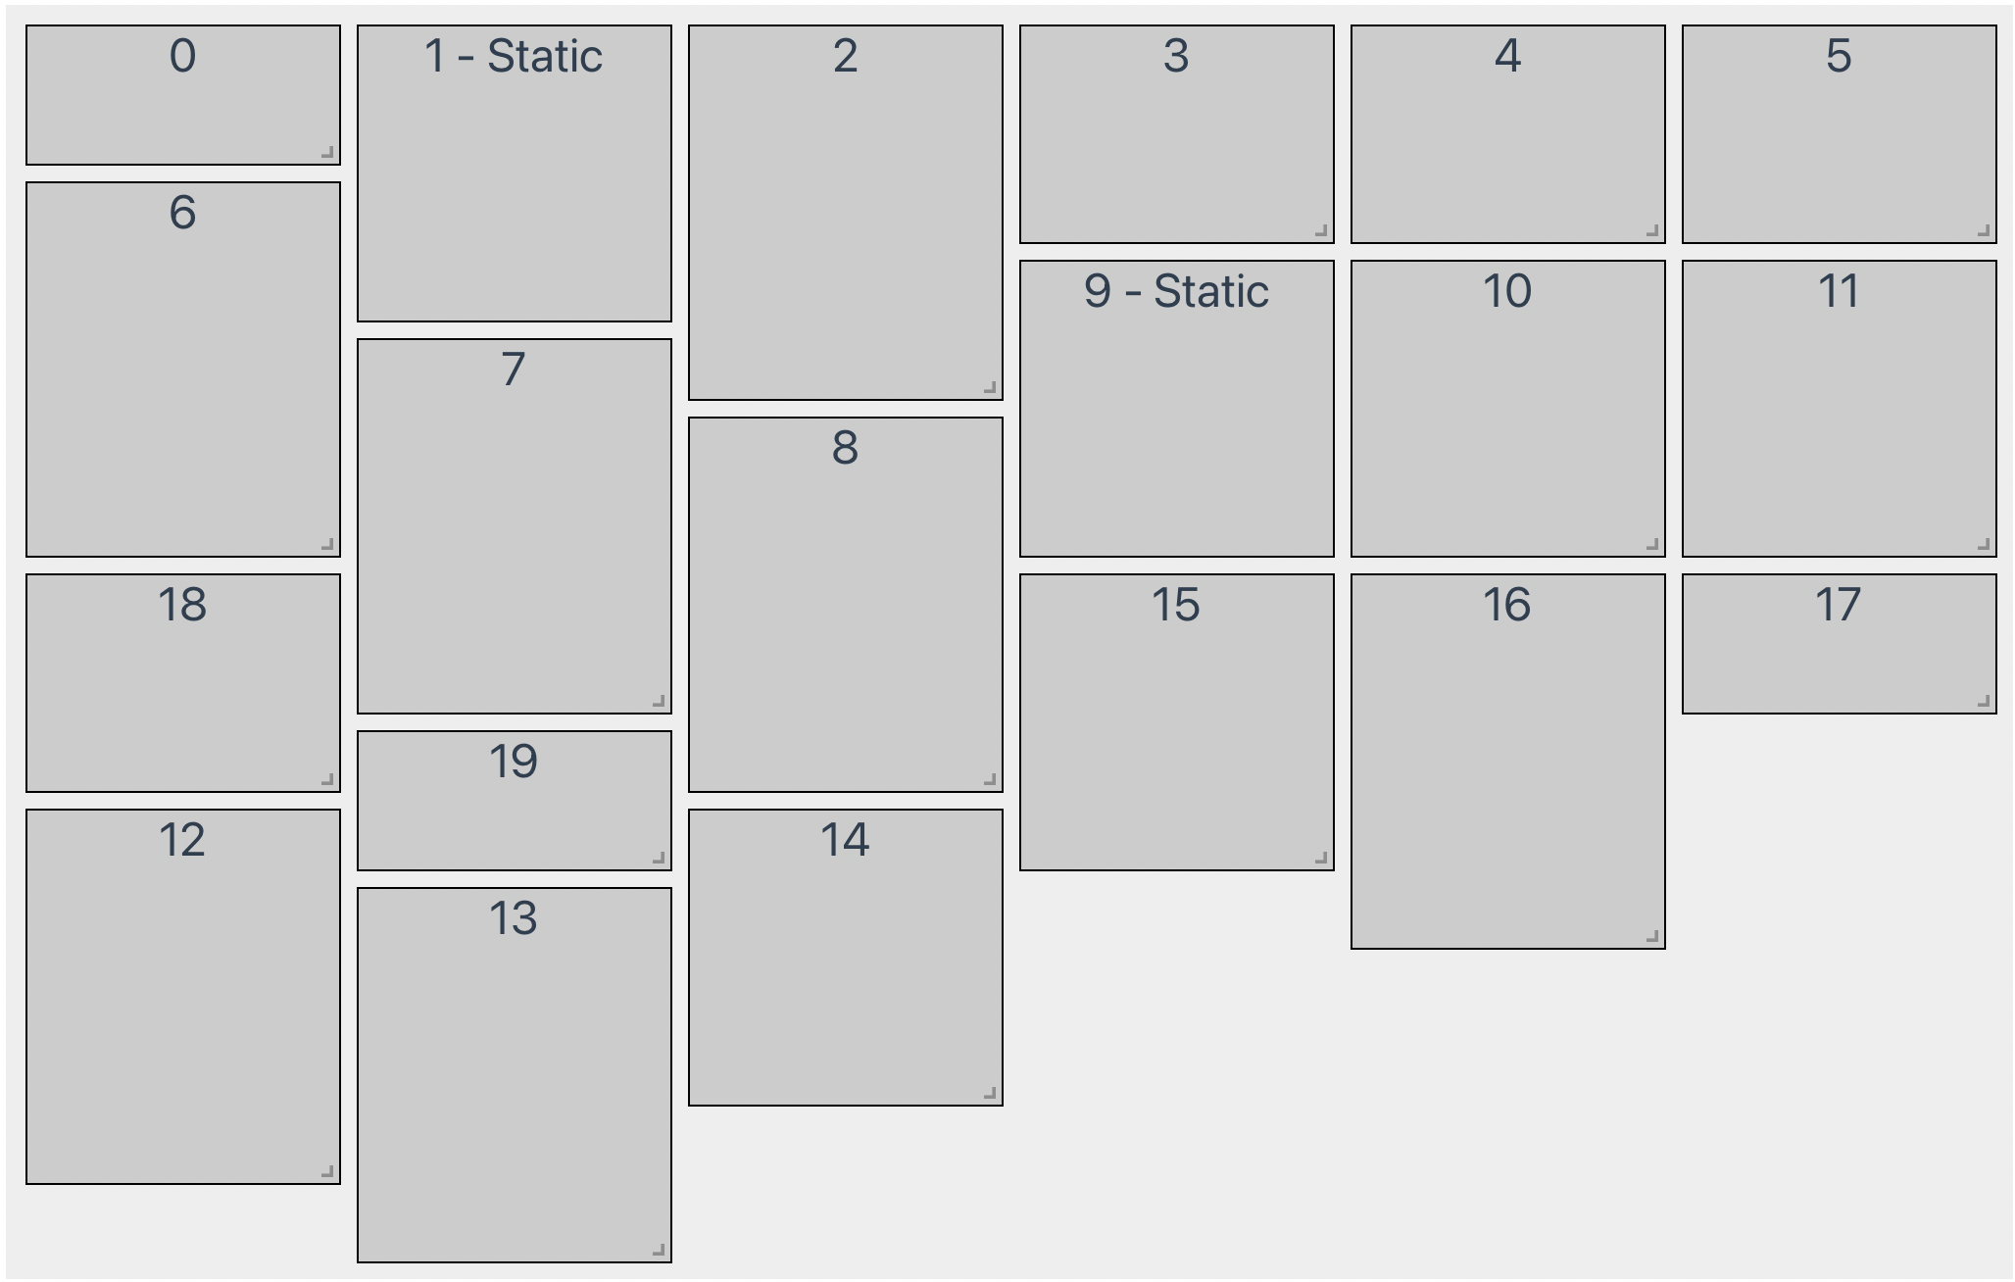

Figure 20 Example of Vue Grid Layout

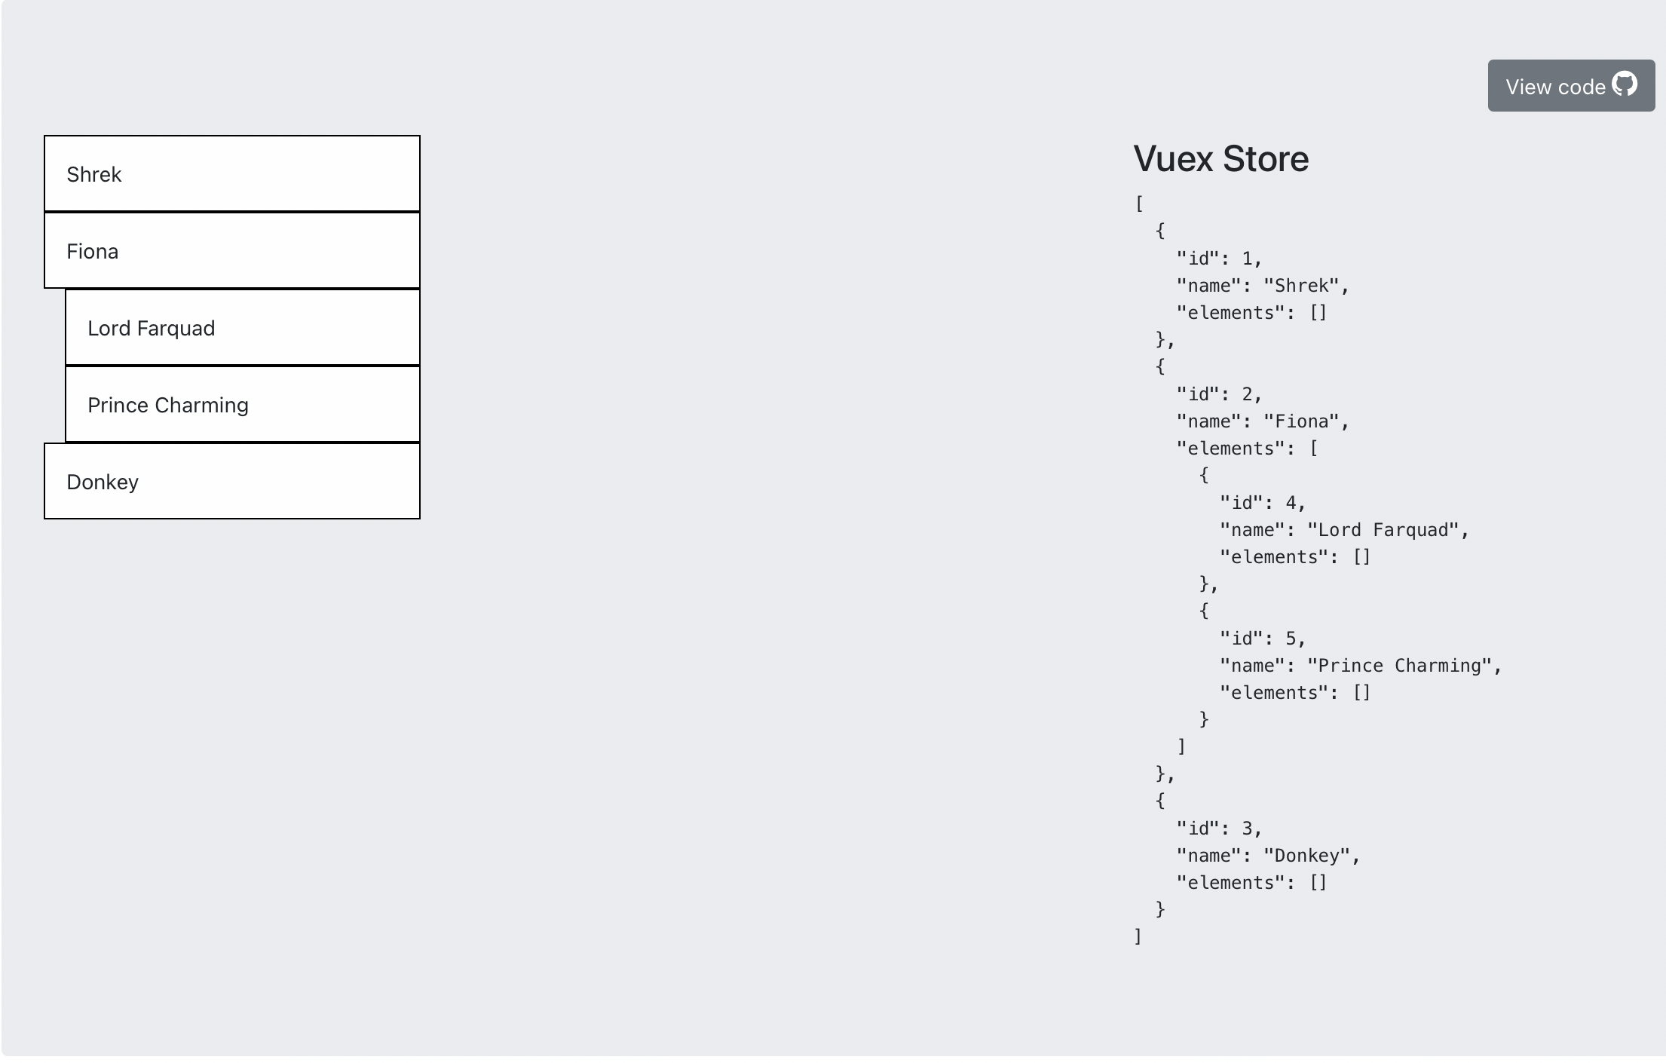

Figure 21 Example of Vue Draggable Nested

By analyzing the above 2D tools, it is obvious that the best way is to simulate 2D view by just 1D view. In addition to the basic codes shown in 4.2.2, the buttons of increasing or decreasing indentation are added in each code line in answer pool. By click these two buttons, the indentation of the line can be changed by adding or deleting four empty spaces before the actual code. And the indent number is also recorded in a list for further checking Figure 22.

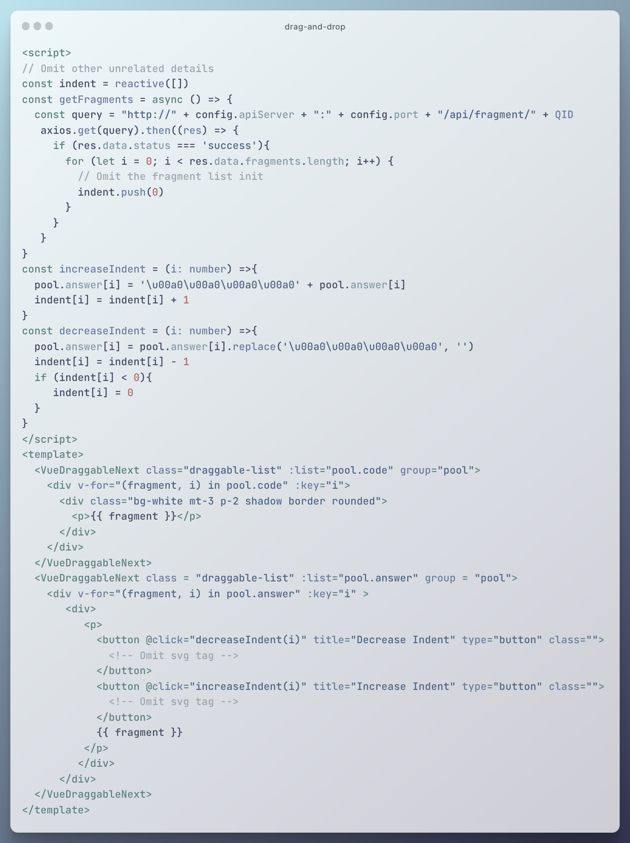

Figure 22 Increase or decrease indent

### Check and Show Feedback

Students’ answers are checked by comparing with the content of standard answers based on the recording fragment sequence. The space in the code is removed in advance to have an accurate string comparison. And the indent number is compared individually. After comparison, different background colors are set to the code line to give student further tips to modify their answers. Moreover, the score (percentage of completion) is also shown to students and stored in the database (Figure 23). (Modify later: the alert does not show once)

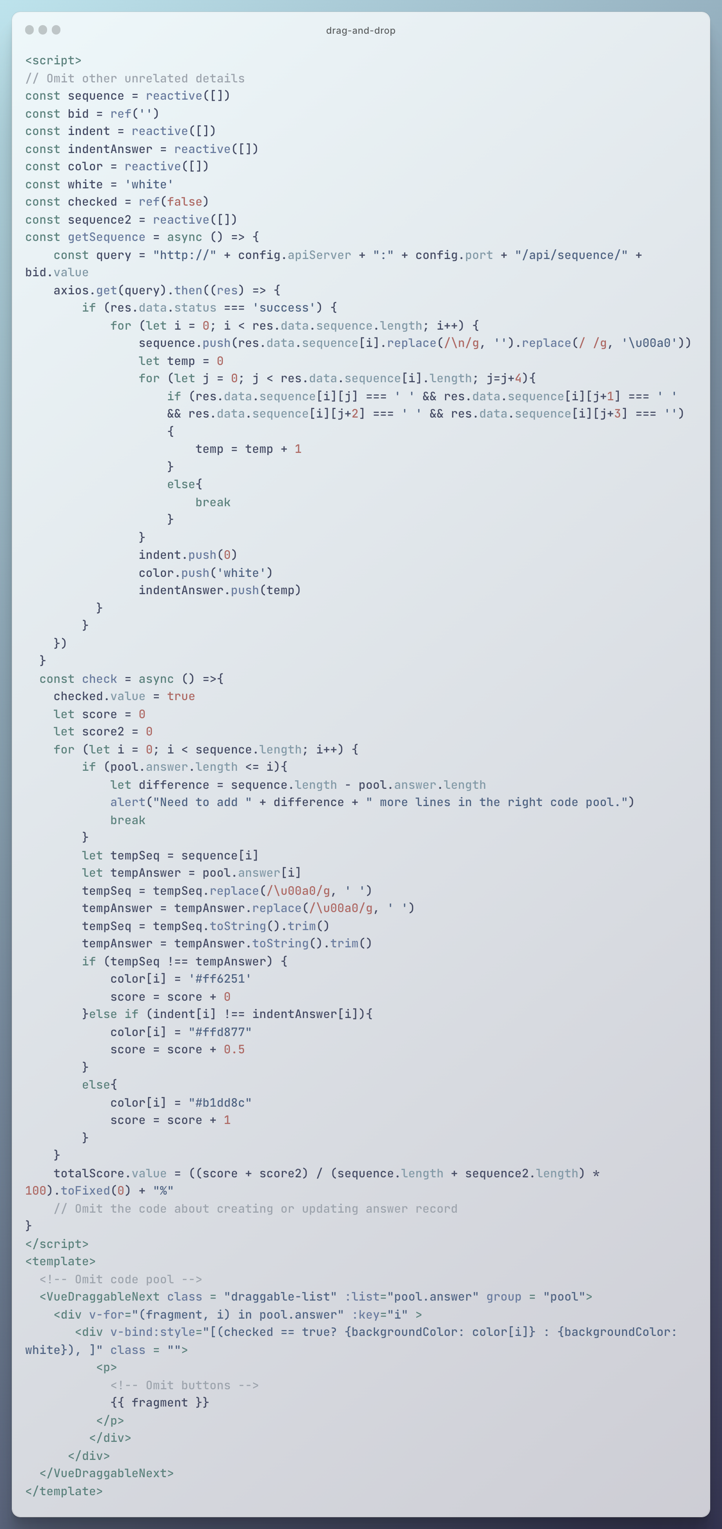

Figure 23 Check and get feedback

### Distractor

The codes about distractor are major in customize solution, showing, and checking. In customize solution, the ‘add distractors’ button is clicked to show the content about adding distractors, and after that the information about distractor is inputted and stored in as a ‘Distractor’ in database (Figure 24). When getting fragments, the existence of distractor of every fragment is checked. If there is a distractor, the distractor is also pushed into code pool (Figure 25). The predefined reason is shown when distractor is selected (Figure 26).

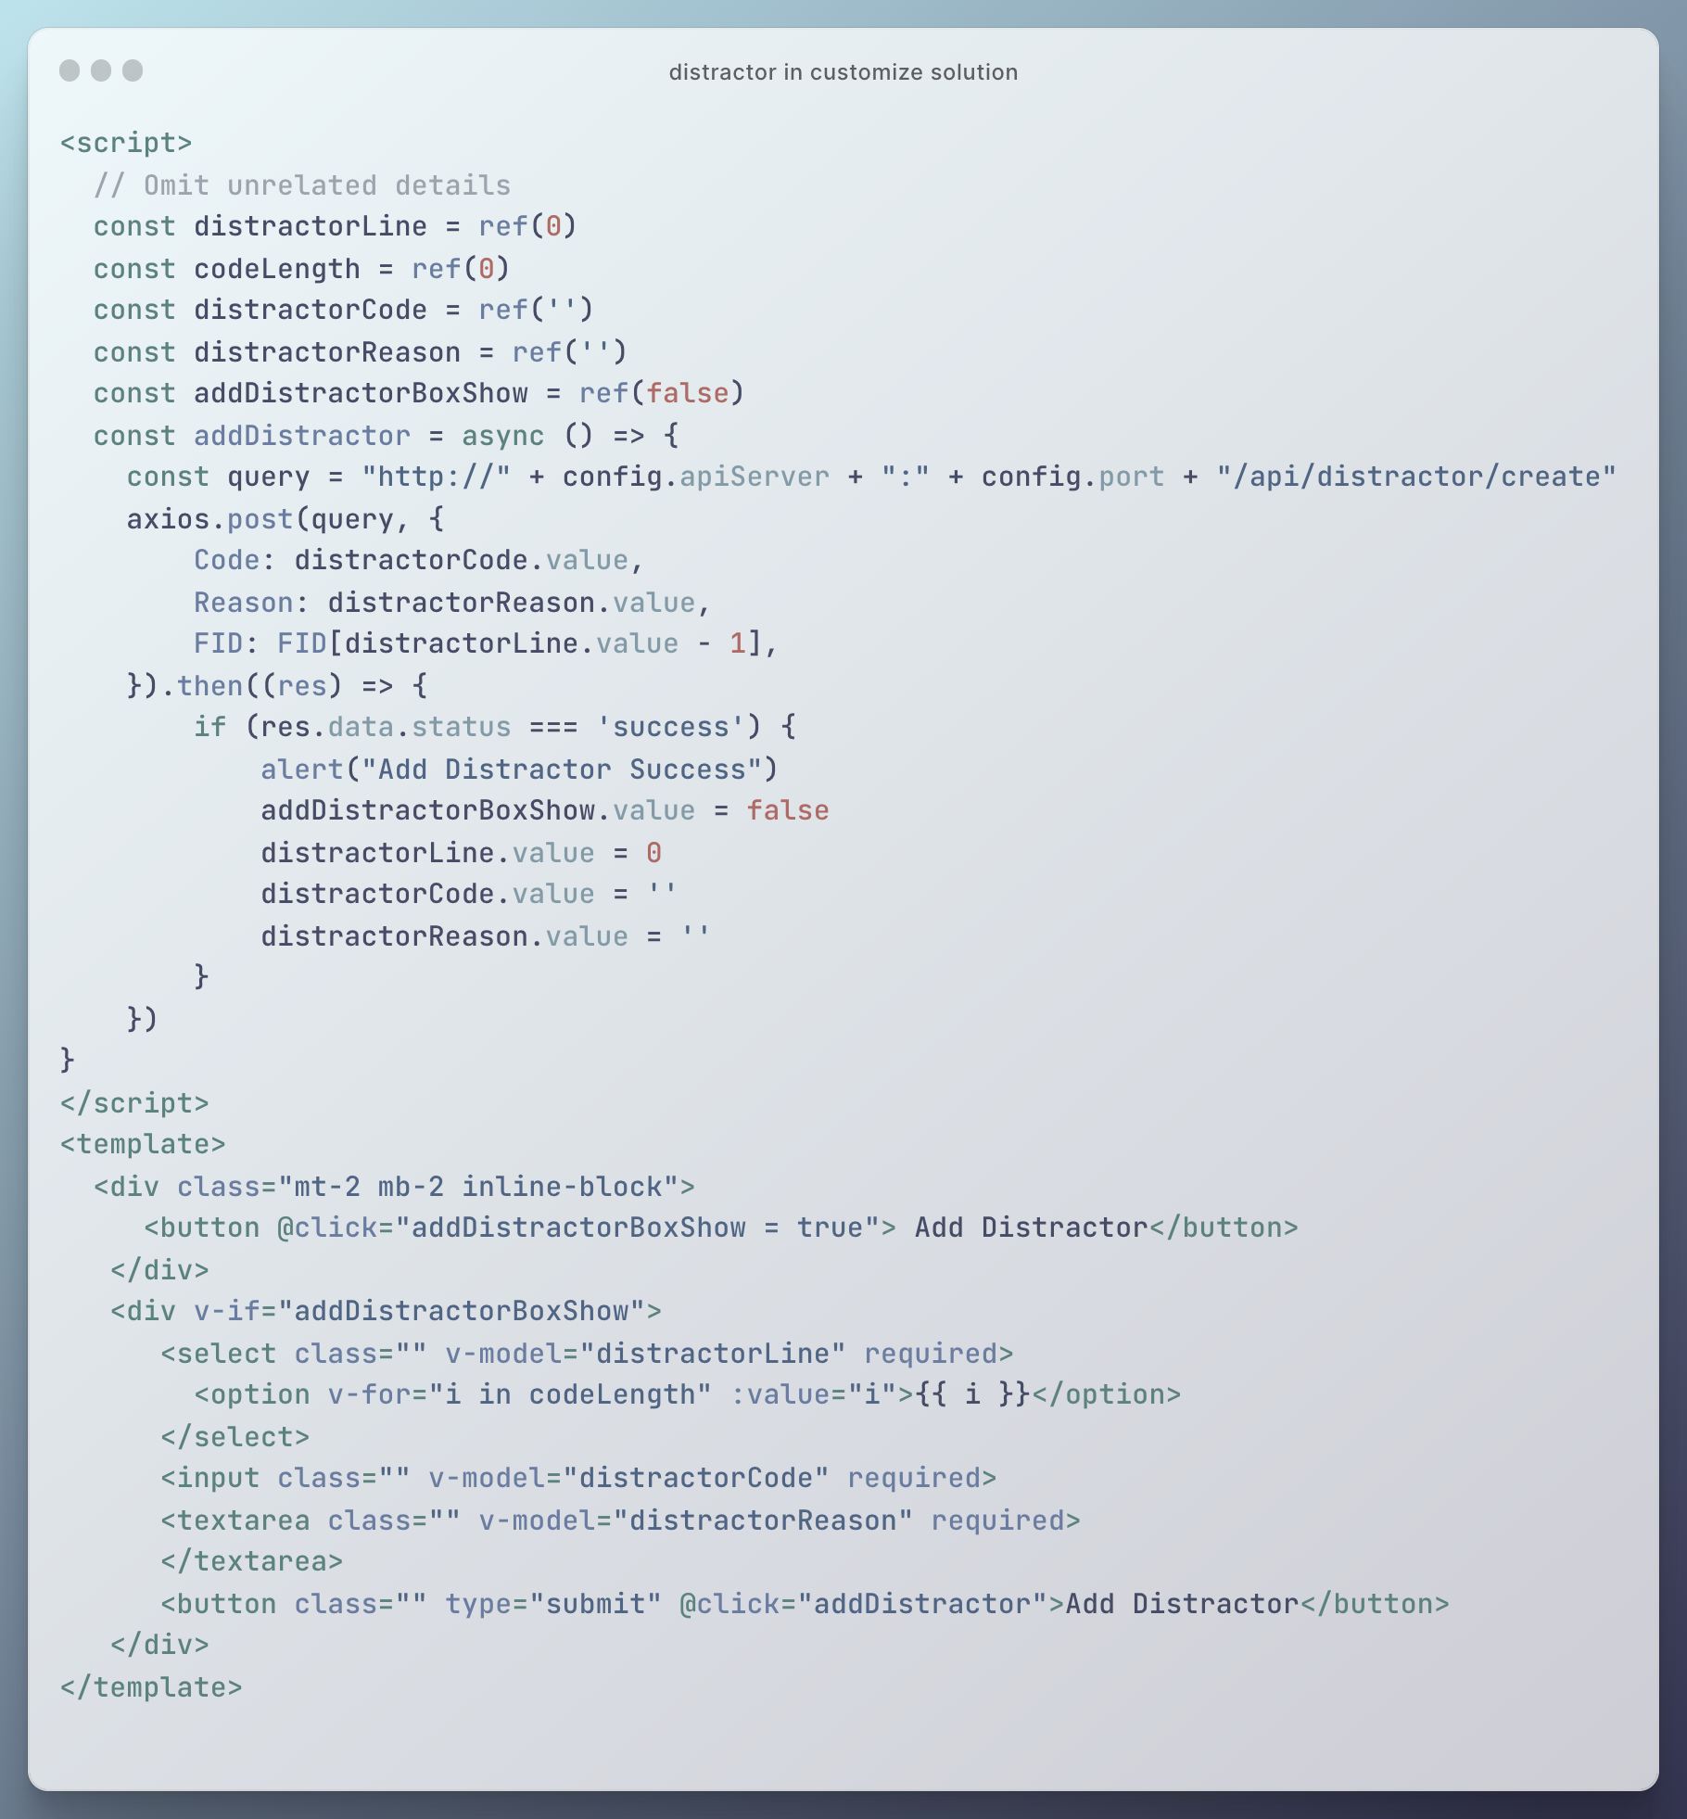

Figure 24 Distractor in customize solution

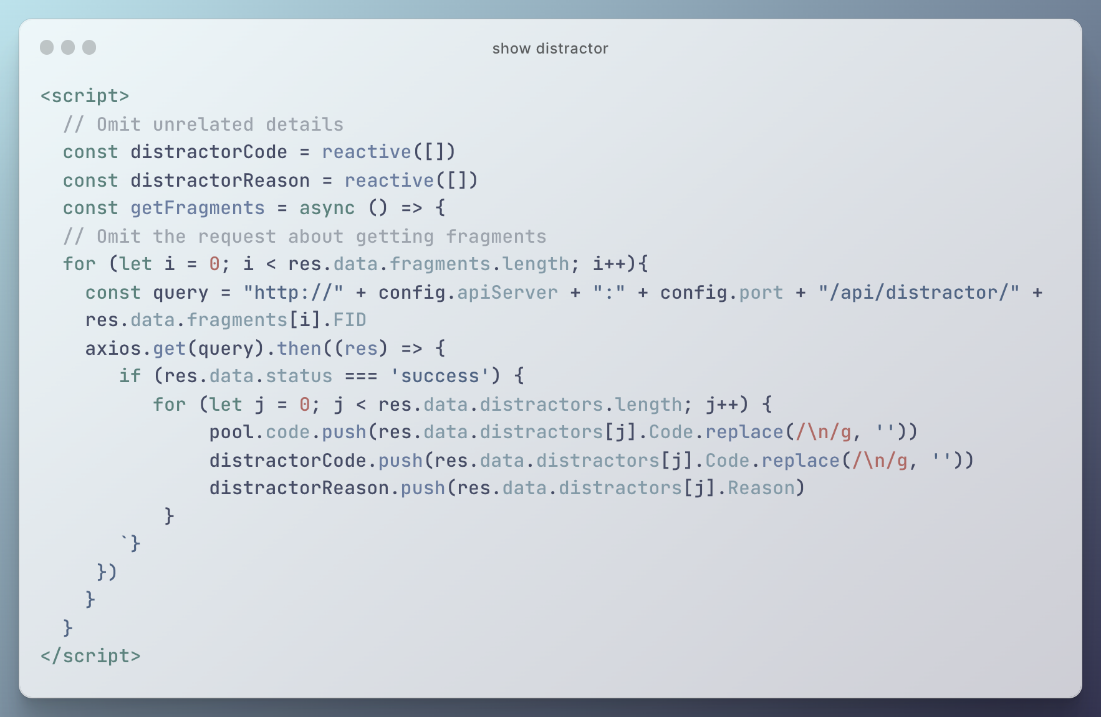

Figure 25 Show distractor

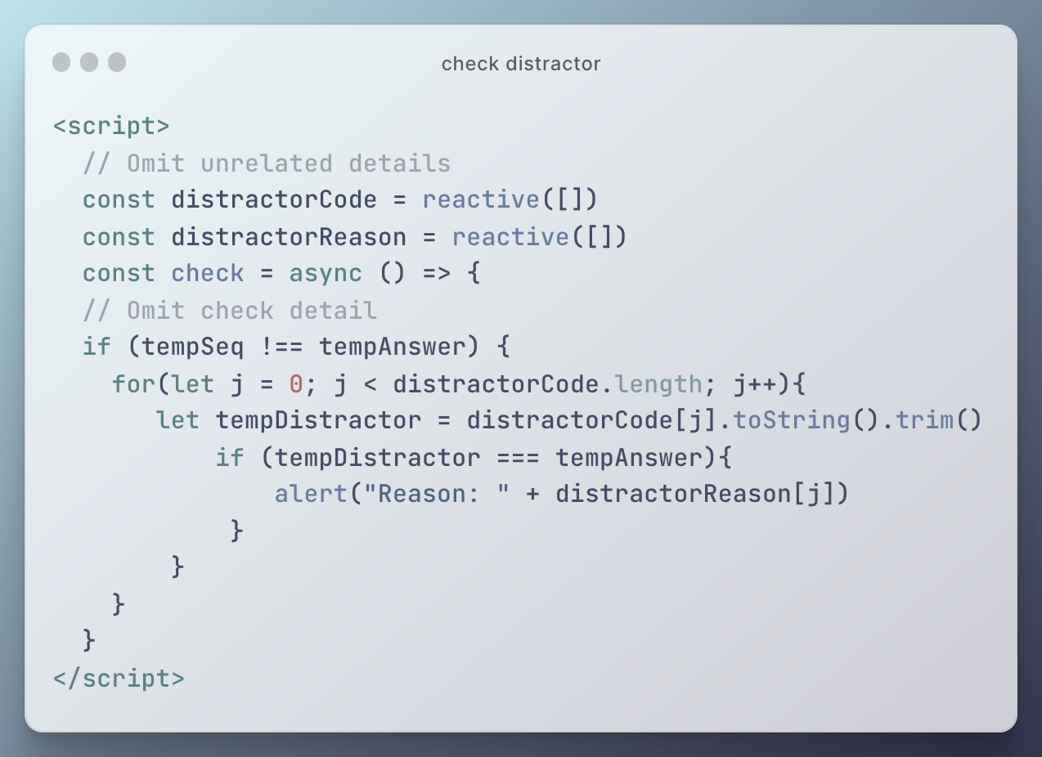

Figure 26 Check distractor

## Contextual Clues

This section focuses on the implementation about category ‘Contextual Clues’ mentioned in 3.3. This category contains two different types – context and insert key code. These two types of question will be introduced in different procedures – customizing solution, showing, and checking.

### Customize Solution

In procedure of customizing solution, both types of question need to mark special code fragments (context or key code). To achieve this function, teachers can click buttons to input the marking information. This information is stored in a list. And according to this list, the corresponding fragment type will be updated after confirming. Figure 24 shows the example of context type of question in customizing solution procedure. Another type is quite similar.

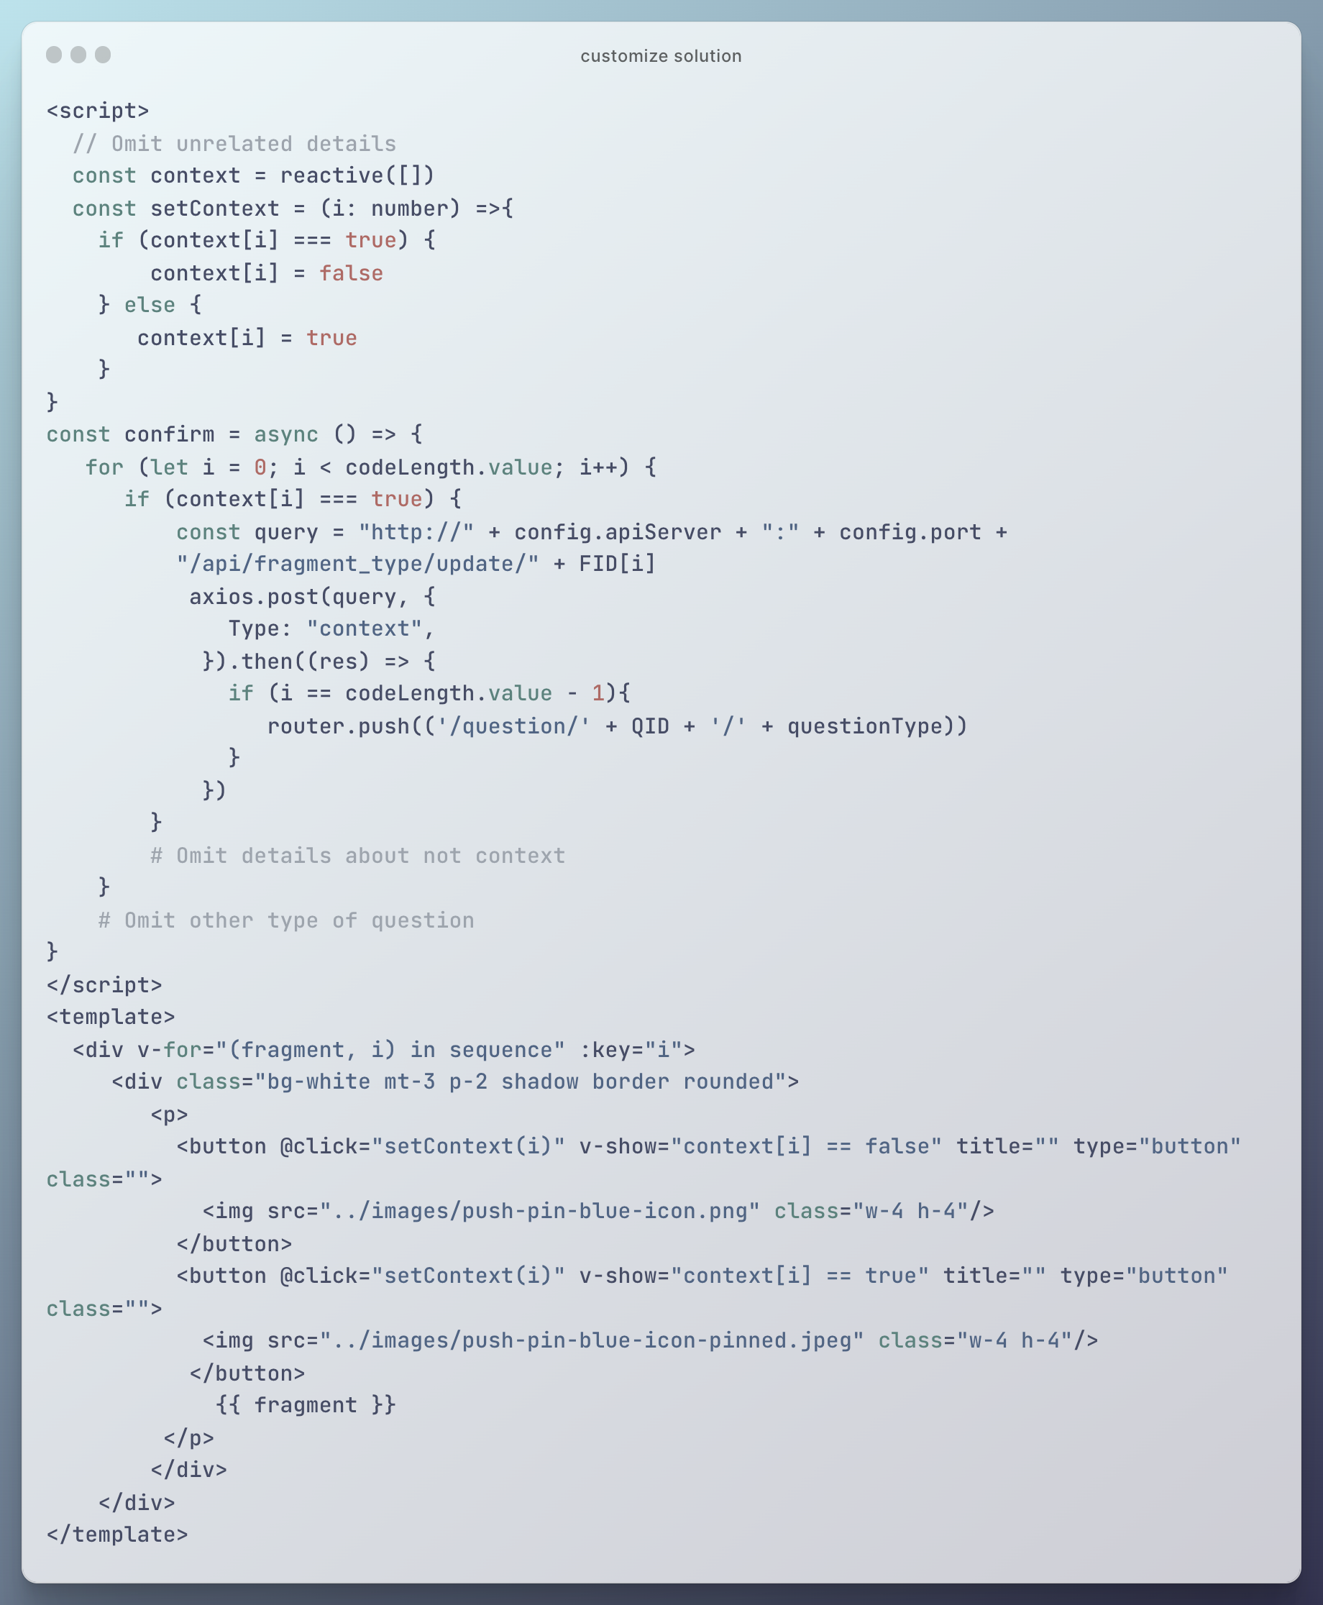

Figure 27 Example of context type of question in customizing solution procedure

### Show in Answer Pool

Unlike the traditional Parsons problem, the ‘context’ or ‘not key code’ codes are directly put in the answer pool. To get codes in order, these kinds of code is pushed into answer pool when getting correct answer. Only the remaining types of fragments are got in the original get fragment method. In the context type of question, the placeholders are also filled in the answer pool as tips of code positions, which is different from the insert key code type (Figure 25).

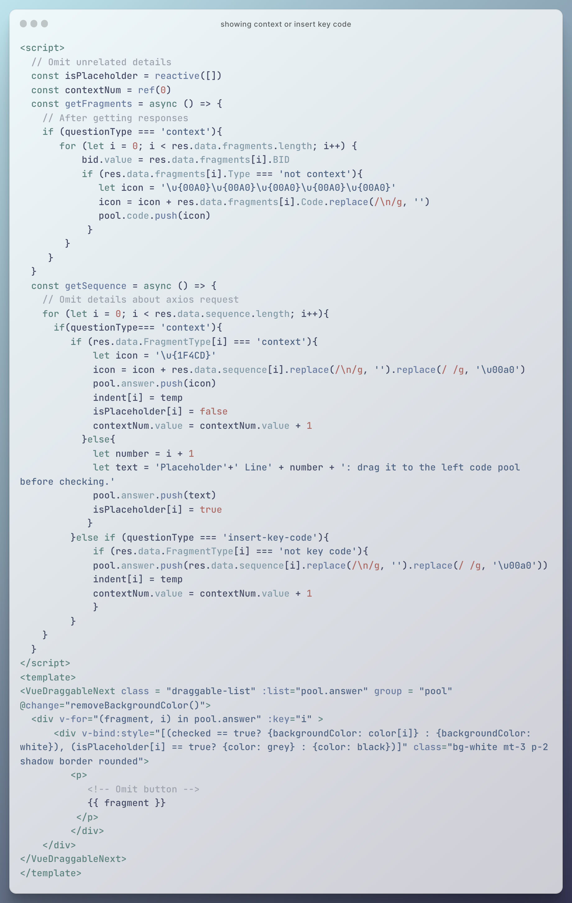

Figure 28 Showing context or insert key code

### Check and Feedback

Checking is almost same as the traditional one except three small differences. Firstly, in the context type of question, the placeholders are moved to the code pool before checking. Secondly, the extra icons are removed before comparing with the correct answer contents. Thirdly, the additional marks coming from the given code are reduced. In other words, only the marks about the codes that students actually manipulate are recorded Figure 26. (Modify alert later)

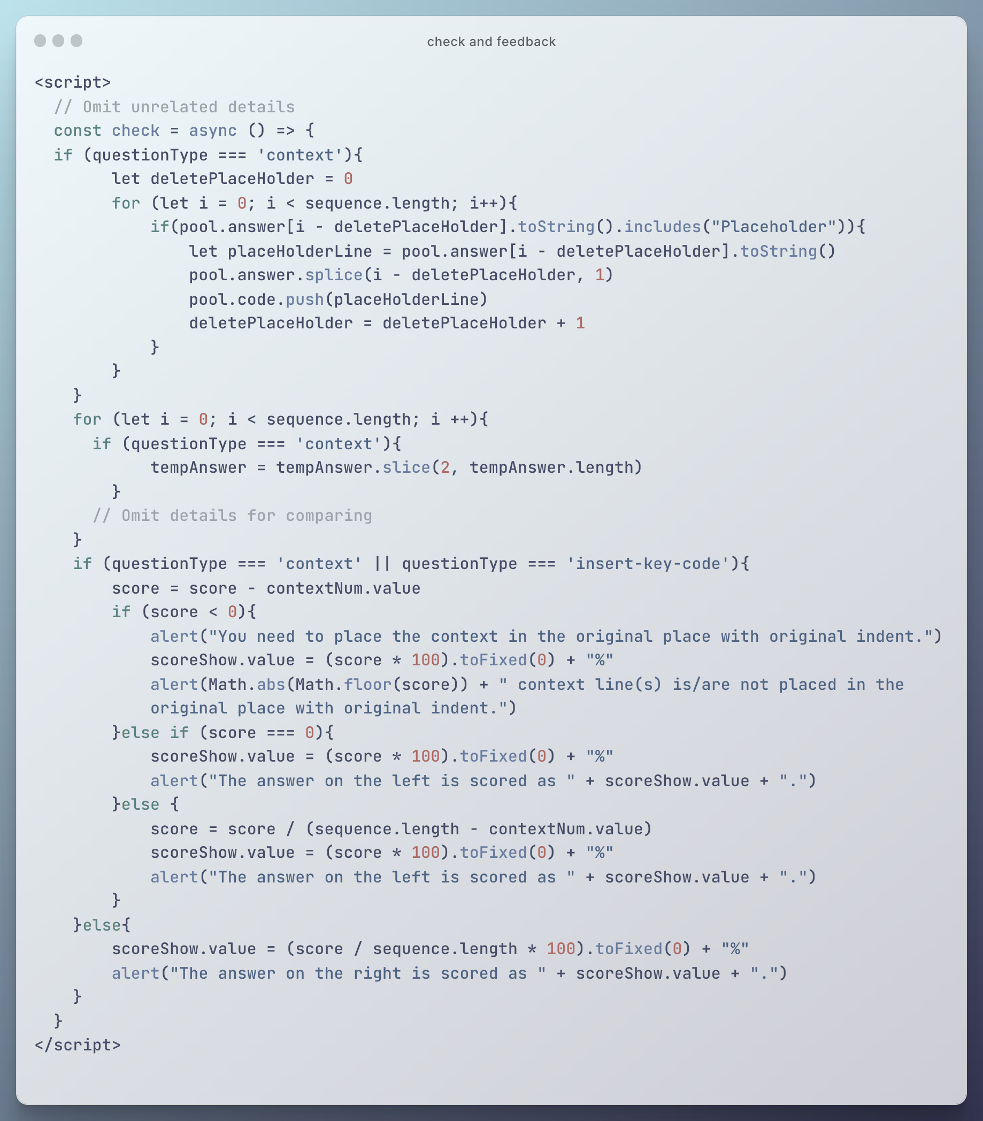

Figure 29 Check and feedback about context or insert key code

## Multiple Step

Compared with the traditional Parsons problem, the Multiple Step type of question is major different in the following three actions: customize solution, show, and check.

### Customize solution

Similar to the previous type of question, the add step view is hidden default and only is visible after clicking the buttons. Lines coverage information is collected through the select input tag. And then, new ‘Difficulty Level’ is created in database (under the same ‘solution’ but with different ‘level’ value), and the grouping information is recorded by the ‘BlockSeq’ in ‘Difficulty Level’, which can record the order of code in a more flexible way. The related codes are shown in the following (Figure 30 and Figure 31).

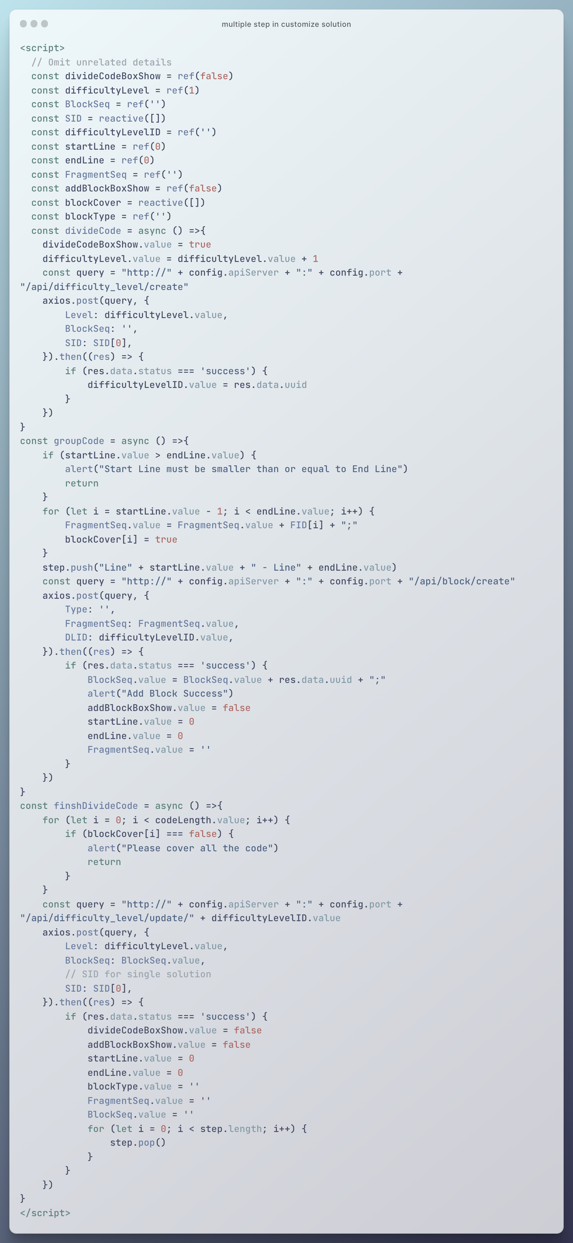

Figure 30 Multiple step in customize solution (script)

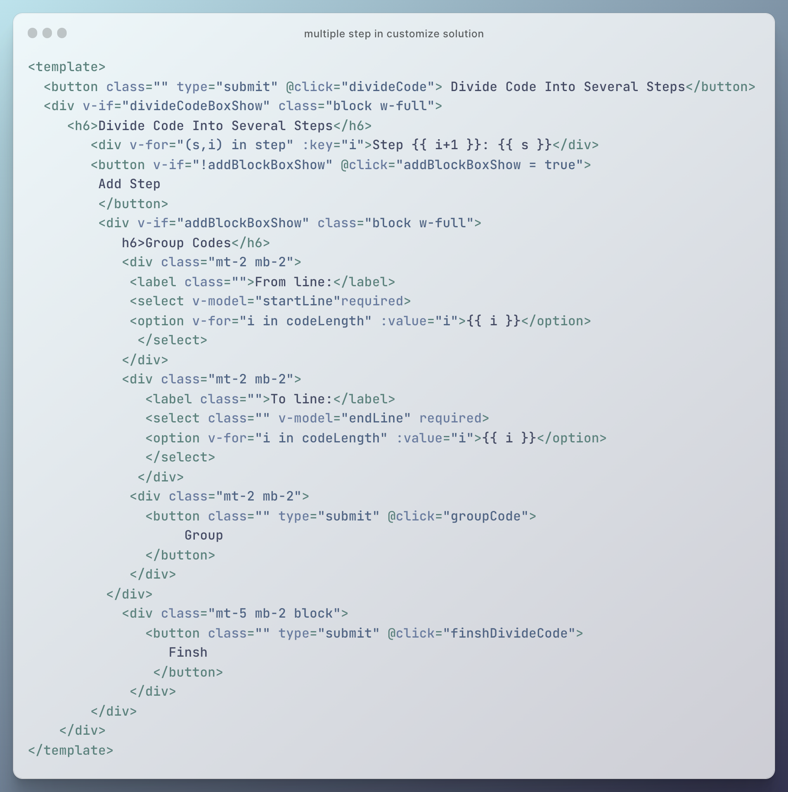

Figure 31 Multiple step in customize solution (template)

### Show and Check

Different groups of codes are indicated as different steps. To make these ‘step’ word distinguish from the code, the Unicode for ‘【’ and ‘】’ is inserted. These special words are removed before checking (Figure 32).

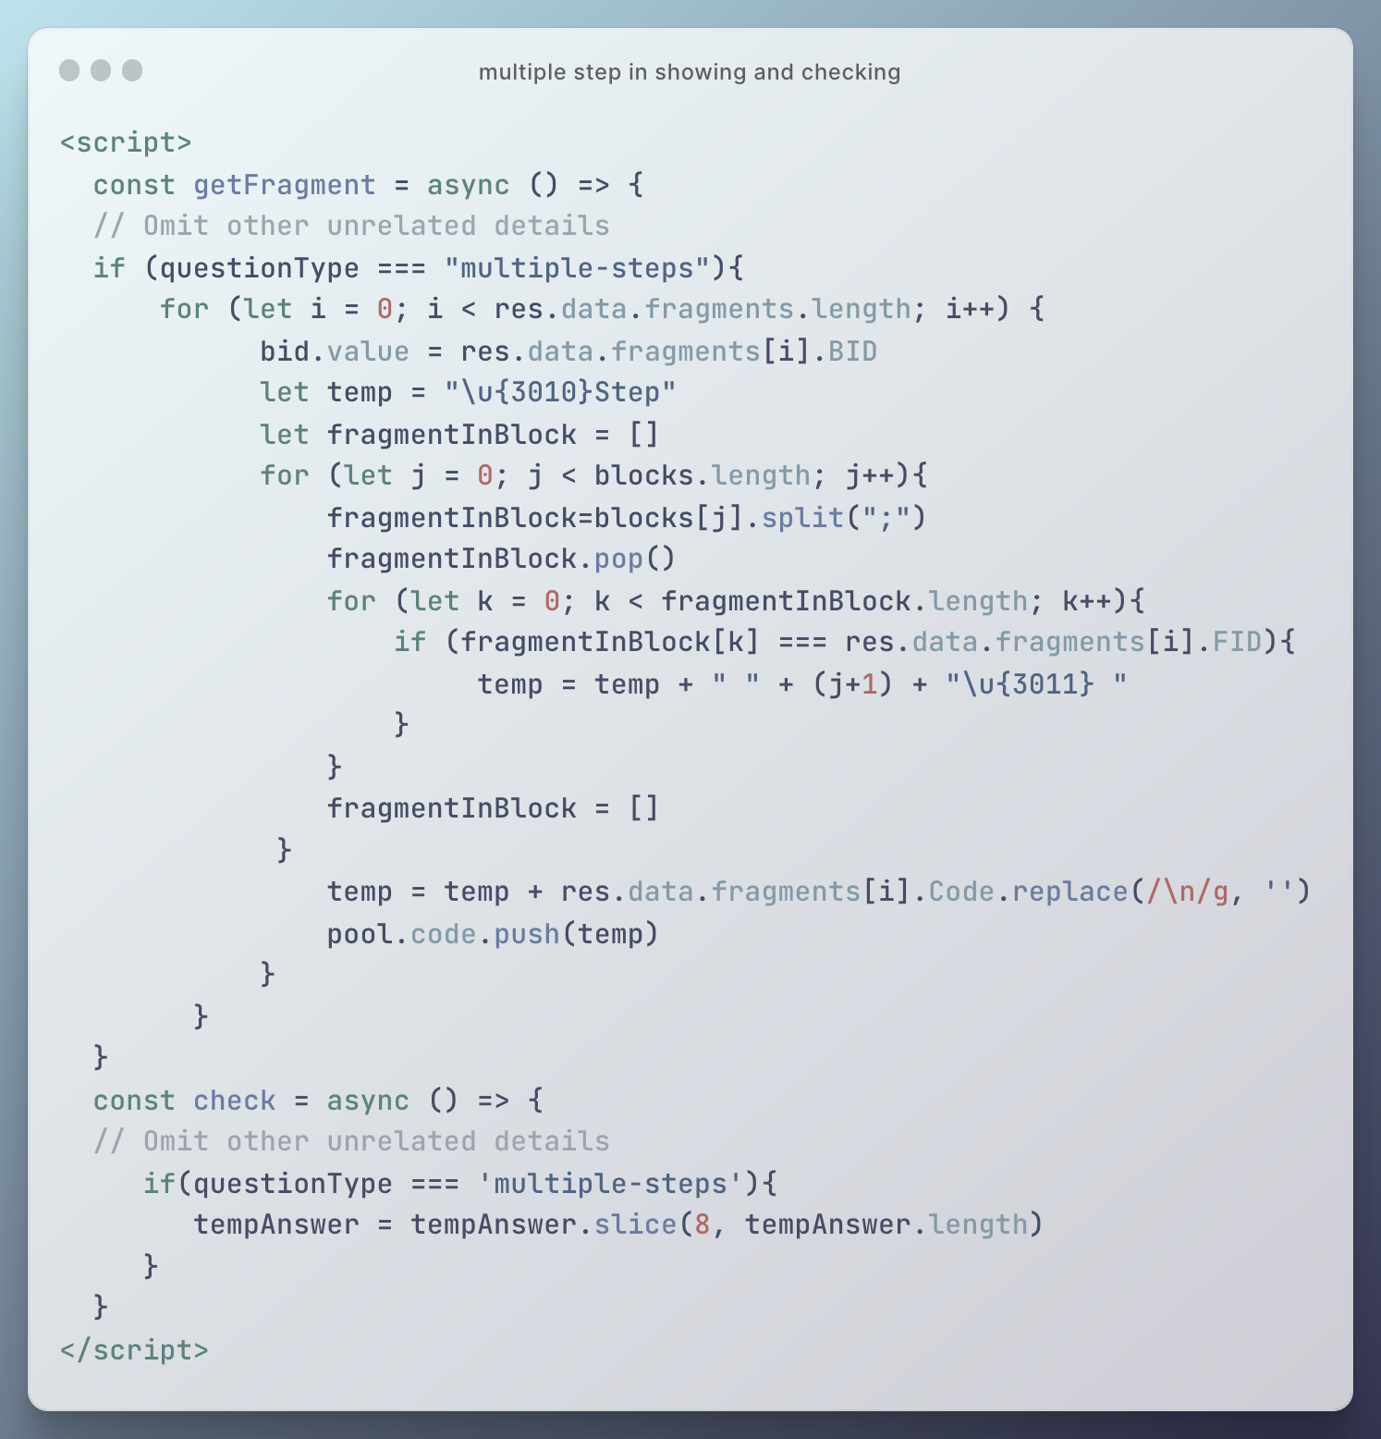

Figure 32 Multiple step in showing and checking

## Algorithm Comparison

This type of question does not make great changes in the logic of program. The only thing is to store the information of the second solution into another set of existing variables like ‘sequence’ and ‘sequence2’. And new draggable area is add in between the original two areas and the items in this area are pushed into ‘pool.buffer’ when showing (Figure 33).

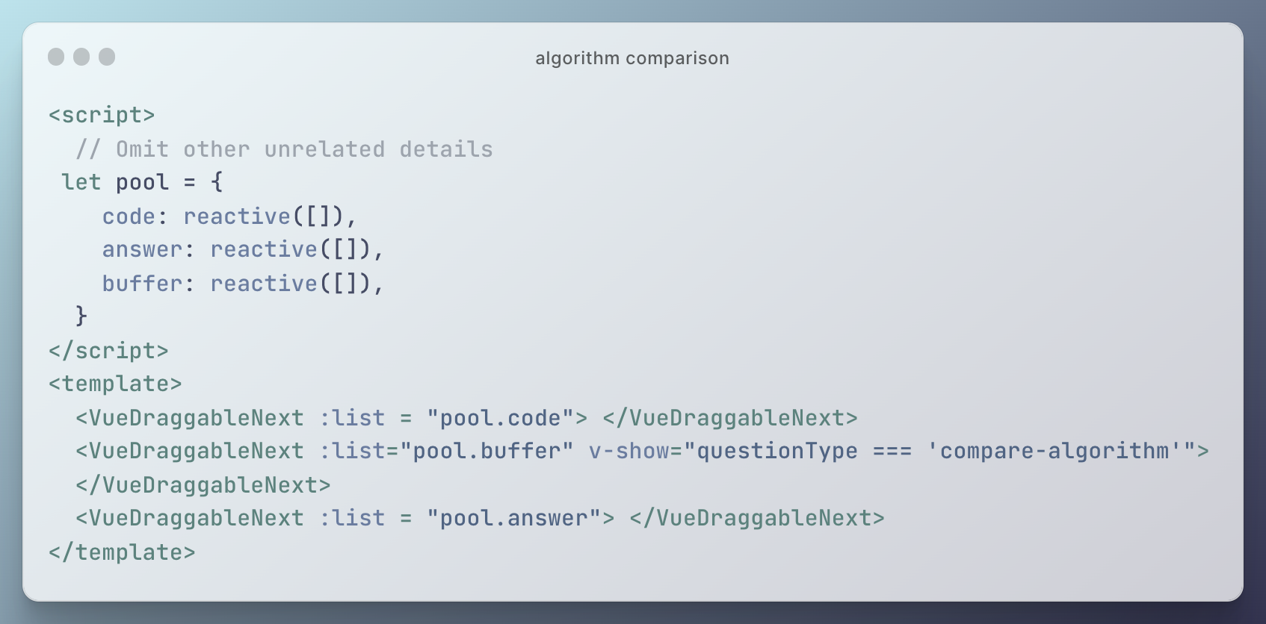

Figure 33 Algorithm comparison

## Switch Difficulty Level

Switching difficulty level can reduce the difficulty significantly. However, the implementation of this function is not easy. The first idea coming out about this function is to use the ‘Difficulty Level’ in database to handle the different organization of different difficulty level. But in that design, the types of blocks and fragments are quite trivial, unclear and not user friently. To handle this question, the types is summarized in ‘Question’ level and all the action about lower level should refer to the question types. Since the ‘Question’ is high level of ‘Difficulty Level’, it is not straightforward to store different question information in the single ‘Difficulty Level’ which is belong to one question. To solve this problem and save time, the ‘Easier Version Pointer’ is created to store the relationship between the original question and the easier one. This final design breaks the restriction of the previous design effectively. By using this design, the teachers can create a question type after customization. The new question is created in the back-end, and the same information of the original one and easier one is automatically stored Figure 34. The teacher only need to choose the new question type and customize solution in the front-end. (Modify: choose question type position later)

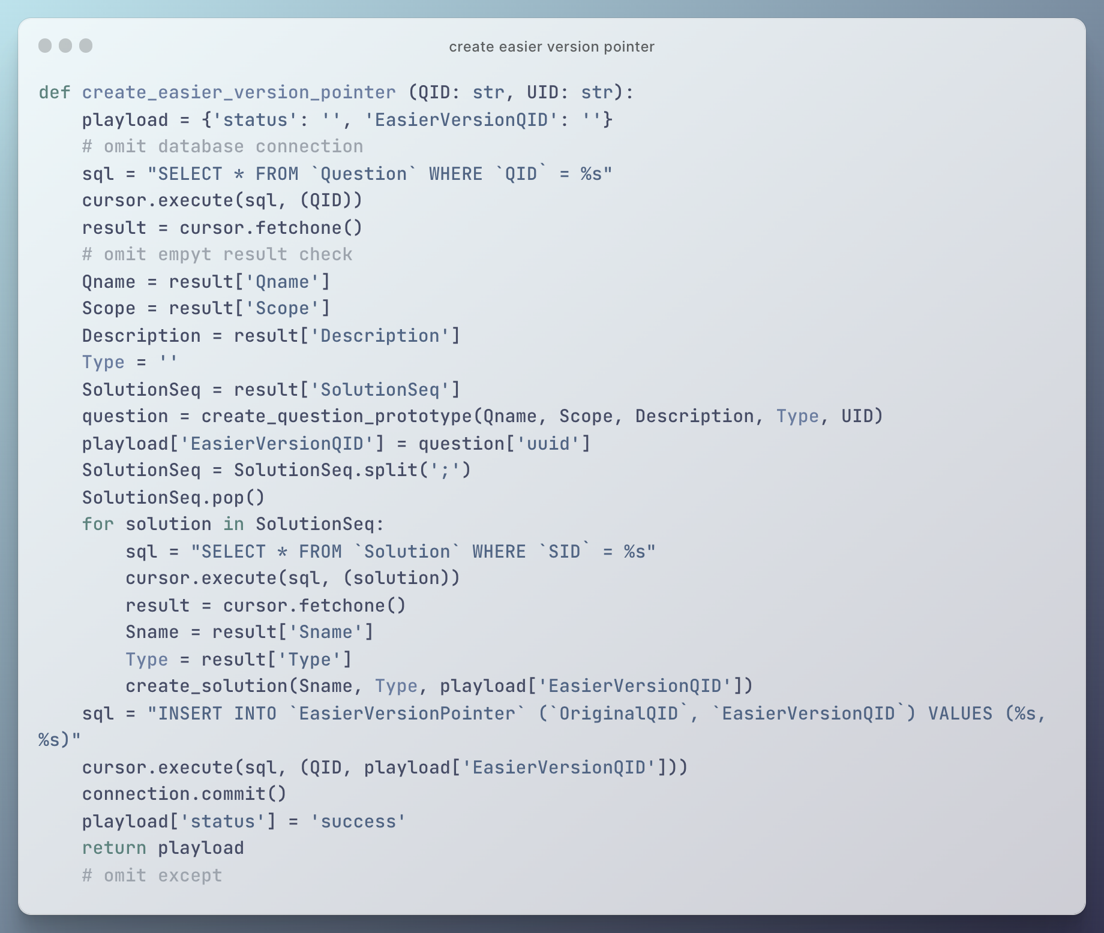

Figure 34 Create easier version pointer

# Results and Discussion

In this chapter, the outcomes of the project are illustrated by screenshots. In addition, this project is compared with existing work to show value of the project. Specifically, the results of activities taken by teachers and students are illustrated in sequence. Subsequently, different question types are introduced based on the basic process. Other additional details are introduced finally. (May be modified later)

## Results of Basic Process: Home Page

When users firstly enter this web application, they can see the home page of this project (Figure 35). There are three major parts showing in this home page. Specifically, basic information of different question is listed in card view in the core area of home page. By reading these question information cards, users can get to know the question names with descriptions and select one question to view details. The navigation bar is shown on the top of the question list to allow the users to take some basic action including login, going to personal center, and creating a new question (only for teachers). The scope filter is shown on the right of the question list.

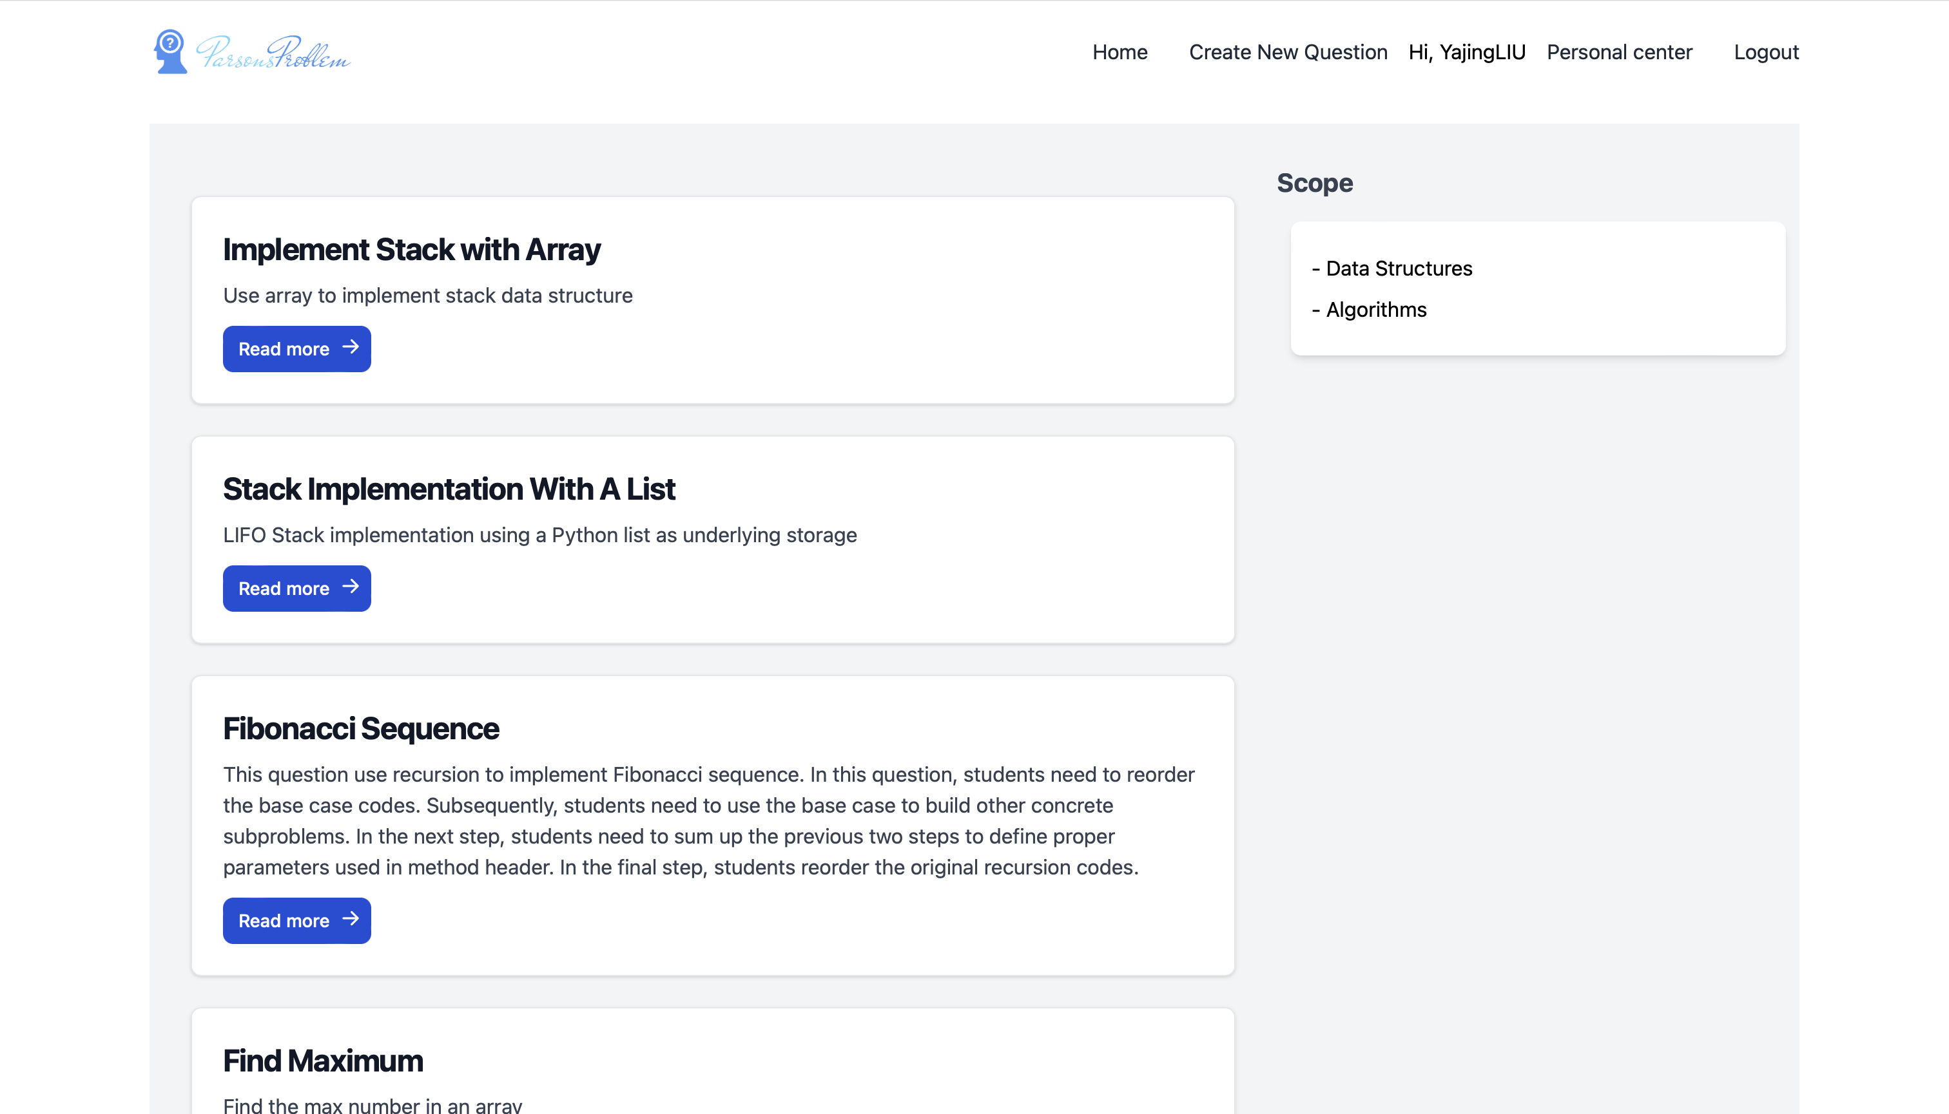

Figure 35 Home page

### Results of Basic Action: Register and Login

Users can enter the login page (Figure 36) by pressing the button ‘login’ in the navigation bar in home page. After users input the email address and password, the information is sent to back-end and compared with the records in the database. It is worth noting that the passwords are converted into hash forms for security reasons (Figure 37). If they are new users without an account, they can press the link ‘Not have an account’ and go to register page (Figure 38). After register or login successfully, the information of users is stored in the front-end for further using. And the navigation bar is changed according to user’s type (Figure 39).



Figure 36 Login page



Figure 37 Hashed password stored in database

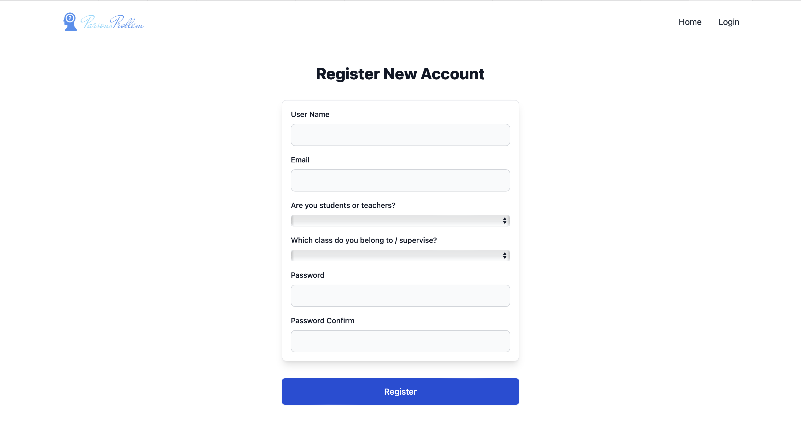

Figure 38 Register page

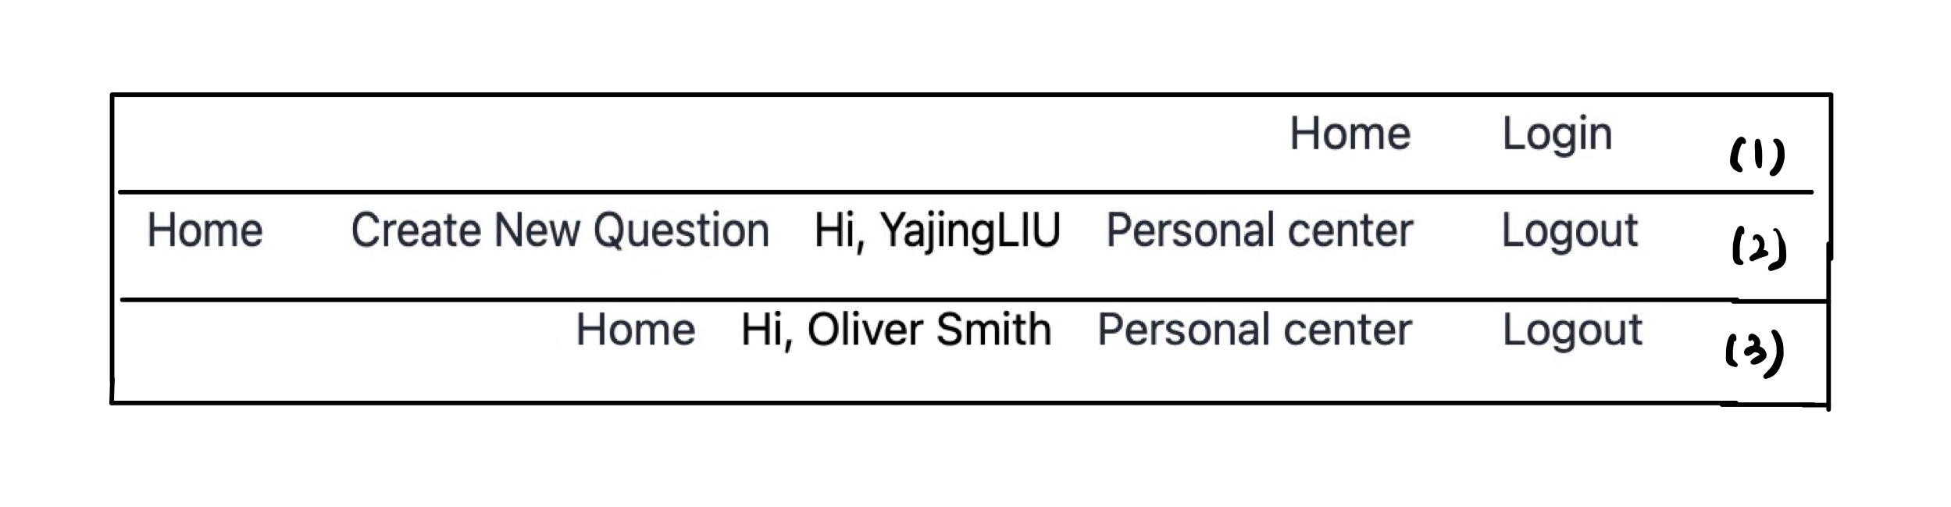

Figure 39 Different navigation bar for visitors (1), teachers (2) and students (3)

### Results of Basic Action: Create Question

Teachers can create new questions by clicking the link ‘Create New Question’ in the navigation bar. There are several steps to create a question – inputting basic question information, choosing question type, customizing question.

Inputting basic information of question is shown in Figure 40. In this page, teachers should input the name, scope and description of question.

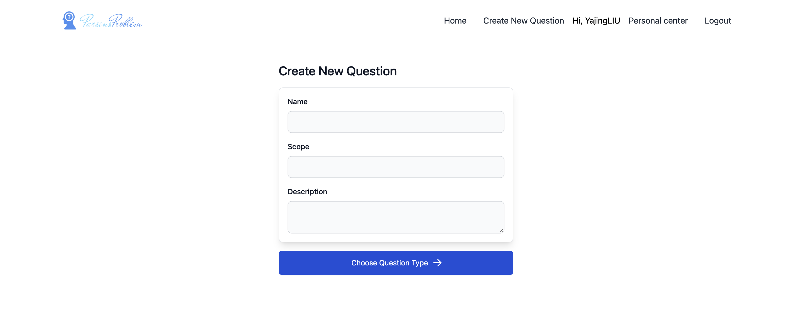

Figure 40 Create new question page

After inputting the mentioned information, teachers should choose the question types (Figure 41). In this page, gif animation and detailed description are used to have intuitive feeling in differences among different question types. Gif images show the conceptual picture and teachers can get some basic idea about how they work. And the description focuses on comparing characteristics of different question types.

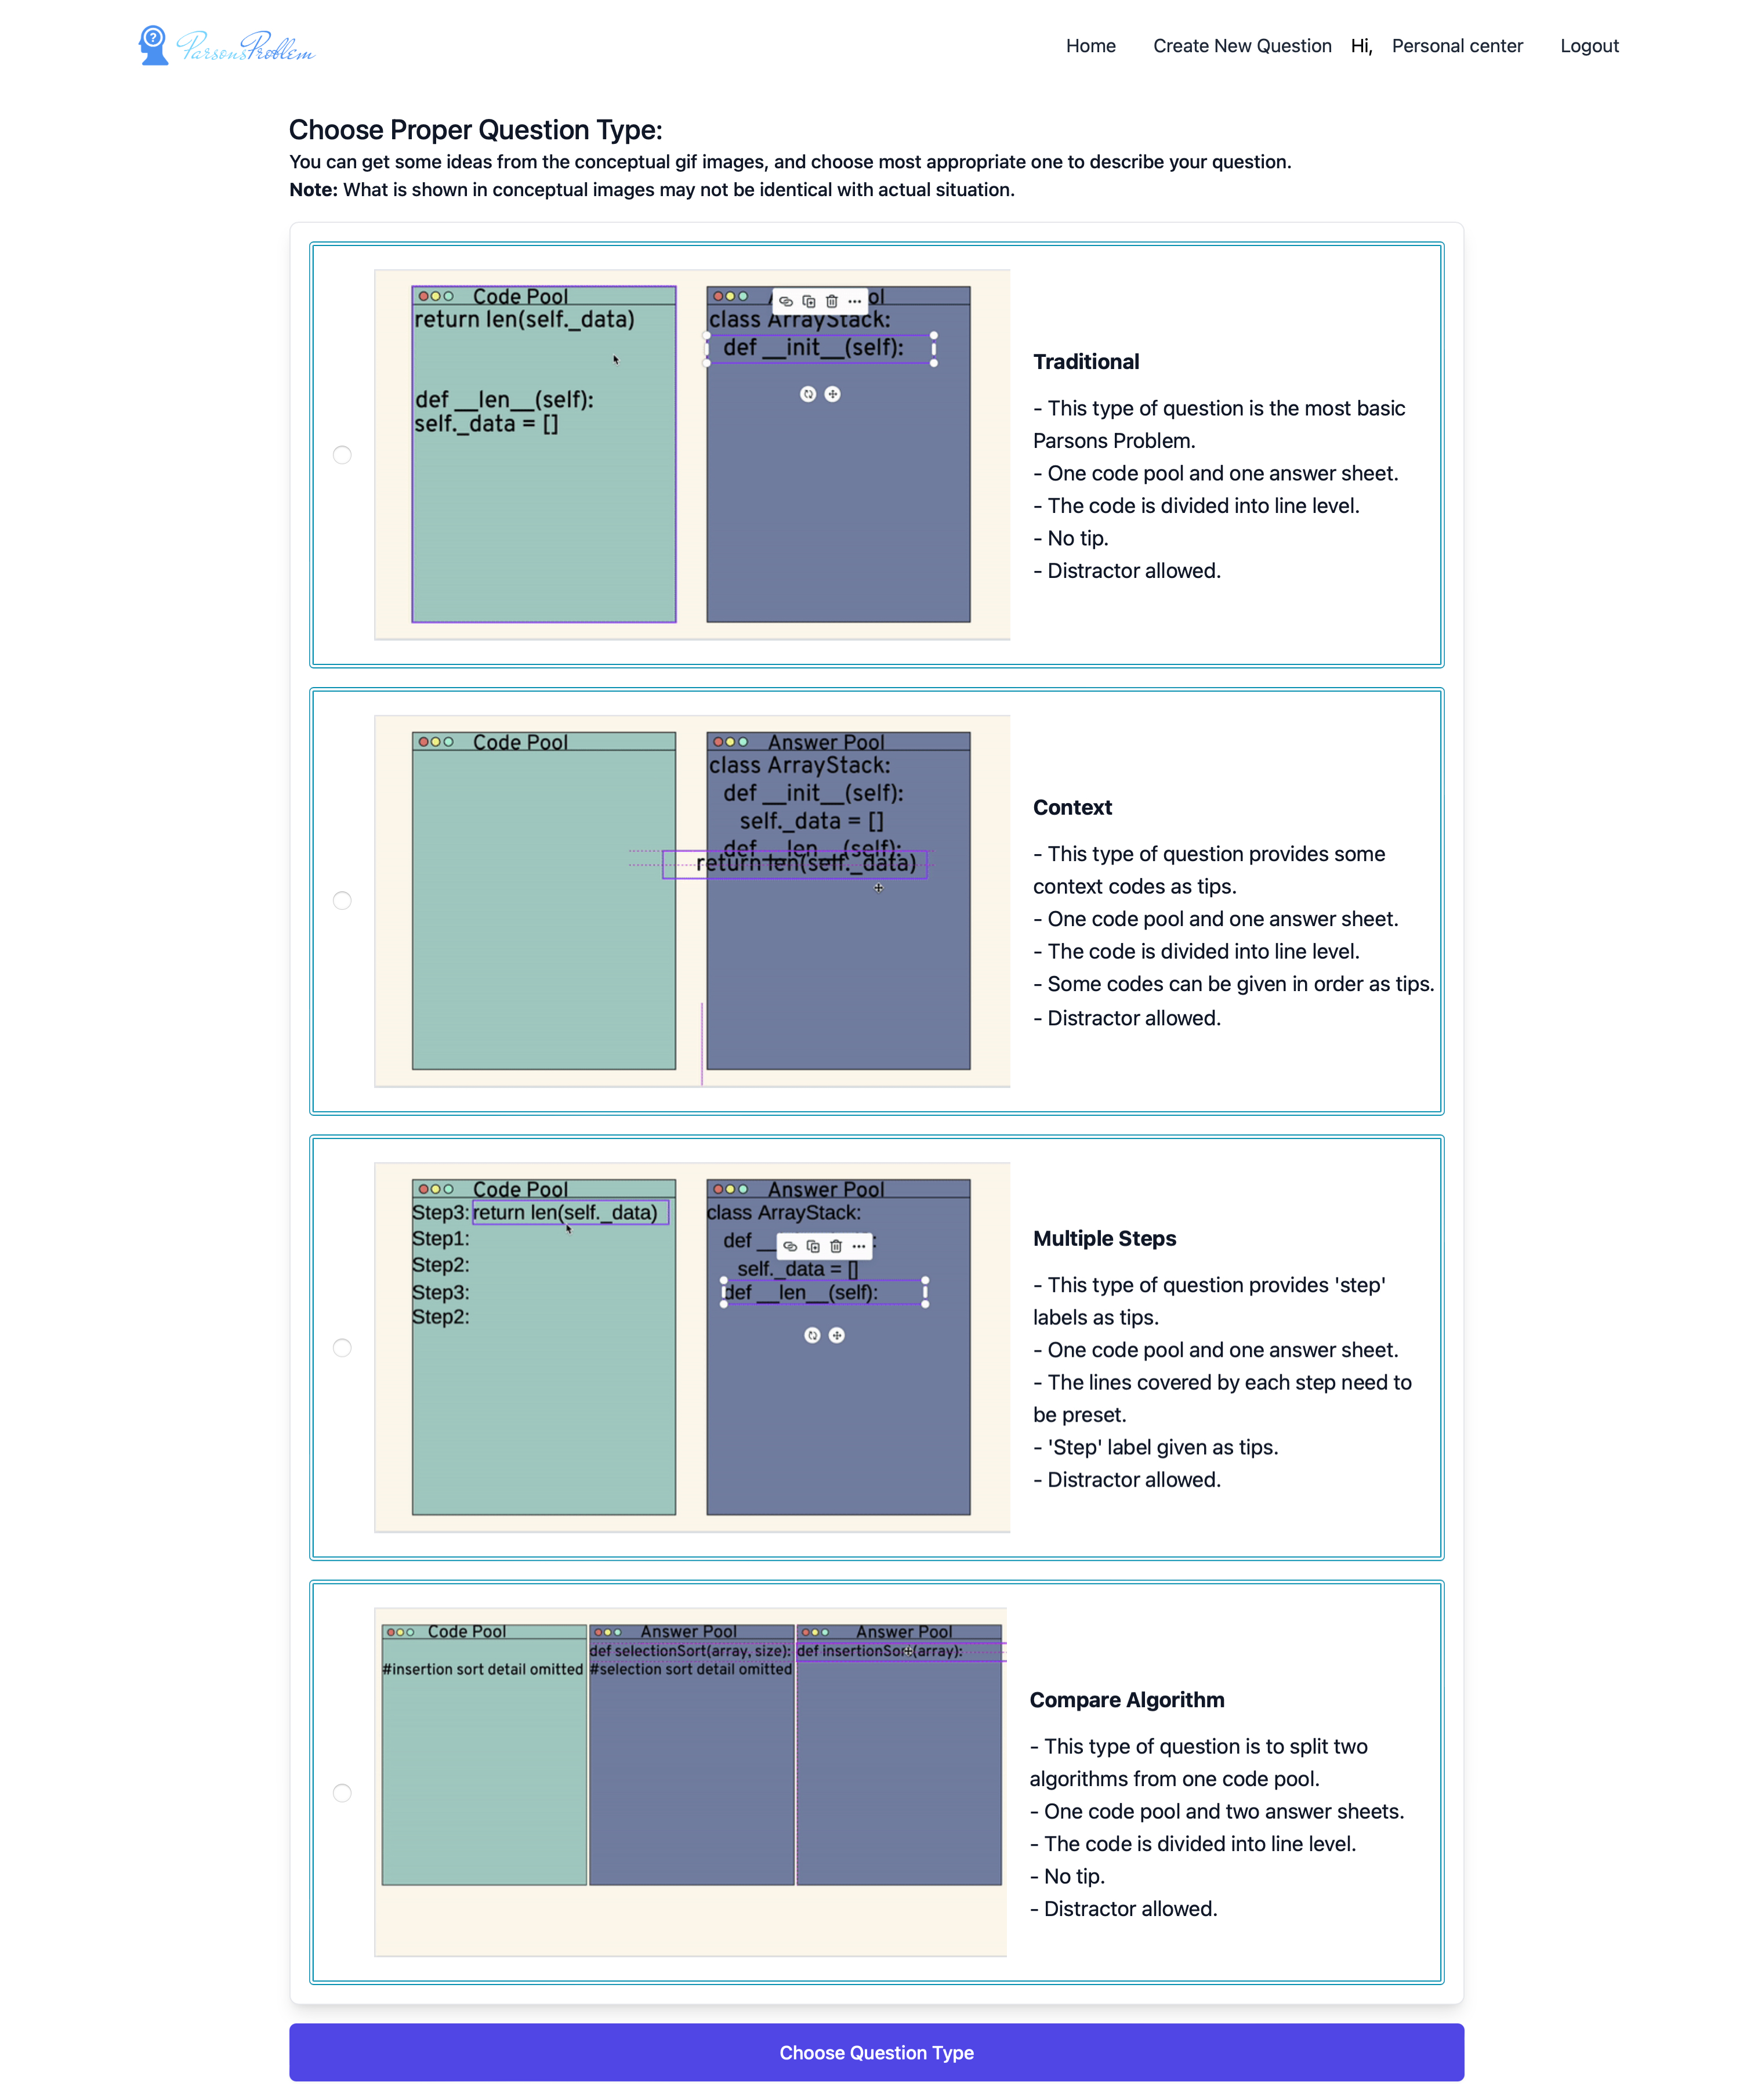

Figure 41 Choose question type page

The following step is to upload solution file (Figure 42). In this step, the prepared python solution file is uploaded into system. This file is cut into code fragments line by line in the back-end and stored in the database.



Figure 42 Upload solution page

In the final step, teachers can customize the solution according to their needs (Figure 43). Specifically, they can refer to the original codes in the uploading python file and take several action including setting distractors, marking special code fragments, grouping multiple code fragments into one block, and choosing easier version. More details will be illustrated when introducing different types of question.

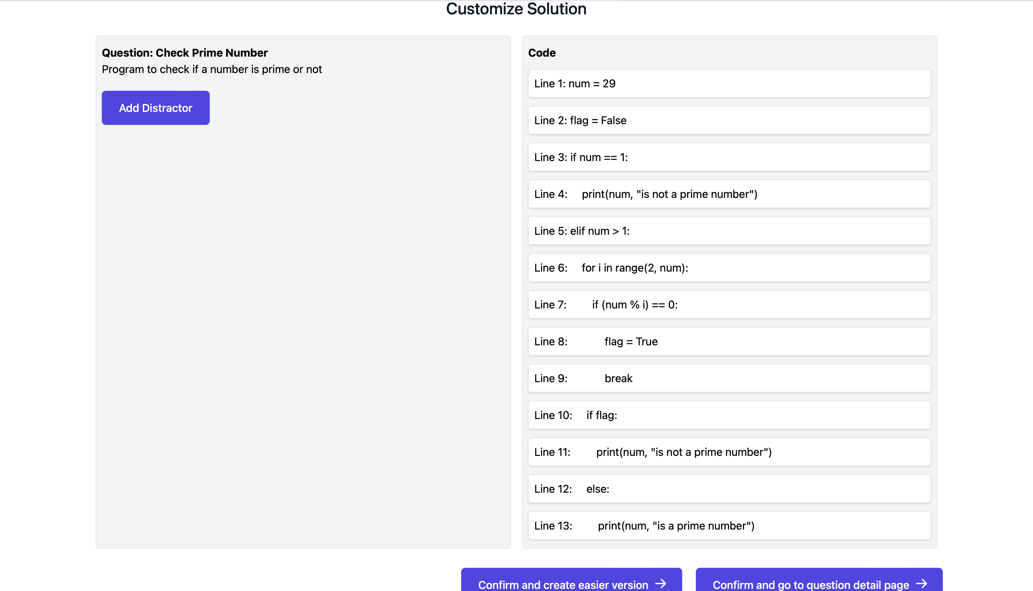

Figure 43 Customize solution page

### Results of Basic Action: View Question Detail and Do Exercise

Students can do exercise in the question detail page (Figure 44) after selecting question from home page. Besides, teachers can also preview this page after creating a new question. Students can reorder the jumbled codes by dragging and dropping the code fragments from left code pool to right answer sheet (Figure 45). Subsequently, they can push arrow buttons shown in the lines in answer sheet to set proper indent of codes. After finishing, they can press the check button to get feedback. In the feedback, the score (completeness of predefined solution reconstruction) and textual indication are shown in an alert (Figure 46). In addition, the codes are marked as different background color (green for totally correct, yellow for right code but wrong indent and rede for wrong code) to give students further instruction (Figure 47). Students need to replace taking exercise until they achieve 100% correct. And each score is recorded in the database once checking.

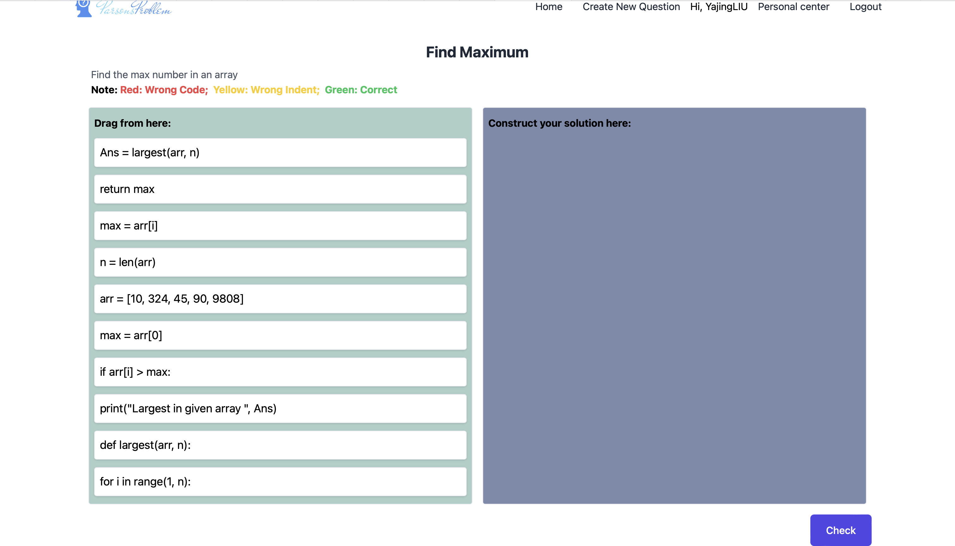

Figure 44 Question detail page

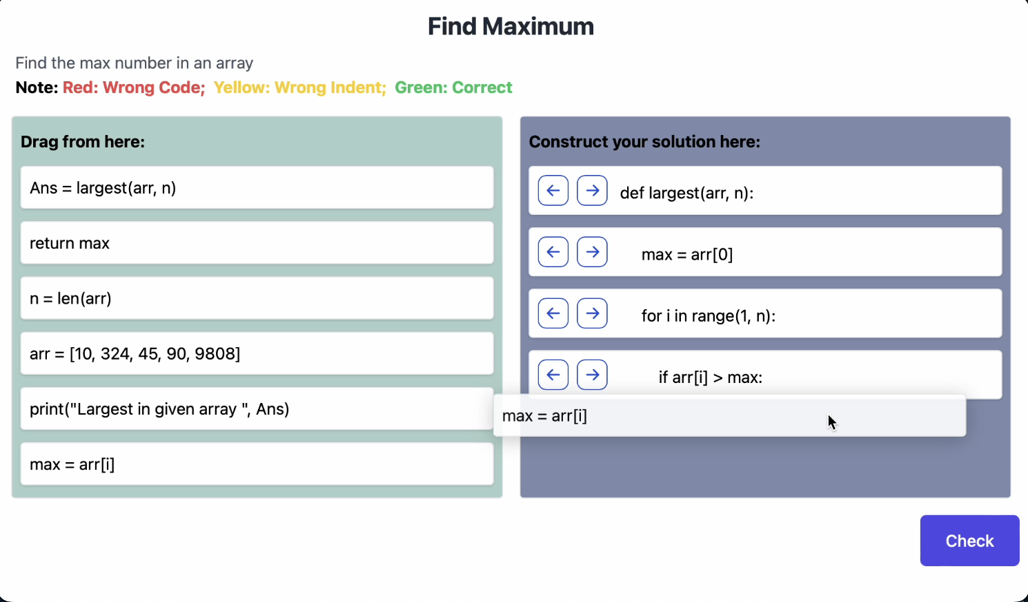

Figure 45 Drag and drop

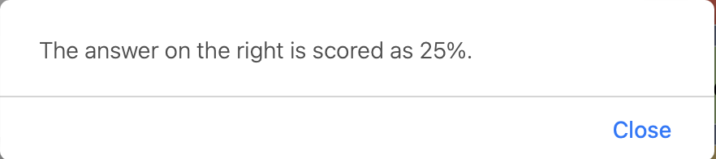

Figure 46 Feedback alert

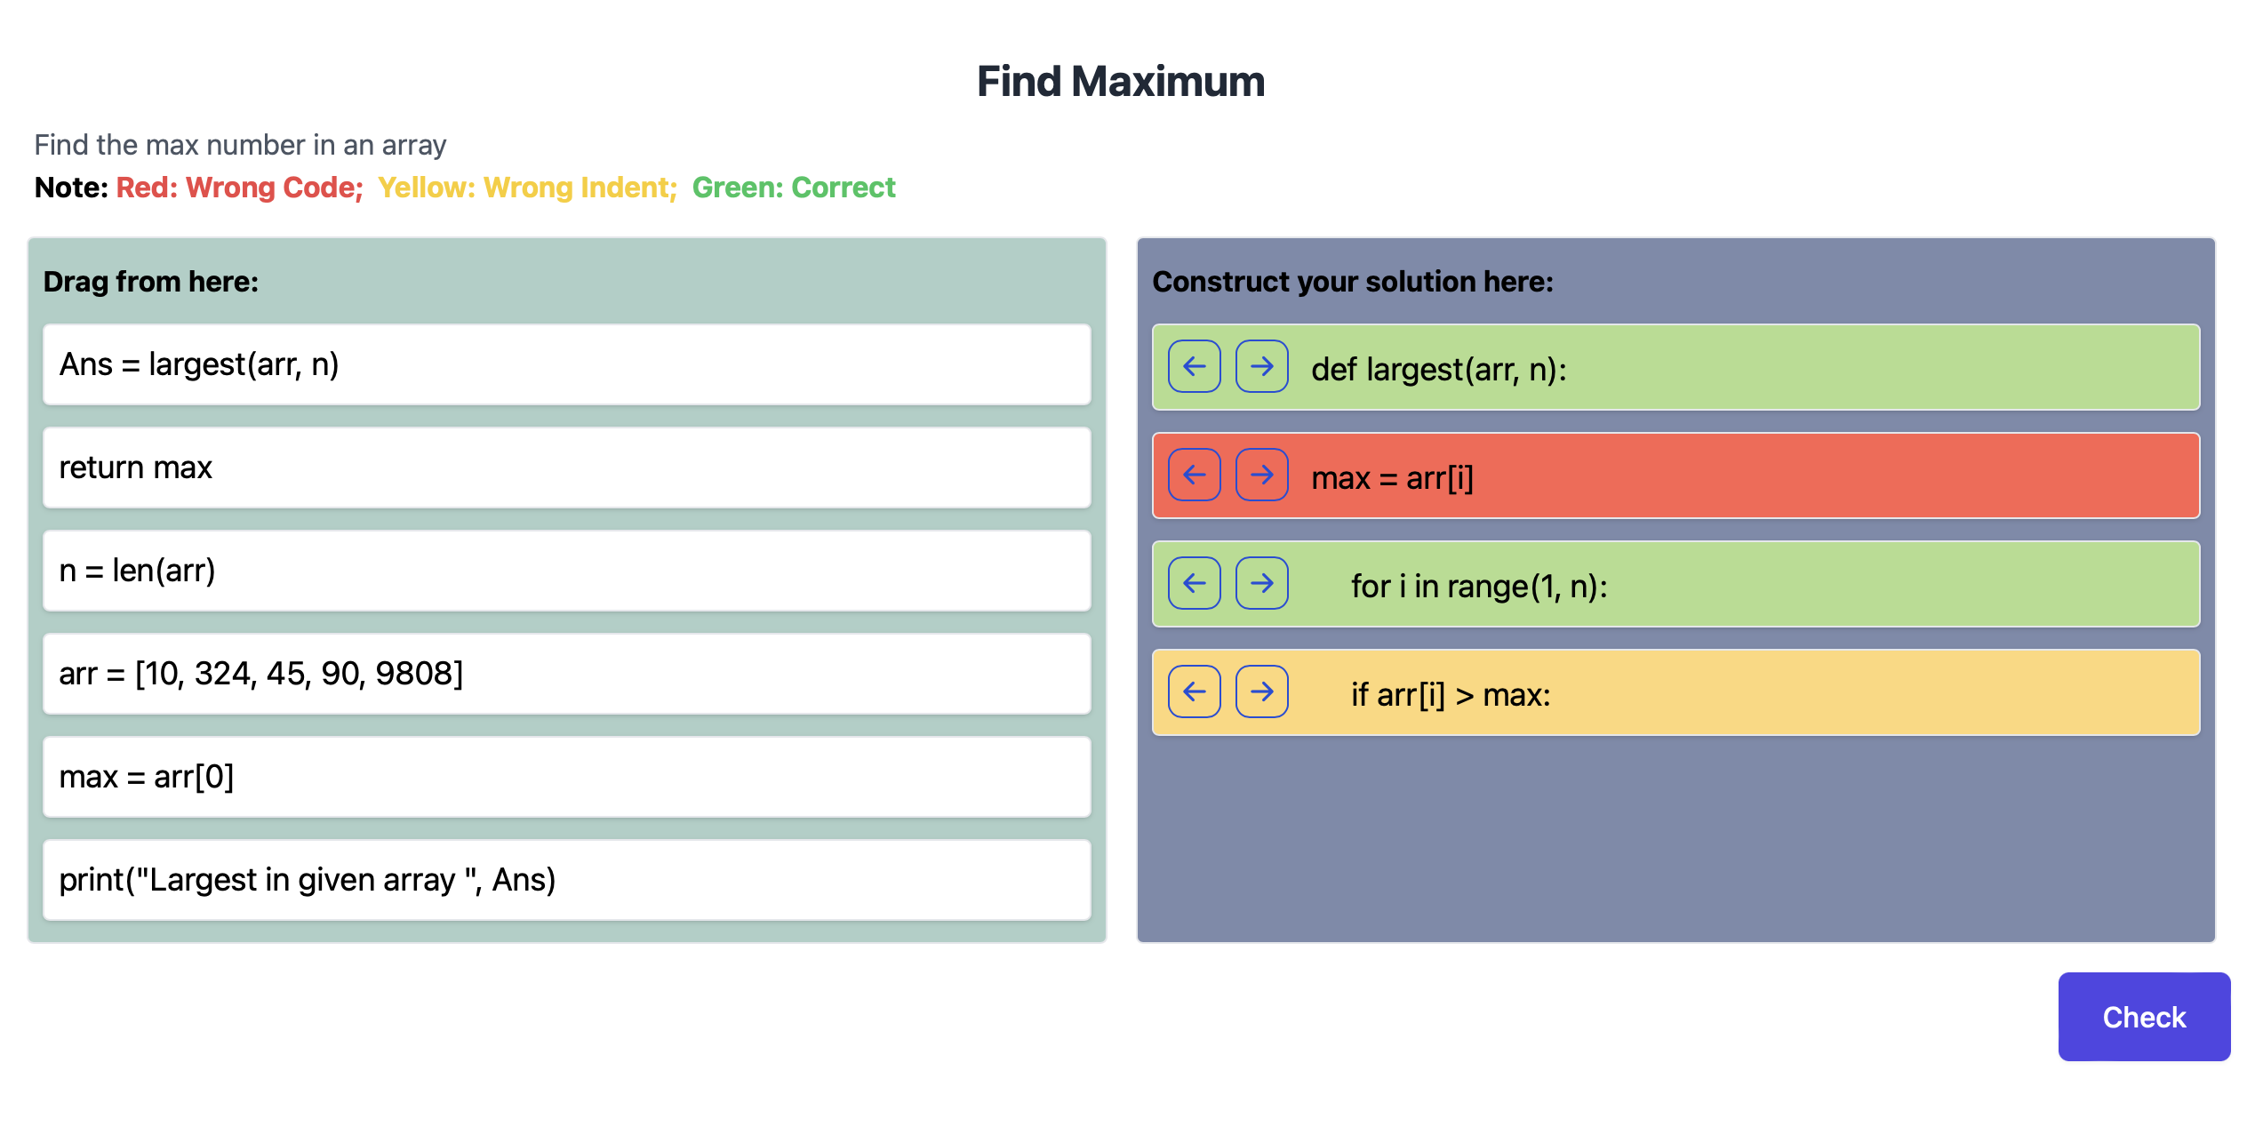

Figure 47 Codes with different background colors

### Results of Basic Action: View Records

The basic information of account and exercise records are shown in the personal center. Students can view their names, emails, types and classes in this page. They can also view the question information and score of previous exercise. In addition, they can redo the exercise they are interested in (Figure 48). past performance.

In contrast, teachers can view all the students’ records group by classes, and they may select questions that are not completed well by most students to explain in class (Figure 49). Review students’ performance. (Only show question title, and show students’ records statistics, check teachers’ status not upload teachers’ records)



Figure 48 Student personal center page



Figure 49 Teacher personal center page

### Results of Different Question Types: Traditional

This is the most basic question type of Parsons problem. It is used as the example to show the workflow mentioned before. To compare with the following question types, the significant page - customize solution page (Figure 50) and question detail page (Figure 51) are shown below.



AFigure 50 Traditional: customize solution page



Figure 51 Traditional: question detail page

### Results of Different Question Types: Contextual Clues

This part shows the Parsons problem with partially ordered codes as tips. There are two types of questions – context and insert key code. For both two questions, teachers need to mark context or key code in customize solutions and then students can view in question detail page. Specifically, compared with customize solution page of traditional Parsons problem (Figure 50), the buttons ‘pin’ and ‘unpin’ are added in the front of every line of code in reference area. And teachers can click these buttons to change the code fragment types (pin used as context and unpin used as not context). As the Figure 52 shown, the lines with pin mark (line 1, 2, 3, 4, 6, 8) are context, while others are not context. Similarly, inserting key code has alike customize solution page (Figure 53). The only difference is to use star to mark key code. As for the question detail page, the context question type provides partially ordered code with placeholder in the initialization phase to reduce the difficulty of the problem (Figure 54). And after clicking the checking button, all the placeholders will be put in the left code pool. It is similar in inserting key code, but there is no placeholder.

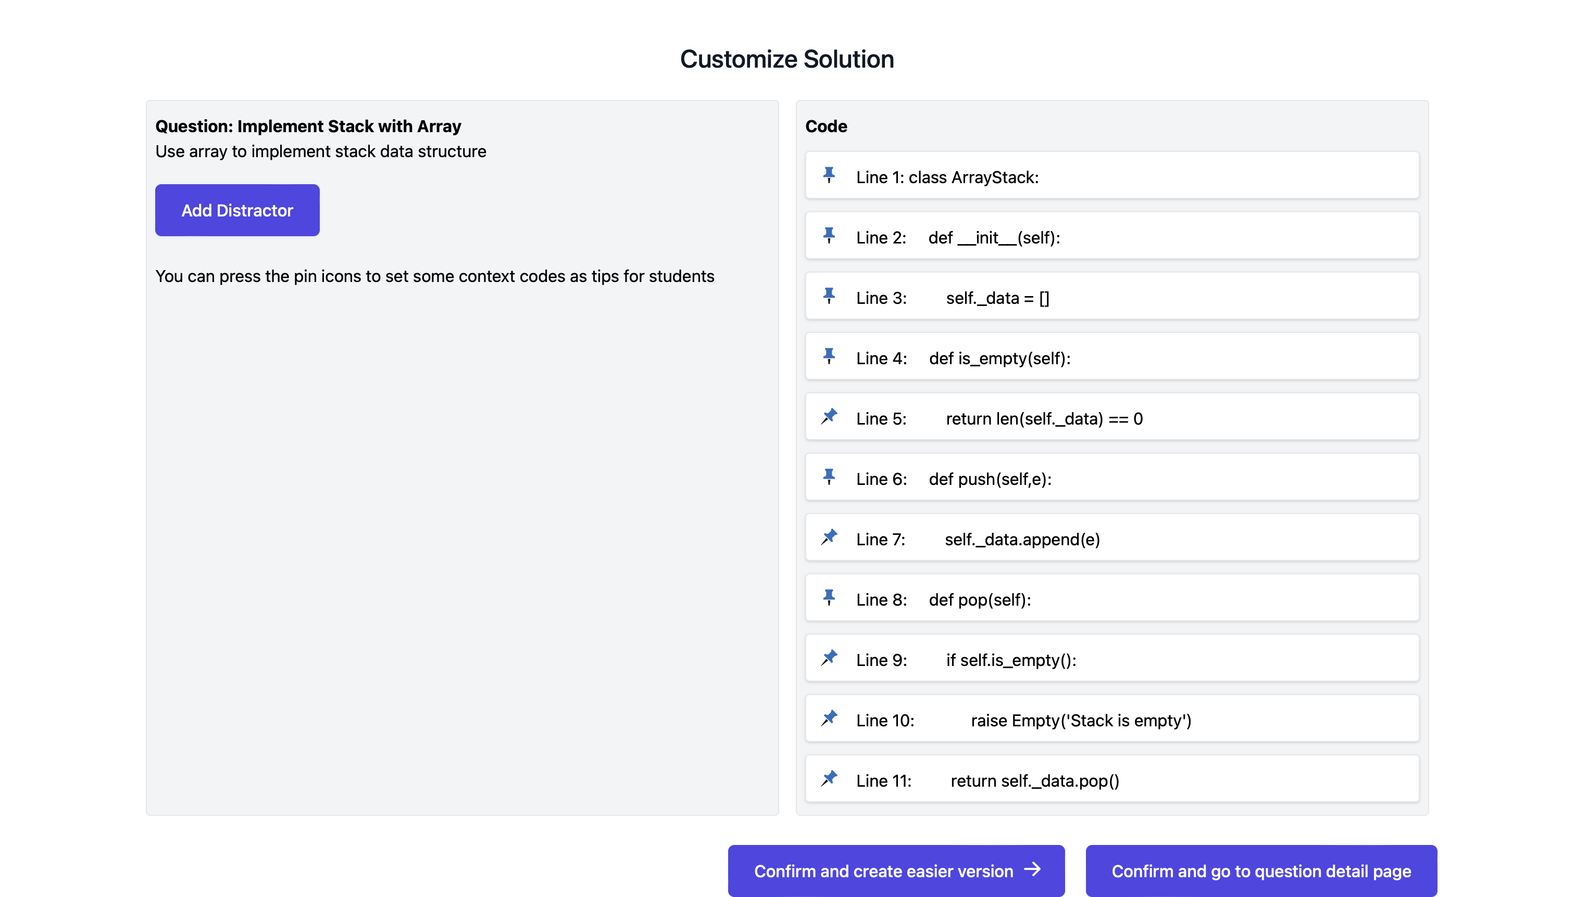

Figure 52 Context: customize solution page

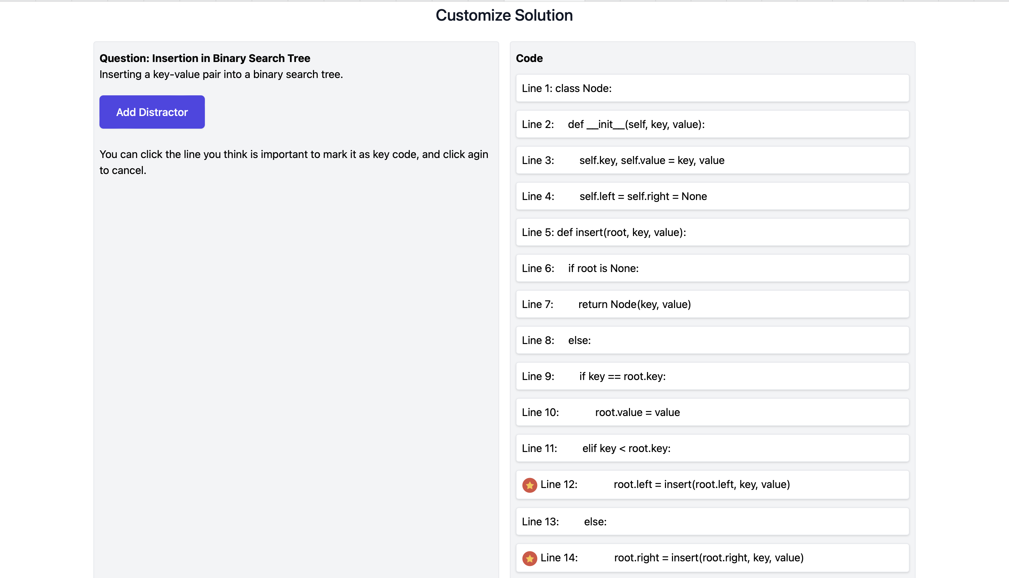

Figure 53 Insert key code: customize solution

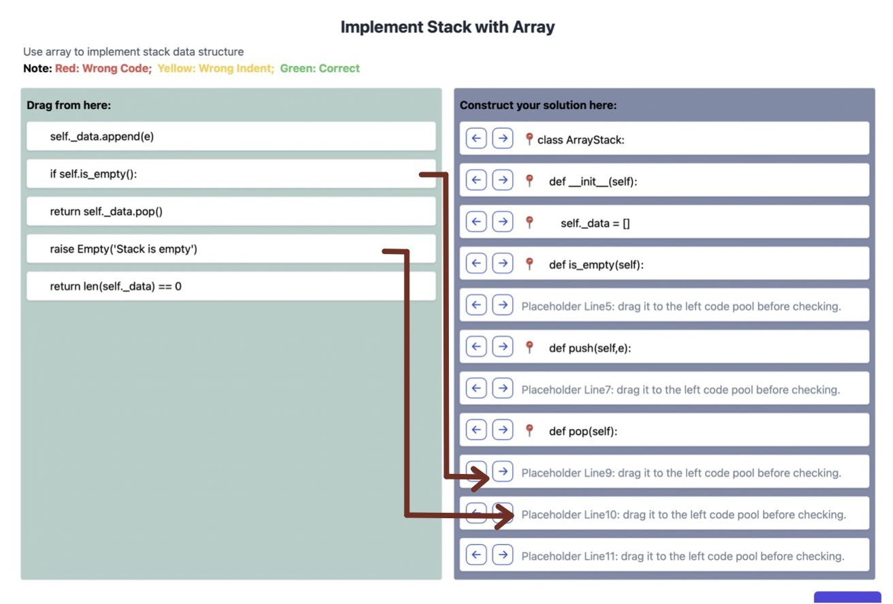

Figure 54 Context: question detail page

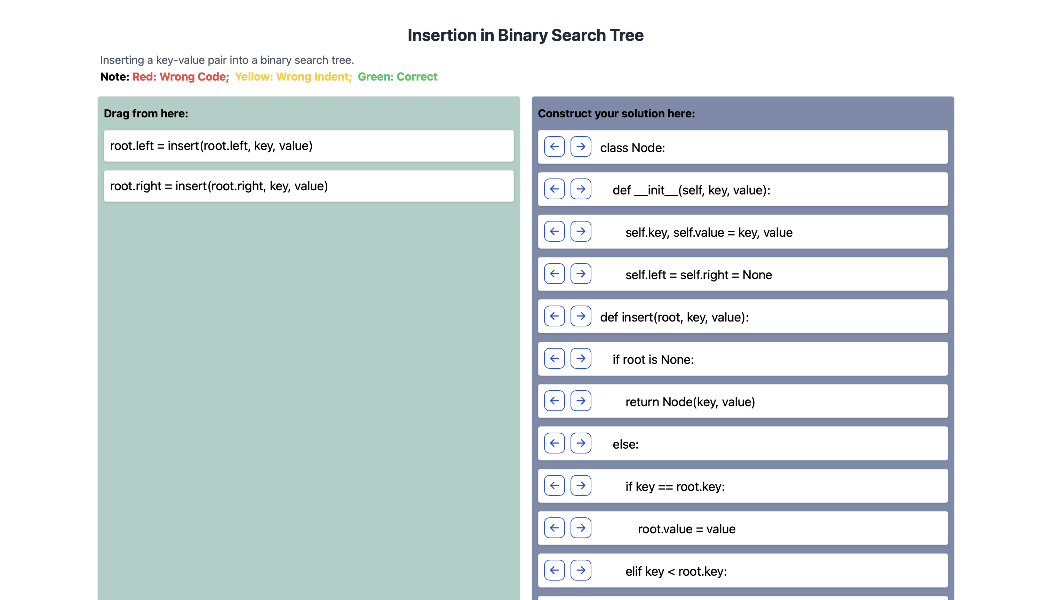

Figure 55 Insert key code: question detail page

### Results of Different Question Types: Multiple Steps

This question type is to break complex problem into several consecutive steps. Firstly, in the customize solution (Figure 56), teachers set step information by making multiple lines of code belong to single step (Figure 57). The step information is stored in the database once every line in the original code is covered. After teachers set the step information, the step number can be shown as tips for students in question detail page (Figure 58).

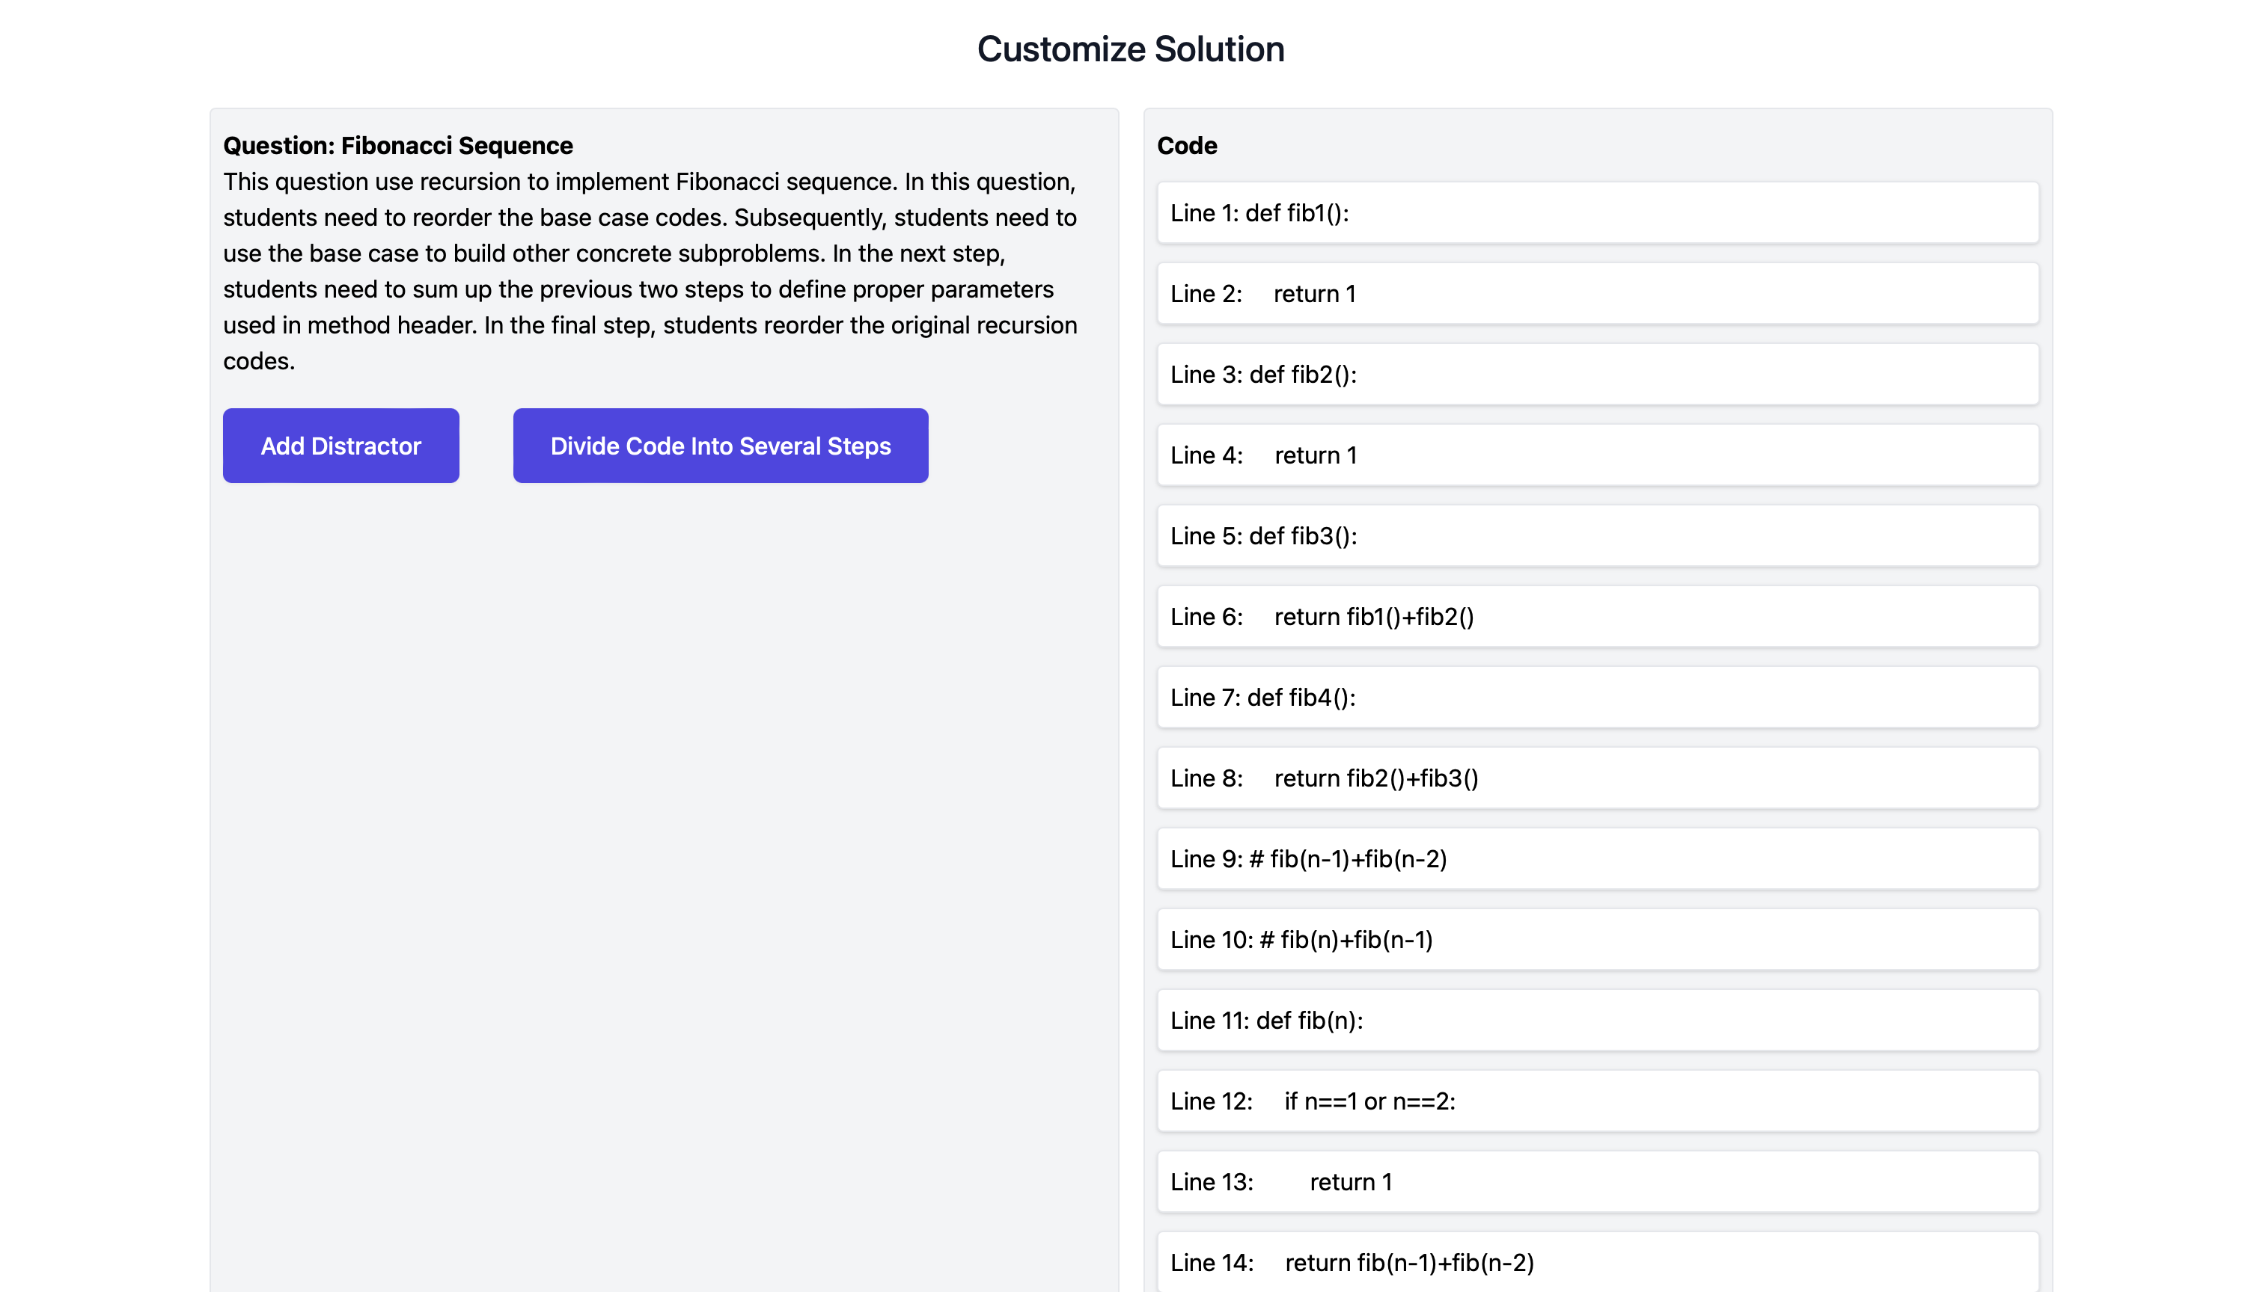

Figure 56 Multiple step: customize solution

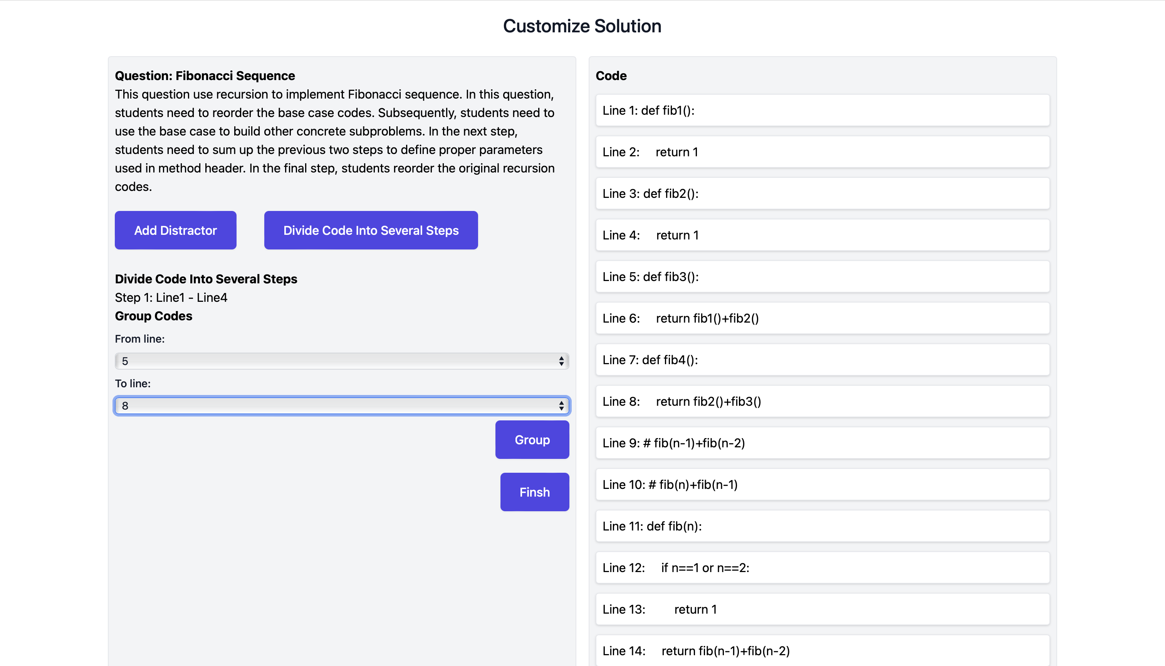

Figure 57 Multiple step: divide into steps

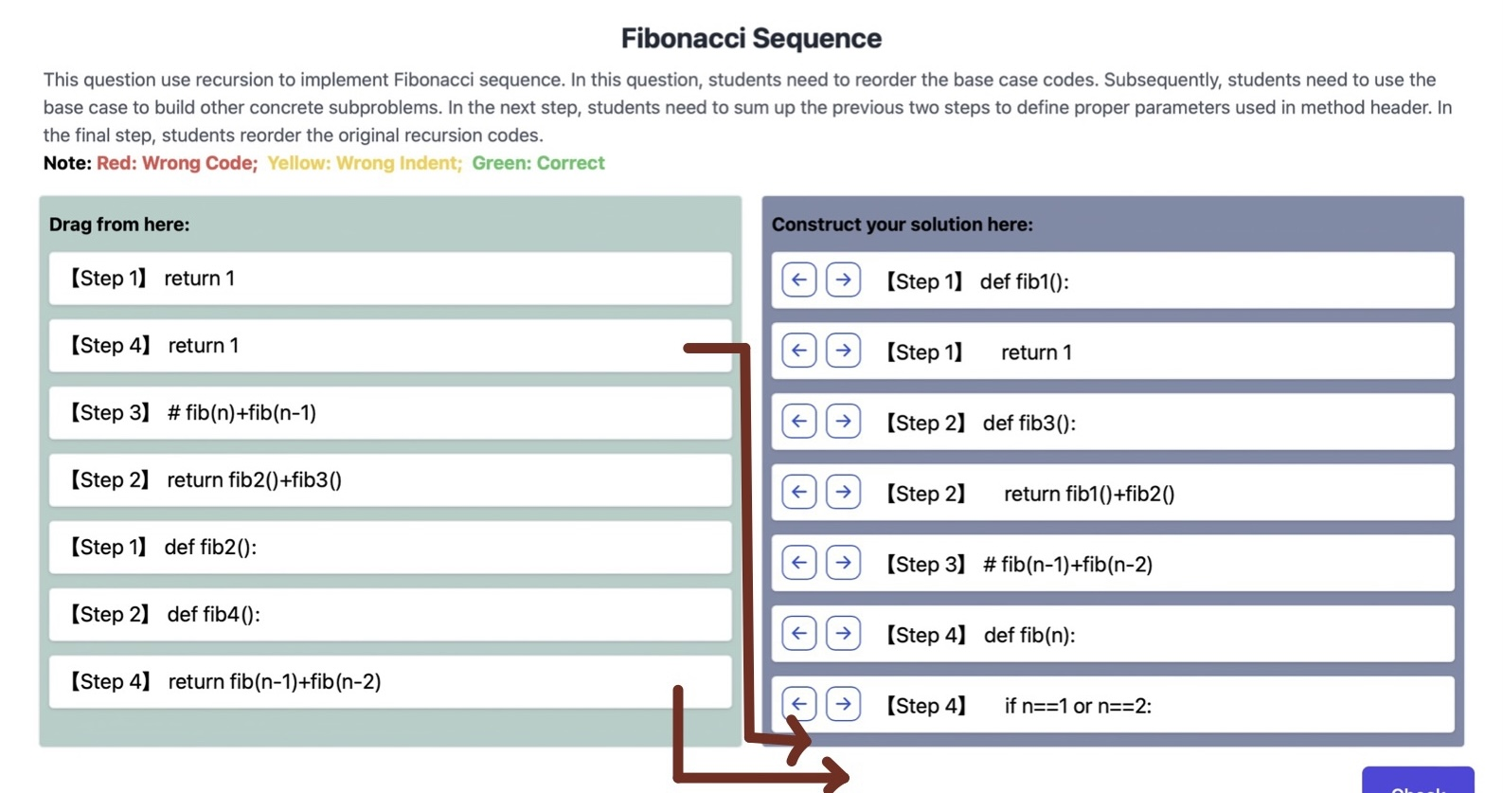

Figure 58 Multiple step: question detail page

### Results of Different Question Types: Algorithm Comparison

Compared with traditional question type, the algorithm comparison can show two solutions simultaneously in the customize solution page (Figure 59). And in the question detail page, there are two answer sheets to hold these two solutions separately (Figure 60). Students need to split two algorithms mixed in left code pool to middle and right answer sheets.

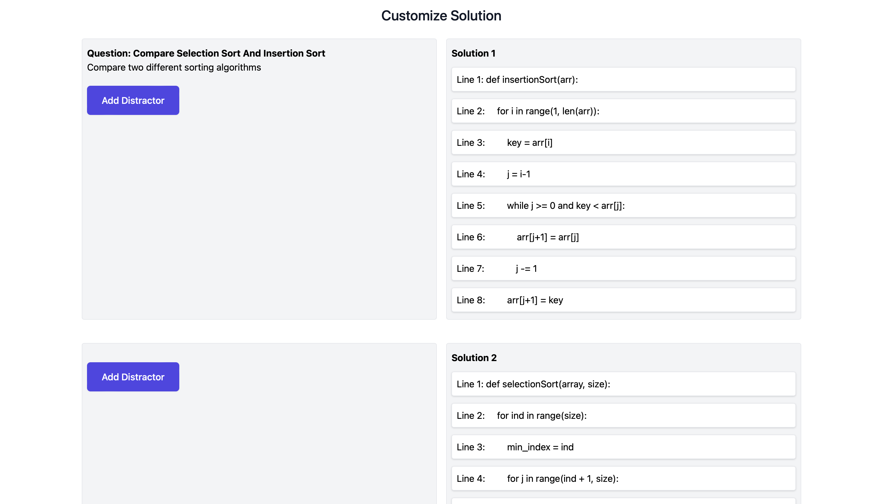

Figure 59 Algorithm comparison: customize solution page

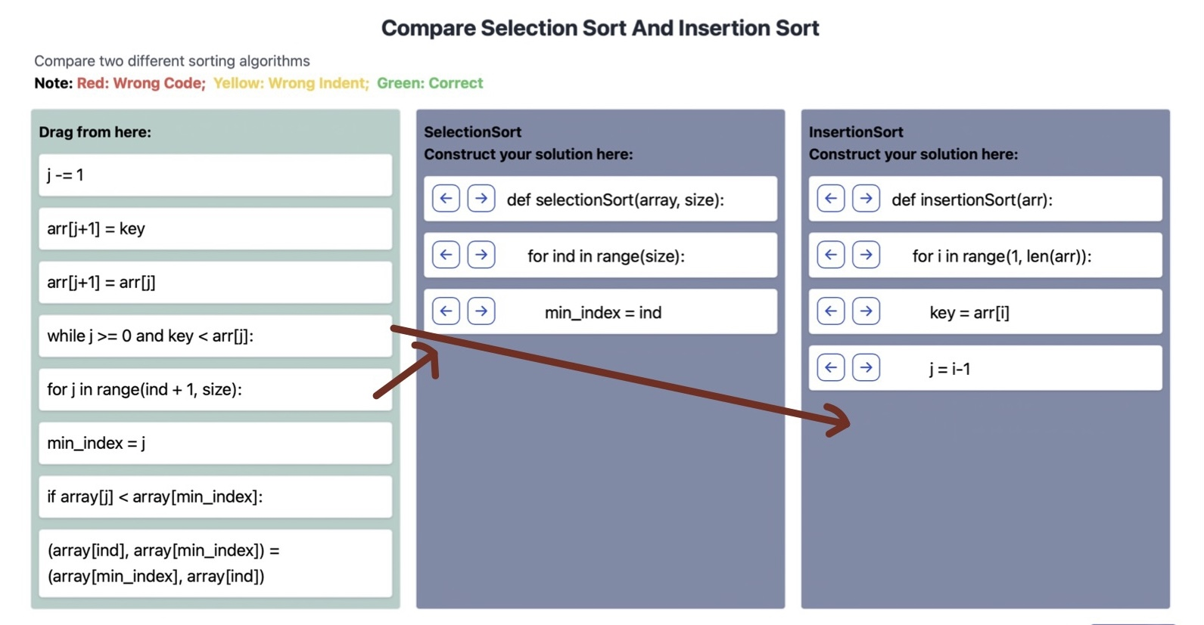

Figure 60 Algorithm comparison: question detail page

### Results of Additional Details: Distractors

For every type of question, it is allowed to add distractors to let students learn to distinguish some common errors. The distractor is set in the customize solution page (Figure 61). And the set distractors are shown with the jumbled code pool next to the comparing line.

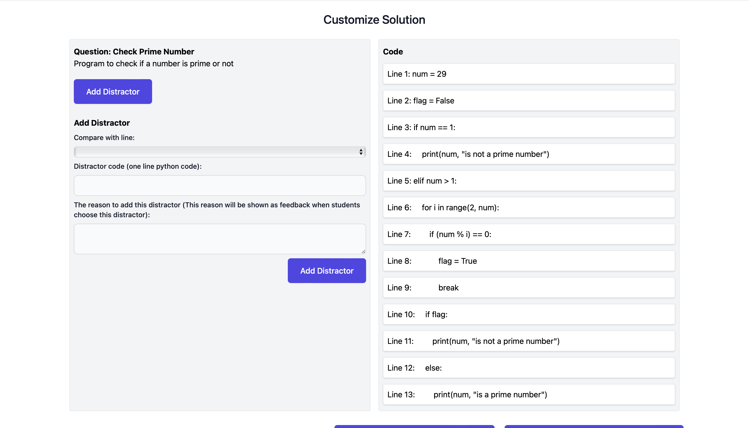

Figure 61 Distractor: customize solution page

### Results of Additional Details: Switch Different Difficulty Level

Switching different difficulty level helps students reduce difficulty of question further. It can be achieved by two action – setting the difficulty level in the customize solution page and allowing students to choose easier version when meeting problems. Specifically, in the customize solution page (Figure 62), if teachers finish the customization, they can confirm the customization and create an easier version with different question types. All the question information and solution codes are stored automatically in the back end, and teachers do not need to enter it again. The only thing the teachers should do is to choose question type and customize easer solution. They can choose the question type in the dropdown list. If they forget what the concrete question type looks like, they can click the link to jump to the previous question type page. In addition, in the question detail page (Figure 63), easier version can be suggested to students when they have check more than three times or they have not taken any action for a long time. After they finish the easier version, they can go back to solve the original one. The easier versions are not shown in the question list in the home page.



Figure 62 Switch question type: customize solution page



Figure 63 Switch question type: question detail page

## Discussion

In this section, the effectiveness of the extended Parsons problem is illustrated by comparing with the traditional Parsons problem in the following four aspects – object orientation programming, algorithm analysis, recursion and comparison.

### Object orientation programming

### Algorithm analysis

### Recursion

### Comparison



Figure 64 Gantt Chart

## Future Work

In the future, the following work needs to be done to finish this project:

* The database needs to be checked and be updated
* Implement the function of inputting and showing multiple solutions
* Implement the function of altering the difficulty level
* Implement the function of handling comments, pseudocodes
* Implement more beautiful user interfaces

# Conclusion

In conclusion, this semester, I analysed Parsons problem in detail and found new ways to use Parsons problem to fit the exercise in CS2. In the future, I will focus on implementation to achieve these new functions.

References

[1] M. Hertz, “What Do "CS1" and "CS2" Mean? Investigating Differences in the Early Courses,” in Proceedings of the 41st ACM Technical Symposium on Computer Science Education, Milwaukee, 2010.

[2] D. Parsons and P. Haden, "Parson's Programming Puzzles: A Fun and Effective Learning Tool for First Programming Courses," in Australian Computer Society, Inc., Hobart, 2006.

[3] Y. Du, A. Luxton-Reilly and P. Denny, “A Review of Research on Parsons Problems,” in Proceedings of the Twenty-Second Australasian Computing Education Conference, 2020.

[4] P. Denny, A. Luxton-Reilly and B. Simon, “Evaluating a new exam question: Parsons problems,” in Proceedings of the ACM Workshop on International Computing Education Research, 2008.

[5] B. B. Morrison, L. E. Margulieux, B. Ericson and M. Guzdial, “Subgoals Help Students Solve Parsons Problems,” in Proceedings of the 47th ACM Technical Symposium on Computing Science Education, Memphis, 2016.

[6] P. Ihantola and V. Karavirta, "Two-Dimensional Parson's Puzzles: The Concept, Tools, and First Observations," Journal of Information Technology Education: Innovations in Practice, vol. 10, pp. 119-132, 2011.

[7] A. Kumar, “Epplets: A Tool for Solving Parsons Puzzles,” in Proceedings of the 49th ACM Technical Symposium on Computer Science Education, New York, 2018.

[8] M. T. Goodrich, R. Tamassia and M. H. Goldwasser, Data Structures and Algorithms in Python, Hoboken: Wiley, 2018.

[9] “Wikipedia of Object-oriented programming,” [Online]. Available: https://en.wikipedia.org/wiki/Object-oriented_programming.

[10] “Python Program for Tower of Hanoi,” GeeksforGeeks, [Online]. Available: https://www.geeksforgeeks.org/python-program-for-tower-of-hanoi/.